Change as the villain
A contemplation of change: refusal and hypocrisy vs. acceptance and advocacy
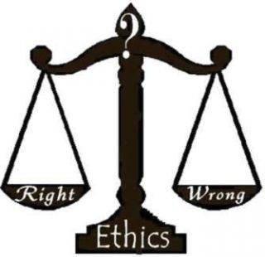
Once someone forms a certain mindset, or a mindset is forced upon them, that becomes the most difficult thing to change. Regardless of whether this mindset is ‘right’ or ‘wrong,’ ‘correct’ or ‘incorrect,’ it is nearly impossible to convert. This fact alone is incredibly dangerous.
Figure i) How do we determine right vs. wrong?
Because of this, sometimes one will force their opinions on others; shove their definition of right down people’s throats until they choke on them and are left grasping at their chests.
Because of this, sometimes one’s mindset turns into advocacy; an ability to pursue their beliefs on how to better society and speak up about issues in society.

“They will completely dismiss anything that disagrees with their opinion.”
Because of this, sometimes certain people simply become stubborn in their views, refusing to believe anything but what they’ve been falsely taught since birth and the words they’ve grown up hearing. They will completely dismiss anything that disagrees with their opinion.
Often, this is because of the environment one was brought up in. The ideas that have surrounded them since birth and the words, be it angry and loud or dismissing and ignorant, are the only ones they know how to understand.
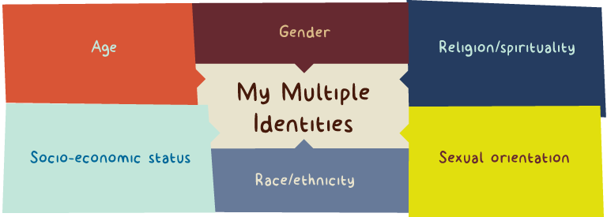
One can be brought up in an environment yet still hold a contrasting idea from the majority. This may be the cause of having a differing identity from the majority, or it could simply be a stubbornness from the possibility of becoming naïve and easily impressionable. When this is the case, an environment like this will appear to become even more hostile than previously thought.
Figure ii) An example of different identities one may have.
Although no matter how much one wants to change their thought-patterns, no matter how hard one tries, one will continue to fall into old habits again and again. It’s truly inevitable. Only after continuous strenuous effort will one begin to see the change in themselves.
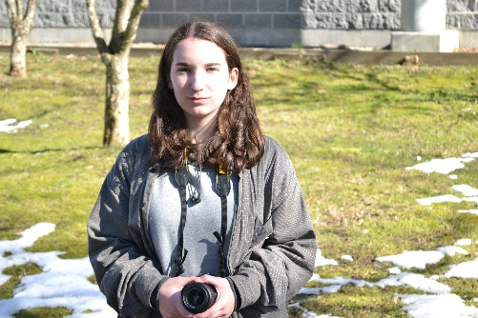
This pattern can be viewed as growth in ways; the fact that they are trying to change is evident enough in itself. More often than not, people don’t even attempt to change. Change is the thing that scares people most; they claim it stalks them and is out for their blood when their views on reality are simply warped. When actually, change is the thing that we all rely on. Small and large changes litter our everyday lives; the fear of change some people hold says more about them than any words they could sputter.
Do you remember? Yesterday you bought that new product.
Do you remember? You moved to a different city a few years ago.
Do you remember? That time that you changed.
Figure iii) These questions make me wonder about change in my life
How can one fear the change constantly occurring in society when one has been changing since the day they were born? It is a concept that is difficult to understand. Often, it’s never thought of—never even considered—that maybe all this change is normal. Maybe, it’s natural and inevitable. Maybe, just maybe, it’s needed.
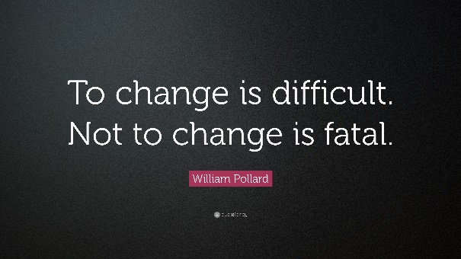
The thoughts that should plague these people’s minds, the sort of things they should be fearing: “Why am I seemingly the only one not changing in a society that never stays the same for a single day?”
I also experience change on a regular basis. For example, I recently started grade 12; that means I have new courses. In the table below is my schedule as an example of a change I went through and therefore had to adjust to.
Figure iv) A quote which ties to these ideas
Block | Course | Teacher | Room Number
A | Journalism/New Media 12 | Ms. Shong | 221
B | 20th Century World History 12 | Mr. Lepore | 123
C | Economic Theory 12 | Mrs. Kim | 120
D | Business Communications 11 | Mrs. Kendal | 221

