
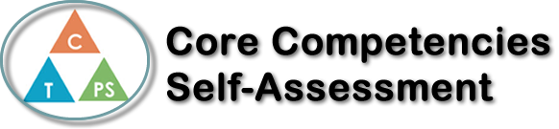
Name: Kylee Holms | Date: November 12, 2019

  How does the artifact you selected demonstrate strengths & growth in the communication competency?  In what ways might you further develop your communication competency? | Self-Reflection  My artifact is an article I wrote for Riversides online newspaper, The Eddy, in my journalism 12 class. The article is titled “LGBTQ+ history needs to be included in school curriculums.” The two core competencies this artifact shows my strength and growth in are creative thinking and critical thinking.  Writing this article took a lot of research and critical thinking; I had to think about what information I was going to cover, the extent of it and which topics I would touch on. I also had to be aware of which sources I was using and how accurate they were as well as making sure I used multiple different sources.  The creative thinking aspect of this article was largely putting the information together into an informative and interesting article; it may not seem like such an article has anything to do with creative thinking, but it takes creativity to be able to tell information in such a way that makes one want to keep reading. I had to present facts and knowledge to my readers in a way which would pull them in; this took a lot of creative thinking on my part.  This article also shows how much I’ve grown in these two core competencies; compared to an article I wrote two years ago, or even one year ago, my writing has very clearly gotten much better. I am more effectively able to communicate information to my readers in an interesting and factual manner. I’m also able to interpret creativity into story ideas and how I present my stories/information.  I chose this story, also as my most recent one, because I am quite proud of it. No matter how many times I read it, I still find it very interesting and enjoyable. My writing skills have also increased tenfold compared to older stories I’ve done, which is visible in this story.


How does the artifact you selected demonstrate strengths & growth in the thinking competencies?

In what ways might you further develop your thinking competencies?


How does the artifact you selected demonstrate strengths & growth in the personal & social competencies?

In what ways might you further develop your personal & social competencies?

Publish Your Self Assessment
You will now attach and/or embed your self-assessment to the bottom of the blog post with the artifact you have chosen. You may choose to make this post private or public. After placing your artifact on a blog post, follow the instructions below.
- Categories - Self-Assessment
- Tags - Now tag your post using the tag that corresponds to the competency that you have written about. You can choose more than one. Please use lower case letters and be exact.
  - #creativethinkingcc
  - #communicationcc
  - #criticalthinkingcc
  - #socialresponsibilitycc
  - #personalidentitycc
  - #personalawarenesscc
- Use the Add Document button located at the top of your post page and embed your self-assessment at the bottom of your blog post.
- Publish

