English Studies 12
Intro-write composition
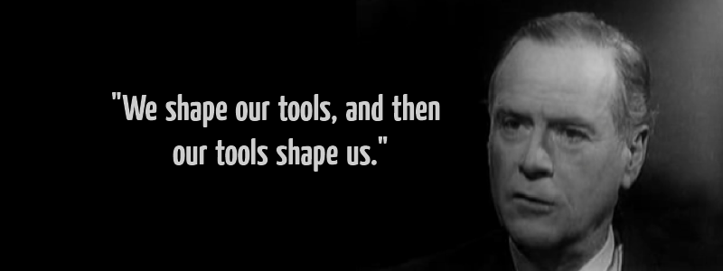
Purpose:
- to explore a current societal issue
- to think critically, understanding different perspectives on an issue
- to read and be informed regarding the different perspectives
- to organize ideas coherently, to inform and to persuade your audience/reader, supporting a perspective with properly integrated evidence
- to write an argumentative composition, in an authentic voice, utilizing various rhetorical strategies
Instructions:
- Reflect upon our class conversations/notes, and the resources which we used; see the RED TAB for resources and the document called Resources Pro and Con
- Address this essential question in your essay:
What does it mean to be a critical thinker or an educated person in a society that is largely mediated by algorithmic data and ever-advancing AI?
- How? In a persuasive composition that informs the reader of both sides of the issue, but ultimately persuades/argues in favour of one stance on the issue based on the evidence you presented:
  - You must have a lead-in sentence that hooks your reader and introduces your purpose; similar to a thesis sentence
  - Acknowledge the two perspectives, starting with the perspective that you don’t ultimately agree with
  - Four references to the SOURCES provided in class:
    - Two must be direct quotes: properly integrated - grammatical or sentence lead-in with a colon (author’s name, publication hyperlinked) – see resources on the blog
    - Min two sources paraphrased: hyperlinked, author’s name and the source publication attributed in the composition for the initial mention; subsequent mentions, last name only
  - Your writing must flow from the beginning, transition through with phrases and words, and end with a definitive stance and take-away for the reader
  - You must incorporate a minimum of one or two writing devices (see PDF document on rhetoric): parallel structure, antithesis, metaphor, the appeals (pathos)…?
  - Minimum 650 words (max two pages) with normal margins, font size 12, 1.5 spacing
- What I want:
  - As the writer, you will discuss the two perspectives (where your sources come in through both a process of purposeful paraphrasing and direct quote/s for evidence)
  - But you will ultimately reveal your own thoughts and critical perspective on the issue: is it the beginning of the end of original, critical thought and creativity or a powerful tool for learning that will benefit all of humanity?
  - Formal, academic style and tone of writing, but persuasive – so no use of the pronoun ‘I’ or ‘you.’ You can use people, we, one etc.
  - Proper formatting – see #3f
  - Edited writing: spelling, proper capitalization, proper sentence structure, proper word usage (their, there, they’re, affect, effect…etc.) will be taken into account
- What I don’t want:
  - A ChatGPT essay you can use AI to organize your thoughts and get ideas; stay tuned for what/how you will do this, but do not tempt fate and get AI to write the entire composition
  - An expository research paper on Artificial Intelligence
  - Slang, colloquial expressions, personal pronouns, or a conversational tone
    - Like, ChatGPT is totally sick! I love it! You should give it a go!
- Where do I start?
  - Re-read or skim the articles and resources – pay attention to possible evidence or quotes you can use; organize the sources/quotes you want to use with the Resources Pro and Con document.
  - Start brainstorming (use the graphic organizer)
    - What is your stance on the essential question/prompt?
    - Go through the questions and prompts on the organizational sheet of ‘what’ and ‘how’ – answer some of them in your own words
    - What/how do you want to inform your readers/audience?
    - What will your hook be?
    - What will thesis (stance or argument) be?
  - Start writing.
    - Don’t worry about structure at this point; get your thoughts down – patterns of organization for your thoughts will emerge as you read, think and take notes, but use the graphic organizer to organize quotes and evidence
    - Edit for structure, proper quote integration, mechanics of writing, and style choices later
- All work (see below) will be completed on TEAMS for marks:
  - Graphic organizer
  - Rough draft
  - Final copy

