OpenAI Film Poster
English 9 and COL - Mr. Barazzuol - Ms. Shong
Overview:
For this project, you will write a prompt, or a synopsis of a short story that you will create from scratch. The idea must be original, meaning your own! The short story should be focused on one of the major themes you covered in class during your short story unit. From this prompt you will use OpenAI software DallE to create a set of images, where you will select one. You will use the image that fits your vision of your story, to create a movie poster. You will then write a short reflection based on the pieces you created, incorporating the core competencies.
Literary Teaching Points that must be incorporated into your synopsis:
- Theme
- Conflict
- Setting
- Characterization
- point of view
- Plot
PART 1 – Brainstorm sheet and Short Story Synopsis (300 words)
1) Brainstorm a short story that has a theme similar to one of the short stories you read in class.
- Complete the Literary Elements Brainstorm Sheet pages 6 - 8 on this document
2) Have the short story be based on one of the themes from the short story unit – see the brainstorm sheet
3) Write a 300 words (page 9) synopsis of a short story - with proper spelling and grammar - that summarizes the story from start to end with characters, setting, plot and conflict – how do these literary elements work to support the theme?
PART 2 – Create an Image using DALLE (AI generator)
Dall*E Is a new AI system that can create realistic images and art from a description in natural language.
1) Go to https://openai.com/dall-e-2/
2) Create an account or use an existing platform, like your Google account
3) In the prompt, take part of the synopsis you wrote above and copy and paste it. You would be best to copy a section of the synopsis that has descriptive or figurative language, rather than copy the entire synopsis and expect the DallE generator to pump out an accurate image. Begin your prompt with “Create an image…” or “Create a painting…”
4) Have Dall*E create a set of images for you, it will provide 4 images based on your story synopsis.
5) Screenshot all four images it produces through DallE
6) Save one of the images that fits your vision of the story, that you will use in the movie poster.
PART 3 – Movie Poster with Canva
1) Watch what goes into a movie poster
“How to Design the Perfect Poster” (0:00-5:49)
https://www.youtube.com/watch?v=h4cd703GfU8
* Want some inspiration >
2) Go to https://www.canva.com/search/templates?q=movie%20posters
3) In the search option, put in “movie posters”
4) Use one of the existing templates or create your own for your short story
5) Incorporate the Dall*E image into the movie poster
6) Change the text and customize the poster
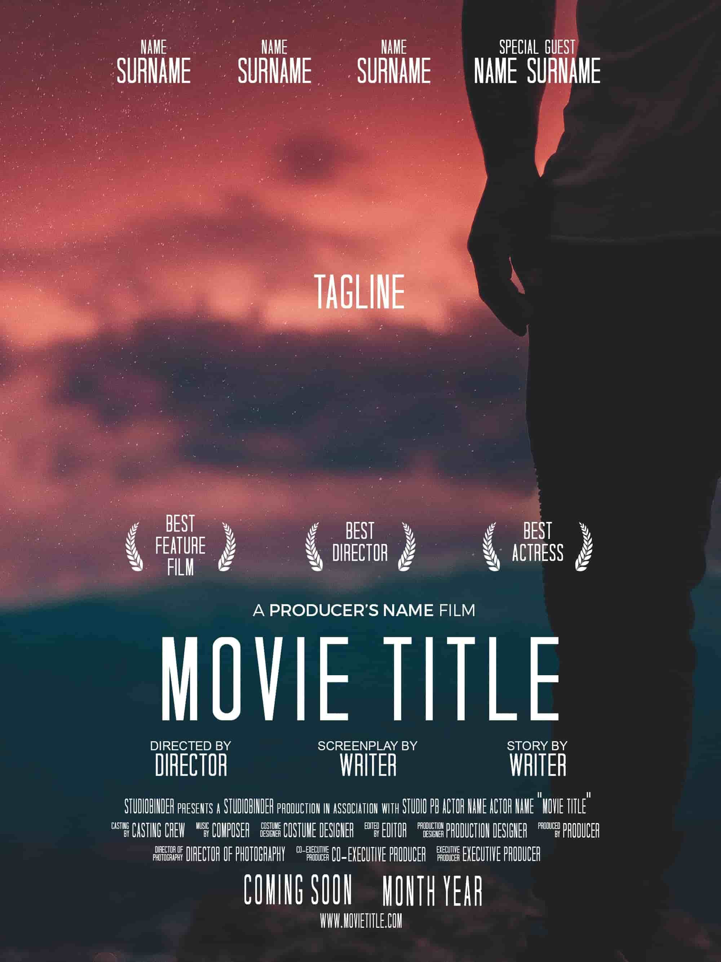

PART 4 – Paragraph Reflection
Write a minimum 250-word reflection paragraph (approx. 13-16 well developed sentences)
- Introduces the title of the short story and provide a quick summary of the story.
> (approx. 3-4 sentences)
- Discuss the theme the story conveys, and how it fits your short story unit.
> (approx. 2 sentences)
- Explain the process you took to create this project
Theme > Synopsis > Dall*E > Canva > Reflection
> (approx. 4-6 sentences)
- Explain how the image you selected from DallE fits the vision you had and why you used it on your film poster.
> (approx. 2 sentences)
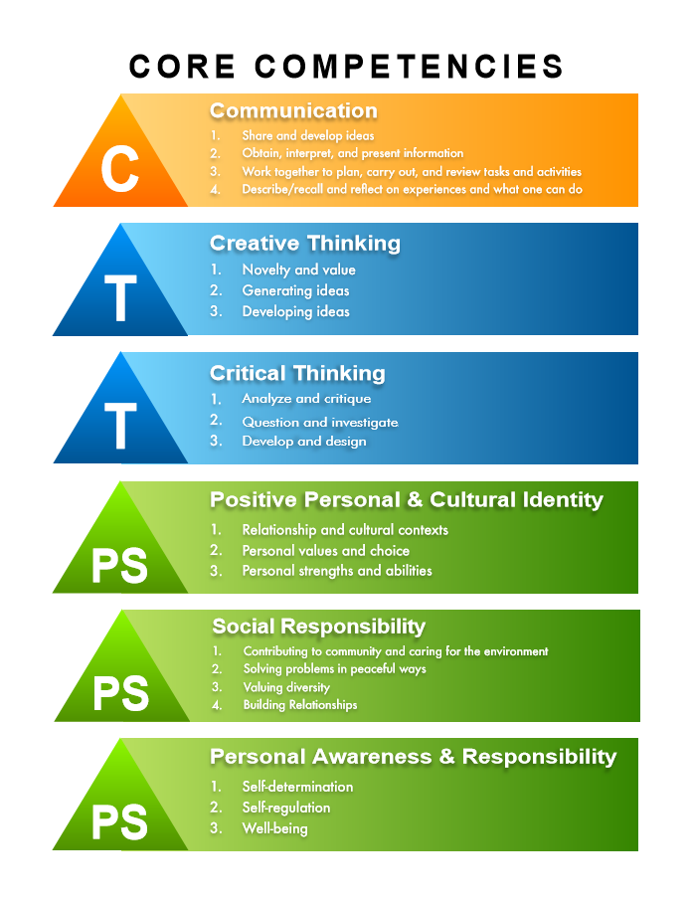
- Discuss how this project builds upon one of your skills in regard to the core competencies
> (approx. 2 sentences)

- Write a concluding sentence that wraps up everything
> (approx. 1 sentence)

PART 5: Posting
1) Open up your Edublog page and login
2) Start a new blog post and
Title: OpenAI Film Posters
Tag: openaifilmposters
Category: English 9
3) Click on “Add Document” and place in your Word Document that has the:
a) “synopsis for your short story”
4) Click on “Add Media”
b) Set of 4 panels for DallE images
c) Larger version of DallE image you selected
d) Film Poster
5) Click on “Add Document” and place in your Word Document that has the:
e) Reflection

OpenAI Film Poster Project Rubric
Shong - English 9 and COL - Mr. Barazzuol
 | 4 | 3 | 2 | 1
CONTENT | Theme from short story is extremely well reflected in work.  Both a film poster and a screenplay are very well created using the artificial intelligence in partnership to your self-developed unique idea. | Theme from short story is reflected in work.  Both a film poster and a screenplay are created using the artificial intelligence in partnership to your self-developed unique idea. | Theme from short story is somewhat reflected in work.  Both a film poster and a screenplay are somewhat created using the artificial intelligence in partnership to your self-developed unique idea. | Theme from short story is minimally reflected in work.  Both a film poster and a screenplay are minimally created using the artificial intelligence in partnership to your self-developed unique idea.
WRITING  (Paragraph) | The piece uses formal writing conventions and is free from errors.  Uses elevated language to express information.  The paragraph contains the following items with great efficiency and flow: introductory sentence, the theme you selected, the OpenAI software, the core competency, concluding sentence. | The piece displays an understanding of formal writing and errors are minimal.  Attempts at elevated language are apparent.  The paragraph contains the following items with good flow: introductory sentence, the theme you selected, the OpenAI software, the core competency, concluding sentence. | The piece demonstrates minimal understanding of the formal writing and errors are often found throughout.  Colloquial language is often used.  The paragraph contains the following items with decent flow: introductory sentence, the theme you selected, the OpenAI software, the core competency, concluding sentence. | The piece does not demonstrate an understanding of the formal writing conventions and errors are distracting.  Colloquial language is used throughout.  The paragraph is either missing items or is lacking flow in regard to: introductory sentence, the theme you selected, the OpenAI software, the core competency, concluding sentence.
TECHNOLOGY | Images display outstanding creativity.  OpenAI format is effectively used to create items that accurately reflect the prompt.  All items are properly uploaded to WordPress (Edublog). | Images display creativity.  OpenAI format is used to create items that accurately reflect the prompt. | Images display some creativity.  OpenAI format is somewhat used to create items that accurately reflect the prompt. | Images have minimal creativity.  OpenAI format is minimally used to create items that accurately reflect the prompt.  Not all items are properly uploaded to WordPress (Edublog).

Short Story Literary Elements Brainstorm Sheet
You are imagining an original story that communicates one of the themes from the short story unit. What story details (below) will you create to help communicate that theme that will then use to write your synopsis. Descriptive imagery from your synopsis will help you create the DALL-E image. Fill in the chart below. Except for the synopsis, this part does NOT go on your Blog post. (10 marks)
1. Theme: which theme will emerge from your story details? Choose one to guide your story synopsis:

Theme (in sentence form) | How is this theme evident in real life? Text to world, self-connections? This is an important section as it will help you think of the details for your synopsis of your short story.
FEC = Social change can happen with the small actions of dedicated individuals.

The Sea Devil = Excessive pride and arrogance can often lead to conflict with nature, resulting in our downfall.

Gentlemen Your Verdict = The nature of what is right or wrong is not always clear, which can result in a dilemma.

2. Conflict
Main conflict in the story – write point form details – this will be important for the synopsis | Type of Conflict:  Internal: person vs. self = dilemma  External: person, environment, society | How is the Conflict Resolved?

3. Characters

Protagonist: main person who experiences the conflict | Protagonist type: dynamic, static, round | Indirect characterization - we learn by what others say about them; what they do or say | Direct description: when the narrator or author directly tells how they look
Other character/s

4. Setting
Setting – Place, time, etc, provide some point form descriptive details | How does this setting influence the protagonist, the other characters, what they believe, and their actions?

5. Point of View

Who is the narrator of the story?  someone in the story? (I, we) Someone outside the story (He, she, they – name of character) | What type of point of view is this? (first person, limited omniscient, omniscient)
6. Plot – Fill in the plot details for your short story.
A. exposition/setting: when, where?

B. rising action (comp incident, crisis etc.)
C. climax (highest point of intensity)
D. denouement
F. ending: (happy, sad, indeterminate?)

7. Figurative and descriptive language – for any of the sections above, especially setting, conflict or characterization, create one sentence using either metaphor, simile, or personification. Remember the figurative language in the short stories that we read would make good visuals for DALL-e image and your movie poster.

Devices from the short stories we read
FEC = Ahhh, we cried as it rose high in the air, borne by the marsh wind, and flew like a bird against the sun, across the road and out of sight, into the ox pasture. (simile and climax)
The Sea Devil = It was not the full-grown mantra of the deep Gulf, but it was close to nine feet from tip to tip and it weighed over a thousand pounds…up into the starlight it went, a monstrous survival from the dawn of time. (Metaphor and crisis)
Gentlemen Your Verdict = It had been just 1430 hours when the submarine shuddered to a blow that felt like the impact of Thor’s hammer. (simile, crisis)
Your examples? This section will be helpful for the Dall-E image creation:

8. The Synopsis (300 words) – you can write it here, but it will have to be uploaded as a separate [add] Document to your blog later:

