- Demonstrate respect, collaboration, and inclusivity in working with others to solve problems
- Apply decision-making strategies to a life, work, or community conflict and adjust the strategies to adapt to new situations

HEALTH & CAREER EDUCATION
English 9 – Riverside Secondary School
Themes:
Steps:
1) Look at the four visuals on pages 5-8 and try to decipher their meaning of each in regard to the above themes of RESPECT, COLLABORATION or INCLUSIVITY (the presence or absence of it)
- Option #1 - “We and I” by Steve Cutts
- Option #2 - “The Arrival: The New Country,” created by Sean Tam
- Option #3 - “No Trespassing” by Banksy
- Option #4 - “Comments” by Steve Cutts

2) Think, pair, and share activity to unpack the meaning of the visuals in small groups.
3) Select one of the visuals from above, and show your understanding of the intended message of either RESPECT, COLLABORATION or INCLUSIVITY in written form based on the visual.
4) Select one visual and you may either write a narrative, write an explanatory or expository paragraph, write a poem (minimum three devices; 9 lines), Venn diagram (some cool how-to’s), infographic, or a creative Canva etc. to show your deeper understanding of the image and its connection to the themes.
5) Save the photo from the option that you are basing your piece on.
6) Post both your response and the photo you based it on, to your Edublog:
- Title: HCE 9 – English Write
- Tag: visualanalysis2023
- Category: English 9

3 Simple Questions to Help Figure out what an Image is Really Saying
“Visual Texts” include pictures, images, icons, movies, videos game images, illustrations in picture books & graphics - anywhere that visuals are used there is communication.

Three Simple Questions
- What do I see when I look at this image?
- How does it make me feel? (first impressions, lingering feelings after)
- What does the image/picture seem to be trying to say? (What do you think the owner/author is trying to say to you?)
To help answer these 3 questions, we can use VISUAL TEXT CLUES:
Subject Matter: What is the topic? Who and what are in the image? What is the image about?
Color: How is color used in the image? What effect do the colors chosen have on the viewer?
Angles: Are we looking from above or below? What is the camera angle? How does this affect what we see and how we feel about it?
Symbols: What symbols are used in this image? What do you think they represent? Are the colors that were chosen symbolic?
Vectors: Can you see the major lines in the image? Are they broken or unbroken? How do the lines create reading paths for our eyes?
Lighting: Can you describe the lighting used in the movie. How does it affect the ‘mood’ of the movie?
Gaze: What type of look is the character giving? Where is their gaze directed? What does this say?
Gesture: What type of gestures is the character giving? What is communicated by these gestures?
Shapes: What geometric shapes can you recognize in the image? Do they repeat? Is there a pattern? Is order or chaos conveyed?

Using these clues, we try again to answer the same 3 questions:
- What am I looking at?
- How does it make me feel?
- What is the owner/author of this image trying to tell me?
-Emerging+  The student is minimally demonstrating competencies in the required standards. | -Developing+  The student is demonstrating some competencies in the required standards. | Performance Standards  Different forms, formats, structures, and features of texts/sources enhance, and shape meaning and have impact. | -Proficient+  The student is independently demonstrating most competencies in the required standards. | -Extending+  The student is independently demonstrating most or all competencies at a refined level.
45% - 58%  D/C- | 59% - 72%  C/C+ | Percent  Letter  Mark out of 20 | 73% - 85%  B-/B | 86% - 100%  A-/A/A+
IDEAS AND CONTENT
- thoughtful, revealing insight into the image
- audience is left with a ‘take-away’
- relevant interpretation is evident as opposed to summary
EXPRESSION OF TEXT TO SELF/SOCIETY
- connections are thoroughly and thoughtfully explored
- specific examples and details are given in relation to the source material
EXPRESSION WITH PURPOSE
- voice is appropriate, communicates in a purposeful and creative way
- demonstrates critical thinking
- sense of flow is evident in the writing (beginning, middle and end)
- any errors in mechanics of writing are not overly distracting

HEALTH & CAREER EDUCATION – TEACHER RUBRIC

Mark Breakdown Rounded Rounded
8 = 66.6 % (13/20) 8.5 = 70.1 % (14/20)
9 = 75.0 % (15/20) 9.5 = 79.2 % (16/20)
10 = 83.3 % (17/20) 10.5 = 87.5 % (18/20)
11 = 91.7 % (18.5/20) 11.5 = 95.8 % (19/20)
12 = 100 % (20/20)

THIS PAGE MUST BE COMPLETED TO RECEIVE A MARK

Student Checklist:

I have responded to one photo in the following way:
written a narrative
written an explanatory paragraph
created a visual – Canva
made a Venn Diagram
made an Infographic
Poem

I have posted my creative response on my Edublog

I have included the photo that my response is based on

I have used the title: HCE 9 – English Write

I have added the tag: visualanalysis2023

I have selected the category: English 9

I have submitted a link to my blogpost (NOT the draft) to the Teams Assignment called “Visual Analysis (HCE)”
Visuals (select one):
Option 1: “We and I” by Steve Cutts https://www.researchgate.net/publication/339003662_Society_50_We_and_I
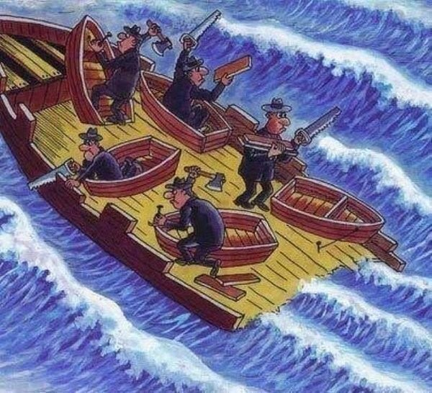

Option 2: “The Arrival: The New Country,” created by Sean Tam
Courtesy of Sean Tam’s “The Arrival” (Print – Book)
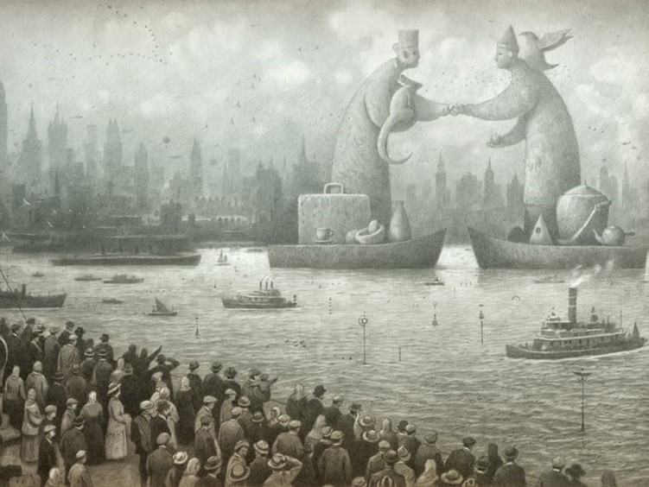

Option 3: “No Trespassing” by Banksy
https://twistedsifter.com/2014/07/the-ultimate-banksy-gallery/

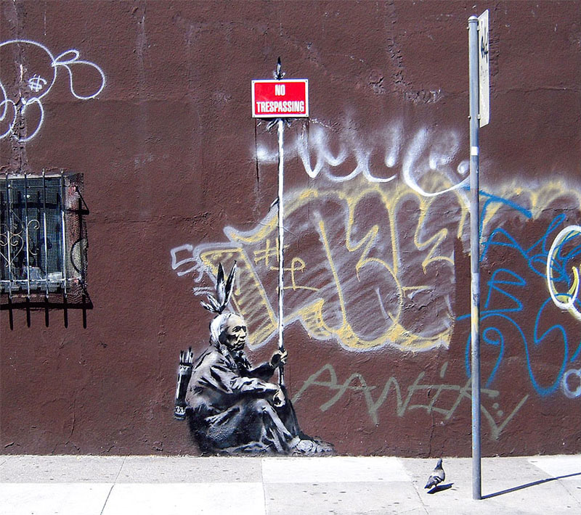

Option 4: “Comments” by Steve Cutts https://www.stevecutts.com/illustration.html

