WHEEL of “TELL us WHO you ARE!!!!!!!!!!!!!!”

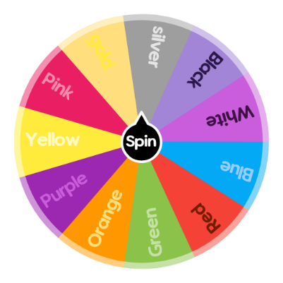
Take a few minutes to think about possible answers to all the questions:

Red:

What fictional place would you most like to go?
Books, movies, video games, nothing is off-limits. The fictional world is your oyster.
Or, what decade would you visit if you could time travel?
Yellow:
What is the best gift you have ever received? Explain.
Green:
What would be your ideal vacation? Beautiful cities around the world – visiting shops, cafes and galleries? Or nature focused: sandy beaches and/or mountain adventure trips.
Or: tell us about an adventure and/or awesome vacation you have gone on!
Purple:
If you could magically wake up with a creative talent tomorrow morning, what would it be? Play a musical instrument? Artist? Dance? Singer? Actor? Explain.
Blue:
If you woke up as (name any famous person or fictional character, dead or alive), who would you be and why? What is the first thing you would do?
Orange:
Two truths and Lie! Can you guess the lie?

