Journalism & Media 11/12

“Freedom of the press ensures that the abuse of every other freedom can be known, can be challenged and even defeated.”
Kofi Annan
1938 - 2018
Former Secretary General of the United Nations
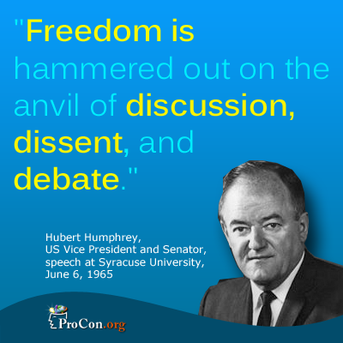

Part One:
Vocabulary for discussion – with a partner, discuss the following words: what do they mean?
Safeguard:
Democracy:
Freedom:
Dogma:
Automatons:
Anvil/hammer of dissent (what is an anvil? What is dissent? How are the two creating a metaphor? And what is the metaphor?):
Blindly adopt (what is another word/expression for this phrase?)

Quotations for discussion:
- Annan quote:
- Roosevelt quote
- Humphrey quote
- Anais Nin quote
Discuss each quote with a partner; take some notes on each. Be prepared to participate in class discussion around each quote and the questions.
- What do you think the quote is communicating?
- How does each quote relate to what is going on in the world today?
  - To what extent is the intention behind each quote happening in the world today?
  - Give examples of how you think the intention behind the quote is or isn’t in our culture/society today.
  - If it isn’t, why not?
Part Two:
- Watch this video on critical thinking. (2:45) Pay attention to the questions from the comic graphic of the little man in the tie specifically. What are some of his questions?
Quick Discuss/Think/Write/Share:

- Watch this video (3:38). What are the pros and cons of the internet? What does the speaker in the first video mean about a ‘shared knowledge’? Why is a shared knowledge important?
Quick Discuss/Think/Write/Share:

- Watch this video (13:00). What are some of the main points the speaker shares about the importance and future of journalism?
Quick Discuss/Think/Write/Share:

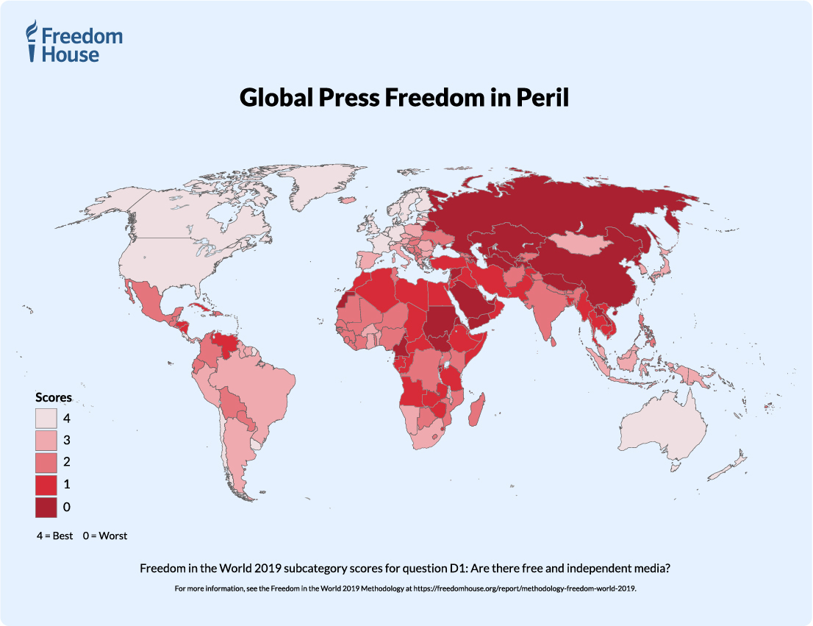
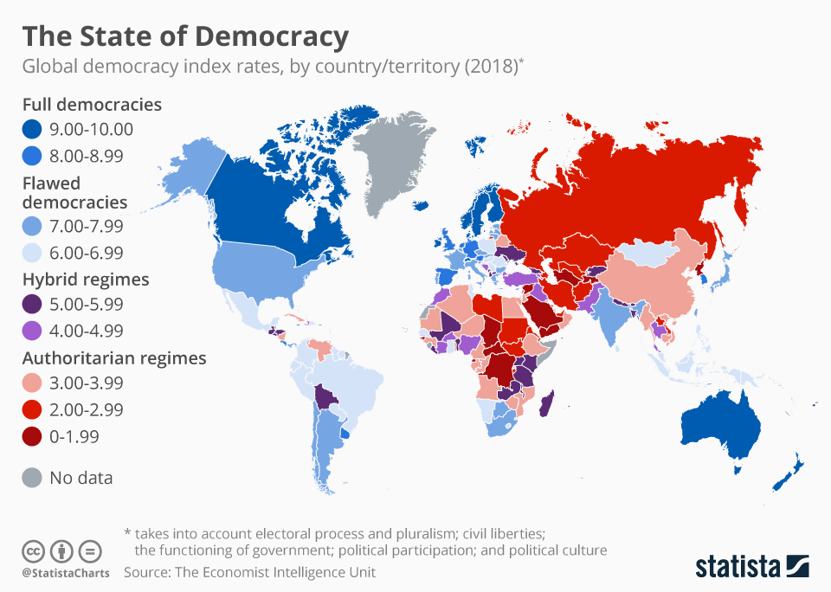

- Examine the two graphics above. What is their relationship with each other?

Quick Discuss/Think/Write/Share:

- Explain what is going on in the picture below. How does what it communicates connect to the quote?
“A lie does not become the truth, wrong does not become right and evil doesn’t become good just because it’s accepted by a majority.”
Booker T. Washington

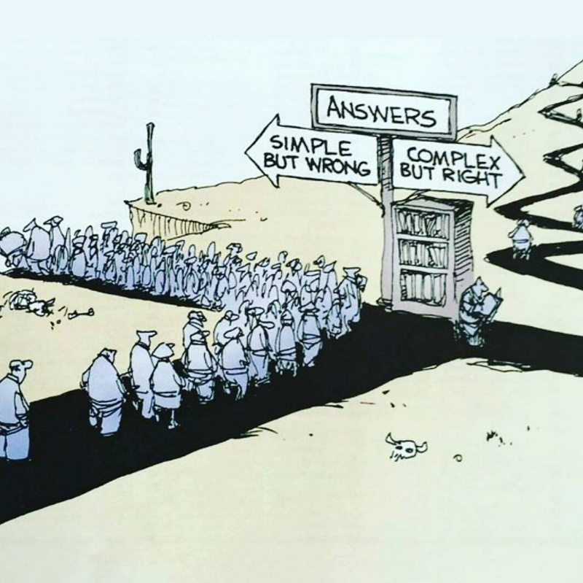

#6 – Complete this response on your own. Read the article – Skim Reading is the New Normal – discuss the prompts/questions with a partner - which quote from the article BEST encapsulates what you have learned from the above activities and last image? Explain WHY you chose the quote you did from the article. Write a small paragraph synthesizing your thoughts.

