Journalism
Riverside Secondary
Ms. K. Shong
How Do I Begin? (Treat this as a checklist)

- 1. Brainstorming begins with editor/sponsor/class about approach to story – class/editors/Ms. Shong decide what type of story it will be – e.g. news, feature, editorial etc.) Story idea is created or assigned. (see content tab)
- 2. School or Community based story: contact information is created: Whom do I talk to? Where are they? What is their contact information? When can I get in touch with them? Personal contact is always best! THIS IS YOUR RESPONSIBILITY!!!! Get the schedule of when/where they teach – teacher schedule is posted on the wall. Before class, lunch time or after school is best for contact. On occasions, you can make contact during class time – but you must get Ms. Shong’s permission first. The last option would be an email or a note. Do NOT email a teacher unless you have Ms. Shong’s permission. Remember your email etiquette: Subject line, opening and closing salutations. You can use your phone or a recording device for your interview.
- 3. Think about the angle/news values your story will take and develop questions that focus on the issues of the story. Create more questions than you’ll need. Try to develop questions that call for an open-ended response, i.e. no “yes/no” answers. (Do you like play volleyball? vs. Tell me what you like about playing Volleyball.) Develop questions that reveal the opinions of those interviewed. Remember: You can’t include your opinion (in a News story) so you must have the person you are interviewing present the emotional/personal aspects of the story. Remember you need direct quotes/attribution for your article – you CANNOT generalize – information must be accurate and be based on fact. See ‘How to conduct an interview document.’
- 4. Use the Work Log (Eddy Documents) for your questions/angle/focus of your story, save it to your folder journalism folder. Give your story a title – Girls Volleyball Story
- If you are doing research on the internet, save (on the document) the websites where you got the information/artwork from that you will be using for your article. Make sure you do the CRAAP test, as well as research various databases. Also check your resources for any Fake News possibilities: https://www.snopes.com/ https://factscan.ca https://factcheck.ca
- 5. When you have your interview/research complete, transcribe your notes or research to the same document. Keep saving this document to your 132-student in One Drive AND your desktop folder. REMEMBER to give it a NAME that reflects what the story is about – this is NOT the headline for your article. This document eventually becomes the draft of your story. See the template for turning into TEAMS.
- 6. Start arranging your information into the journalistic style of writing (editorial, feature, hard/soft news, blog). See resources on the class blog if you have forgotten. Be aware of the proper word count: 350 for news or blog; 400 to 450 for editorial or a feature. DOUBLE and TRIPLE check the spelling of names of the people you interviewed!!!!
- 7. Format your article in Word as follows: Font – Calibri, size 12, 1.5 spacing. Do not do paragraph indentations, one return space counts as the paragraph break. See the TEMPLATE.
- 8. Visit the AP Style Guide and the resources on the class blog to make sure you are following the proper rules for newspaper writing. Duffy’s guidelines is a good resource to look at.
- 10. When you are done:
  - write the word count at the bottom of the page, upload to TEAMS.
  - Put the # of the draft first when naming the document (#1 draft)
  - Make the necessary changes suggested by Ms. Shong. Do not save over the docs. Rename it # 2 draft and so on.
  - This process continues until Ms. Shong writes FINAL on your draft. This helps you to keep track of the type of errors you are doing. When you have been ‘Finalized’, you can create the post in WordPress and copy and paste the article in. The most up to date, edited draft should always be in WordPress.

- 11. ARTWORK – Very important!!!!
  - Take as many pictures as possible with either the Journalism cameras, your own camera, or your iPhone.
  - Take as many as possible in Landscape for your main feature photo (see instructions for WordPress)
  - Take some in vertical to upload into your text space (see instructions for WordPress)
  - If you are staging a photo – get as close to your subject matter as possible – see links on the Images and Photography tab of what makes a good photo.
  - All photos from the internet – Save them in a folder on your desktop called Journalism folder – have two sub-folders: one for story drafts and the other for images. NOTHING GETS UPLOADED RAW TO WORDPRESS WITHOUT A COPY SOMEWHERE!!!!!! Do not fill up the Media Library with pictures you might use. This slows down the website.
  - ALSO - save the link of where you got the photo to your draft of the story!!! For some pics we must give credit. There are copyright issues that we have to deal with as we are public. Always double-check with Ms. Shong if you are uncertain.
  - RULES for ALL photos that get uploaded to the Eddy-WordPress Media Library:
    - all photos must be saved to a specific resolution - ALL!!!! This is different from cropping, which is about the photo's dimensions - the height and the width
    - this can be done using this free Microsoft App.
    - steps: 1. upload your photo to desktop 2. Open the photo with the Microsoft App 3. go to Image, then choose Image Size 4. All photos must be at 72 dpi and 1920 x 1080 (or there about) for the feature photo then save and properly NAME (Vape feature photo - for example) 4. Save the altered photo back to the same folder on your desktop. 5. when you have done this, then you can upload the photo to the eddy-WordPress
    - I will be checking and following this procedure WILL BE PART OF YOUR MARK!!!!!!!
WordPress Instructions

- 12. Go to the eddy and login: your username and password
- 13. Go to your dashboard and create a new post.
- 14. Write the (possible) headline in title box - MAKE sure that your headline reflects your content and that you have a verb somewhere in it.
- 15. Copy your article into the Visual (if there are formatting issues, then copy and paste into the HTML Text, then click Visual).
- 16. Scroll down to Subtitle and add a sub-heading (should give further detail about your article). Do NOT punctuate either as a sentence. AND the subtitle should be different from your heading.
- 17. Pick Post Template: Style 3
- 18. Pick Sidebar Position: the third one with no blue bar – blank grey.
- 19. Scroll down to Category, and choose the PRIMARY category your story is under (e.g. News, Sports, Special Feature, Blog, Opinion, etc) (One of the categories that you see on the top bar in the view pane of the paper)
- 20. Check mark the different categories that corresponded to your article in the category box on the right side. (e.g. Your story could be both a News Story and a top Story - see an editor or Ms. Shong about this).
- 21. If you wish to add photos into your article (Not the main article picture), click onto Add Media, navigate to the folder where you saved your artwork and upload the picture. Adjust the photo so that it fits into the article. Click on the picture and use the icons to adjust. Write a caption under the photo (a cutline) that reflects what’s in the picture – click on the picture, hit the little pencil edit icon and in the proper pop-up box, write the cutline. The cutline should be written as a sentence with a period. (more detailed info below)
- 22. Save a draft, and check preview. Make sure that there is not a lot of ‘white space’ at the top, bottom or side of your article.
- 23. IF you make changes to the article after you’ve uploaded, copy and paste article back into word and check with an editor or Ms. Shong to get FINALIZED a second time. It is important that the most recent version of your article gets published.
- 24. For your main picture, open the draft for your Post, scroll down to featured image on the right, and click set featured image. See rules above about photos.
- 25. Click on upload files and select your main artwork from the appropriate Journalism artwork submission folder – don’t upload a whole bunch of photos to the media library in the eddy. Your pictures should be photoshopped and ready to go before uploading to the media library.
- 26. Select your image, and under attachment details, there is ‘edit image.’ If you wish to crop the image you can, save any changes, and press set featured image.
- 27. Make sure under format on the right side, it is under standard and not video. Unless you are uploading a video. If you are uploading a video for your article, you still need a feature photo for the front page.
- 28. Add tags to your article, ones that reflect the content.
- 29. Save Draft, Preview (if you’d like); check with Ms. Shong BEFORE you publish

Special How To’s

- Pull quotes – here is an example of one: http://riversideeddy.ca/mental-health-issues-in-young-boys-and-men-is-often-neglected/
Steps:
  - Open your post where your article is
  - Choose a quote which is significant, stands out or will catch the reader’s attention
  - Put your curser where on the page you want the quote and choose the pull quote icon on the ribbon bar, that will insert the pull quote brackets: 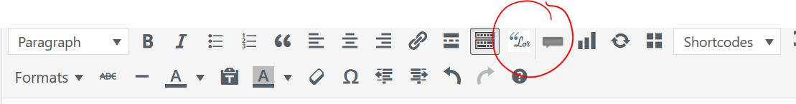
  - In between the brackets, copy and paste the quote and italicize it – write the name of the person if it is a direct quote beneath the line. But make sure everything you want to be in a pull quote is inside the brackets.
  - If you want the quote on the right, leave the brackets as is: 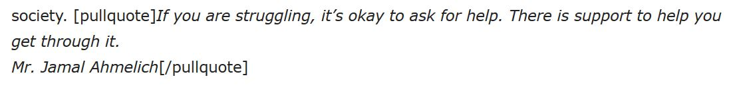
  - If you want the quote on the left, write class = “left” after pullquote, but inside the brackets. Exactly as this example: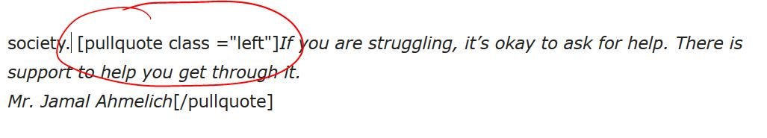
- In-text pictures. Here is an example of one: https://riversideeddy.ca/the-riverside-tradition-of-spoken-word-is-back/

Steps:
- Photoshop size (72 dpi) and dimensions (height and width) of the in-text picture and save it to the Media Library. The dimensions can vary (ie a square etc.) depending on the content of the picture.
- Position your curser on the horizontal plane (ie near the top, middle or bottom) where you want it. Sometimes this is tricky.
- Add media from the media library and insert the picture. It will come in larger than you want it, so grab the little box on the corner and size it down.
- To add a caption, click on the picture and then the small pencil (edit icon), this will make an edit box come up. Type your caption in the space titled ‘Caption.’ It is not necessary to change anything else.
- Also, you can move the picture to the left or the right by choosing the appropriate icon button after clicking the picture.
- Make sure you do punctuate the caption as sentence, unlike the Heading and the sub-heading.
- Click ‘update.’

