Journalism & New Media 11/12

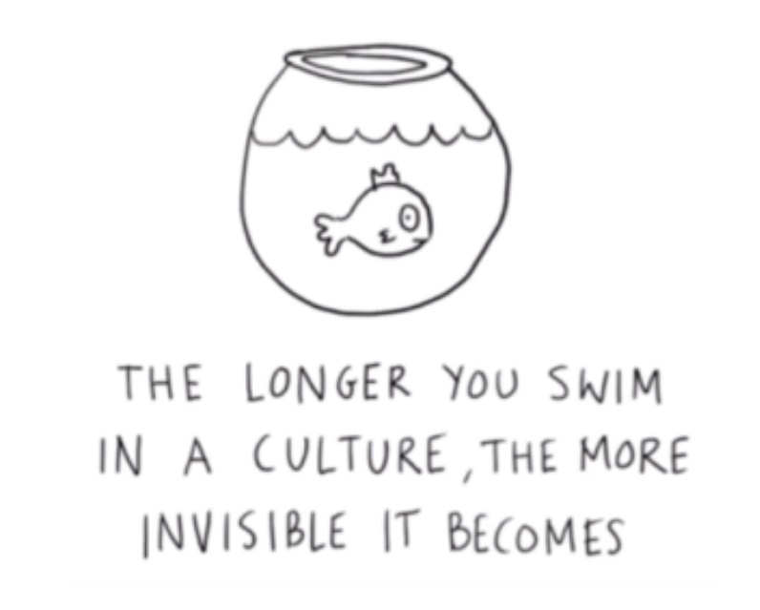

kshong@sd43.bc.ca
http://myriverside.sd43.bc.ca/kshong/journalism/
The course is a thematic exploration of the following essential questions:
- What kind of world do I want to live in?
- How does New Media impact our perception of ourselves and the community/world?
- What does it mean to be an educated citizen in our information saturated world?
- What are my rights and responsibilities in this social media consumed world?
- How can knowledge of journalism help one to become a better citizen?
- What is the link between social media and storytelling?
- What is the connection between critical thinking and a functioning democracy?
- Who decides what truth is going to be told? Whose stories do you value?

Objectives of this course: (this is the intention or a ‘Roadmap’ depending on the pacing of the semester
- To understand what’s happening around us and why knowing it matters (essential for a functioning Democracy kind of stuff – more about this later)
- To understand how the consumption of information has changed.
- To explore and understand different types of text and narratives.
- To understand the monetization of content and that the consumer’s attention and their data is what is for sale.
- To understand that there is a massive amount of data on the internet – some of it is worth our time; some of it is not, and to recognize that information saturation does not mean news exposure or a balanced or critical understanding.
- To become critically aware of how and what content is created and consumed; to acquire the tools to unpack the ‘intentions’ of the content encountered.
- To become critically aware that there are unintended consequences because of new technologies and social media – both good and bad!
- To understand the different types of content – both as a consumer and producer of it.
- To recognize that we have a responsibility to be critical consumers of information, that current technologies can make anyone a content producer or a citizen journalist, that there is responsibility to share our insights about the world in a thoughtful way and interact with our community through a wide variety of digital media via the Eddy, Riverside’s digital newspaper.
Some Guidelines, Suggestions for Unit Development:

Units | Suggestions for Lessons, Mini-Units or Entire Units
Journalism and publishing on the eddy (Content by students for students) | Students will:  - aim to engage and influence their audience.  - will develop skills to uncover news, to document events, and to tell compelling stories.  - will observe, interview, research, and develop concise writing skills to meet the standards of quality journalism within expected deadlines  - will experiment with journalistic formats to deliver content to real audiences: opinion pieces, features, hard news, blogs.  - Learn about the stylistic choices a writer makes
Information technologies, social media, society, and personal world views | Students will learn:  - the relationship between Democracy and a free press.  - the various forms of information bias  - about the tension between hate speech and free speech  - about the post-truth environment and fake news  - about the rise and effects of polarization
Digital Communication and storytelling | Students will learn how stories and meaning are communicated through:  - Podcasts – analysis and creation, narrative Arc  - You tube and short videos - deconstructing content, purpose, effect, and theme.  - Narratives: memoirs, personal essays  - Rhetorical techniques in images, video  - Advertising – current new media storytelling elements of design.
Literature | Students will learn how some of the above content can be understood through a study of:  - novel, short stories or poetry

Assessment:
Formative assessment will be done through daily checks of smaller assignments (40%). Summative assessment (60%) is done by single point rubrics around various Performance Standards as they relate to the curricular competencies. Improving on your work through goal-setting and self-assessment becomes the evidence of your abilities in the curricular competencies. The goal is for your final mark to be based on your best work.
→ → → → Proficiency level → → → →
Emerging  “I am just getting started.”  “I learn best with extra help.” |  | Developing  “I get some of this and am beginning to do more on my own.” |  | Performance Standard Skill | Proficient  “I can do this on my own.” |  | Extending  “I get it and can go beyond what is expected of me.”  “I could teach this to a friend.”
The student is beginning to demonstrate basic knowledge in relation to the learning standards. Works with ongoing support |  | The student demonstrates some knowledge is relation to the learning standards. Works with some support. |  | For example:  Understands how different forms, formats, structures and features of texts enhance and shape meaning and impact. | The student demonstrates good knowledge in relation to the learning standards.  Works independently. |  | The student demonstrates knowledge beyond the learning standards.  Works independently.
 | Rubric level |  | Letter Grade Equivalent |  |  | Equivalent Percentage
 | Extending |  | A+, A, A- |  |  | 97%, 91%, 86%
 | Proficient |  | B+, B, B- |  |  | 84%, 79%, 73%
 | Developing |  | C+, C, C- |  |  | 70%, 66%, 57%
 | Emerging |  | I |  |  | varies
Procedures and Expectations – common-sense stuff that you have heard before, but here we go again…
- Be on time!
- If you are absent, please find out what you have missed: TEAMS -add the App to your phone!!, Blog (Today in New Media/Journalism), other students, email teacher
- You will, of course, use all your own wonderful ideas, not the work of others. Plagiarism will be discussed.
- Respect the rights of others in the learning environment as shown through your courtesy and self-discipline. Be a respectful, thoughtful, and mindful listener and speaker in the classroom and online. Everyone has a right to feel safe with their opinion!
- Respect the classroom/school – use the recycling bins around the school correctly.
- PLEASE participate to the best of your ability in class discussions – ask questions, give comments; if you are thinking of a question, chances are someone has the same question! Ask away on TEAMS or email me.
- Please be prepared for class with a CHARGED device, charger, paper, pens, pencils etc.
- Organize an English 11 or a New Media 11 folder in your One Drive and/or Desktop to keep documents organized; keep your blog up to date
- And lastly, PHONES ARE A PRIVILEDGE IN THE CLASS. THEY ARE TO BE USED WISELY – FOR ACADEMIC PUROPOSES. If a negative pattern emerges, consequences will be applied on an individual basis (such as you having to collect it from the administration)

I am available for extra help at lunch or after school. Have questions or concerns? Come see me!
Kathy Shong

