Essential Questions and Mental Health:
- Lack of empathy for others in society. How might a lack of empathy from peers or society result in youth struggling with mental health? What does empathy look like? How does one develop empathy? What are some aspects or areas of our lives where empathy is important? Apathy (indifference) and polarization are the opposite of empathy.
- Stigma and ‘Othering’ – What does ‘othering’ look like? What is stigmatization? Who is ‘othered’ – how and why? How does ‘othering’ lead to youth mental health issues? Do people suffer from self-stigmatization? How does one quiet the ‘othering’ voice…both in our heads and from the culture/social media/peers?
- Social issues and inequalities in our culture: poverty – unequal access to… (you name it); bullying due to racism, sexism, orientation, status – etc.; external pressures (advertising and social media) and the perceived notion that ability to consume (materialism) is the route to happiness; How do inequalities and social issues impact youth and mental health? How does one begin to navigate solutions? How do young people have agency (power to affect change) over these issues?

Instagram accounts that deal with mental health:
Youth Mental Health Canada
Crazyheadcomics – Swedish artist and MH advocate
Anxiousblackgirlcomics
Lifeinthefastbrain
boysgetsadtoo
Themaskyoulivein
mensmentalhealthawareness

Meaning can be captured in small spaces
Choose a minimum of three visuals from any of the above accounts (not each), and answer the following questions:
- Find quotes/ ideas about mental health that you find interesting, relevant, resonating. What is being communicated about mental health in the image/quote: contributors to the problem? Possible solutions? Both? What is your personal understanding, thoughts and opinions on what is being communicated in the image/text?

- How does the image/text connect to the essential questions above? Copy and paste your images in the chart below next to your analysis.

Instagram account and image | Analysis
From: Youth Mental Health Canada  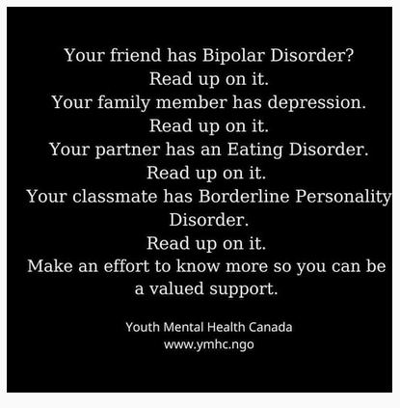 | - I think this image reveals both the problem and the solution because….  - Empathy and understanding is what is needed for people who struggle with their mental health… the image reveals how we play an active role in helping others; we need to de-stigmatize and de-mystify ….. Knowledge takes the fear away and …

