WHEEL of “TELL us WHO you ARE!!!!!!!!!!!!!!”

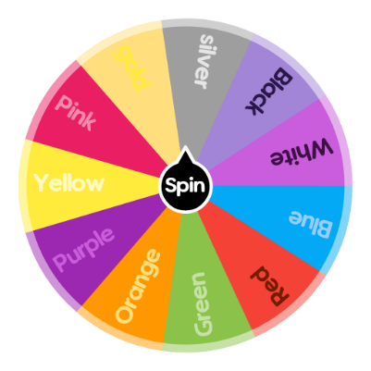
Take a few minutes to think about possible answers to all the questions:

Red:

What fictional place would you most like to go?
Books, movies, video games, nothing is off-limits. The fictional world is their oyster.
Yellow:
What is the best gift you have ever received?
Green:
What is your favourite book, movie, or song - one that you could actually quote a line from… Why is it your favourite?
Purple:
If you could magically play a musical instrument tomorrow, which instrument would it be and why?
Blue:
If you woke up as (name any famous personality or fictional character, dead or alive), what is the first thing you would do?
Orange:
Two truths and Lie! Can you guess the lie?

