English 9 – Initial Writing Assignment Ms. Shong

Welcome to English 9! The purpose of this first writing assignment is to:
- Help me to get to know you better: what you like; what interests you; what inspires you etc.
- Get an initial assessment of your writing abilities:
  - Content (how creative and original are your ideas?)
  - The mechanics of writing (sentence structure, spelling, correct word usage – are you editing your work?)
  - Style – the writer’s voice. How is your writing voice unique? Do you use comparisons (simile, metaphor, personification) examples, humour and/or descriptive language?
  - Structure – your writing has a clear beginning, middle and end.

- Start by choosing one of the options below:

- Song lyrics that you love! Why do you love them? The lyrics must reveal something about you: your attitude toward life, friends, the environment, hope, despair….tell me about the song: when did you first hear it? What were your emotions/feelings….Who is the artist? Is this a popular song? Or less well known? Write a composition that addresses these prompts holistically.
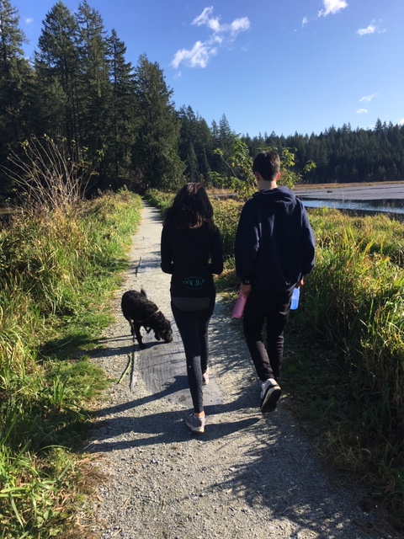
- Write a descriptive paragraph about the photo – take me to that experience. Here is a good definition of DESCRIPTIVE WRITING: it is the clear description of people, places, objects, or events using sensory details and descriptive language to describe what the writer sees, hears, smells, touches, and tastes. Descriptive writing re-creates a moment or an experience or a memory.
- An inspiring video that you found and you think is worth sharing: what is it about the video that you love? Is it magical, funny? What feelings or emotions does the video raise in you? What is clever or inspirational about it (give details). Does the video have some sort of message? Write a composition that addresses these prompts.
- Find a writing prompt from the link and go for it!!! Include the visual prompt along with your writing. If I was doing this assignment, this is what I would pick!

- Here are the particulars:
- You must write a minimum of three quarters of a page (font size 12). About 350 – 400 words. Do not go over two pages.
- You must imbed whatever you choose from above (video, picture, visual prompt, song and/or performance of it) into your document.
- Make sure you give an original title to your work
- The value of this assignment is 12 marks (holistically marked according to the criteria) See the rubric.
- Upload to your blog: TAG = eng9introwrite2020
- If you want this private, save it with a password and send me the password via email

