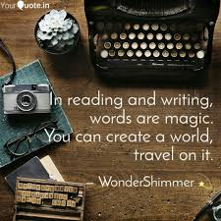
English Honours 9 – Initial Writing Assignment
Ms. Shong

Welcome to English Honours 9! The purpose of this first writing assignment is to:
- Help me to get to know you better: what you like; what interests you; what inspires you etc.
- Get an initial assessment of your writing abilities:

  - Content (how creative and original are your ideas?)
  - The mechanics of writing (sentence structure, spelling, correct word usage – are you editing your work?)
  - Style – the writer’s voice. How is your writing voice unique? Do you use comparisons (simile, metaphor, personification) examples, humour and/or descriptive language?
  - Structure – your writing has a clear beginning, middle and end, with effective transitions between your ideas.

- Start by choosing one of the options below:
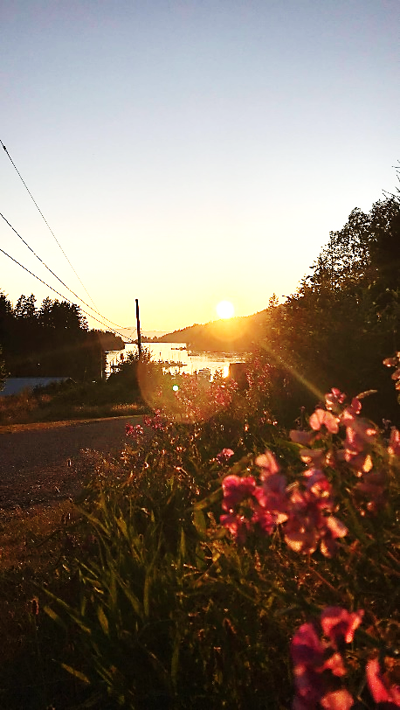
- Song lyrics that you love! Why do you love them? The lyrics must reveal something about you: your attitude toward life? how do you want to live your life? friends, the environment, hope, despair? Tell me about the song: when did you first hear it? What were your emotions/feelings…? Who is the artist? Is this a popular song? Or less well known? Write a composition that addresses these prompts holistically.
- Write a descriptive paragraph about a photo – take me to that experience. Here is a good definition of DESCRIPTIVE WRITING: it is the clear description of people, places, objects, or events using sensory details and descriptive language to describe what the writer sees, hears, smells, touches, and tastes. Descriptive writing re-creates a moment or an experience or a memory and makes the experience ‘come alive’ for the reader.
- An inspiring video that you think is worth sharing: what is it about the video that you love? Is it magical, funny? What feelings or emotions does the video raise in you? What is clever or inspirational about it (give details). Does the video have some sort of message? Write a composition that addresses these prompts.
- Find a writing prompt from the link and go for it!!! Include the visual prompt along with your writing. If I were doing this assignment, this is what I would pick! Be creative and clever!

- Here are the particulars:
- You must write a minimum of three quarters of a page (font size 12). About 400 words. Do not go over two pages.
- You must imbed whatever you choose from above (video, picture, visual prompt, song and/or performance of it) into your document.
- Make sure you give an original title to your work! Not ‘Intro-Writing Assignment’
- The value of this assignment is 12 marks (holistically marked according to the criteria) See the rubric.
- It is optional if you want to post to your blog. TAG = Introwrite2021Hons9 - If you want it private, set the password and email it to Ms. Shong.
- Turn it into TEAMS for assessment.
- Due date: Monday, February 8

