@KTN | Menu >

British Columbia
Yet Another Royal Murdered

A 16-year-old royal gets stabbed and bled out in the alleyway.
Posted Oct 3, 2019 1:04 PM | Last updated Oct 3
On a rainy night, a 16-year-old Royal’s life ended early due to a stabbing. The young man was laying on ground with his Royal jacket sitting beside him. Luckily, from the footage that was found of the scenery, we were able to see the people around the event that have witnessed the incident.

It wasn’t the most beautiful day at NYC. It was raining at midnight. The event took place in a dark alleyway. But before getting into the details, these are some quotes of what some witnesses had to say about the incident.

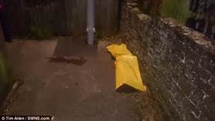
“The dude was as drunk as I was, he passed out in the middle of the alleyway beside some garbage cans!” Says Billy Stallenger. “I was almost about to pass out myself! But then I heard some other people coming, so I knew I needed to get out of there quickly.” Billy looked like he had been drinking a lot seeing as he dropped to the floor mid-sentence.

Now let’s look at the couple that was spotted there at the time. “We wanted to help that poor boy, but we didn’t want the Guardians coming after us for helping the boy. We hated to just leave him to die out there, in the freezing cold.” We don’t know yet if they were telling the truth but for now, this is all we could go off from.

