Thermos Project (Min, Kota)
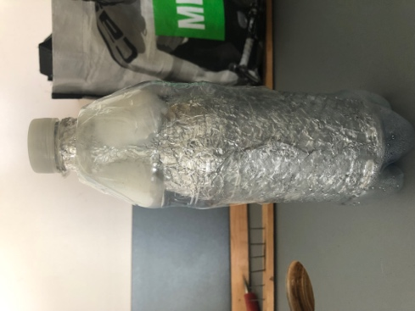
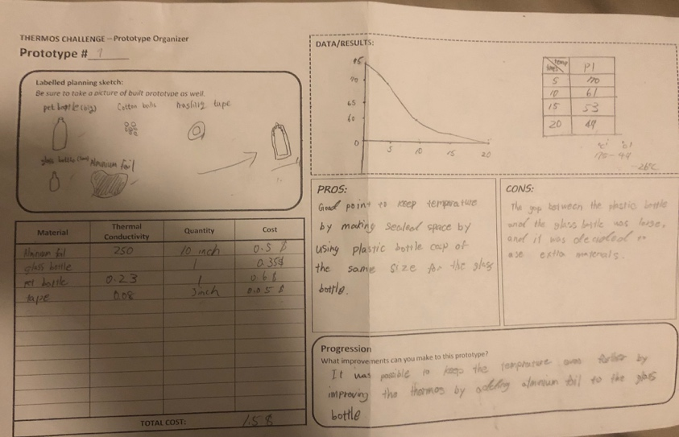
prototype 1
Material lists: Aluminum foils, tape, cotton ball, glass bottle, and pet bottle.
planning: First, wrap aluminum foil around the glass bottle,
Second, prepare a plastic bottle that is larger than the glass bottle.
Third, cut the plastic bottle in half and cover the plastic bottle cut for glass bottles.
the last, the temperature is maintained by putting a cotton ball in the gap between the glass bottle and the plastic bottle.
process: In this process, we narrow the gap between the glass bottle and the plastic bottle. It can maintain the water temperature by preventing the water vapor from leaking from the plastic bottle.
Analysis: We checked the temperature of the water every five minutes. The result is lower than the temperature we were thinking of. I think two main reasons.
The first one was to use aluminum foil further. If I use it for the glass bottle, I think that the temperature was more kept. The second is the size of the glass and plastic bottles used for the thermos. Since the thermos was large, it is difficult to maintain the temperature because there is a large space in the water bottle even if you put water.

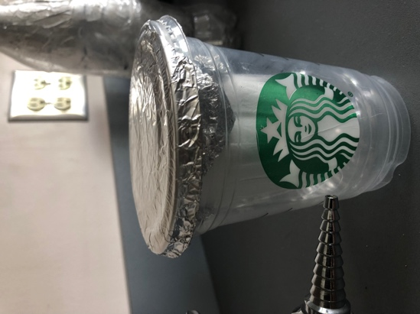
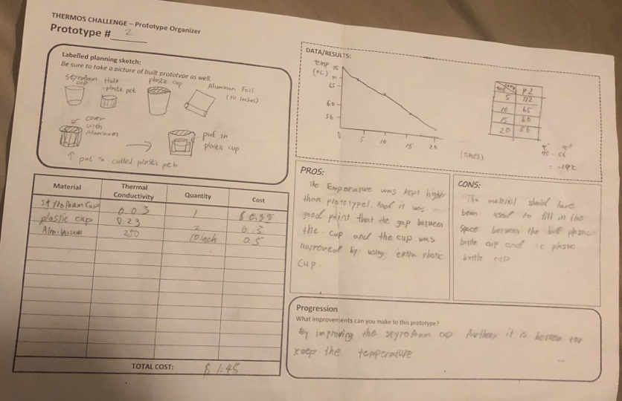
Prototype 2
Materials lists: Styrofoam Cup, plastic Cup, and Aluminum foil
Planning: First, cover the Styrofoam cup with aluminum foil. Second, put the Styrofoam cup in the plastic bottle cup. Put them in a plastic cup. Cover the lid of the plastic cup with aluminum foil.
Process: The space in the cup is reduced by maintaining the temperature by putting the cup between the foam cup and the plastic cup. Use two aluminum foil lids. Therefore, it is difficult to release the temperature.
Analysis: We checked the temperature of the water every five minutes. The results higher temperature than prototype 1. I think two main reasons. First, The results higher than the temperature. Second, Although prototype 1 was covered only with plastic bottles, prototype 2 can keep temperature more than prototype 1 by using a plastic bottle and a plastic cup for a cover.

Prototype Testing Produces
