Wonder project

Kota Katsunuma

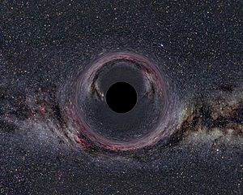
Where can the black hole be made?
Black hole is a celestial body whose density has become extremely high. Especially when a heavy star (over several dozen times of the sun) makes a supernova explosion, black holes remain.
Before these 10 heavy stars explode and become black holes without fail, in the universe there will be as many black holes as the number of heavy stars.
How many black holes are in the universe?
Also, in the center of most galaxies there is a super huge black hole heavier than a million times the sun. Given that there are the same number of super high-sized black holes as there are galaxies, there will be more than 100 billion pieces within the observable range
How will black holes affect the earth?
If there is a very small black hole on Earth, damage like the atomic bomb of World War II will occur but there is no big influence on the Earth itself, but when a planetary size black hole comes out, not only human beings but Earth It is swallowed and disappears.
What is at the center of the black hole?
At the center of the black hole is what a physicist is called "singular point", that is, a very large amount of substance is pressed into an infinitely small amount of space. However, there is no quantum theory of perfect gravity and it is impossible to observe the interior of the black hole, so no one can know for sure.
What happens when a person falls into a black hole?
When you approach straight towards the black hole, you will not feel the shock or shake, your own body will not be distorted by limp as seen from the outside, time will slow down, It seems that there is no such thing as the body burning with heat. It is because it falls freely towards the black hole, and the person who falls does not feel gravity.

How many kinds of black holes are there?
There might be three types of black holes: stellar, supermassive, and miniature black holes – depending on their mass. These black holes would have formed in different ways.

3 types of Black holes

Stellar black hole supermassive black hole miniature black hole
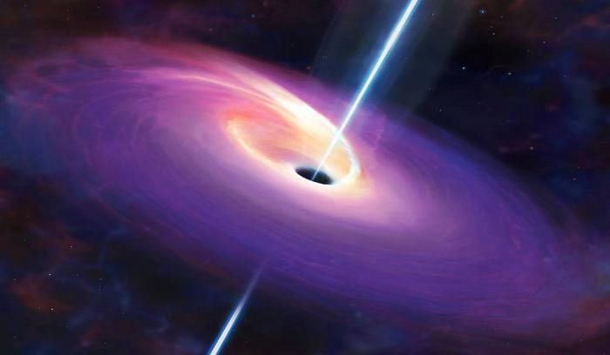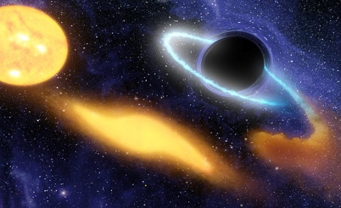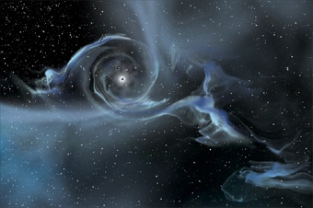

URL
https://science.nasa.gov/astrophysics/focus-areas/black-holes
http://hubblesite.org/reference_desk/faq/answer.php.id=62&cat=exotic
https://www.quora.com/How-does-a-black-hole-affect-earth
https://www.livescience.com/32662-whats-at-the-center-of-black-holes-.html

