Circle of Influence

To begin our journey through history in Social Studies 10, it is important for us to first begin a journey of reflection through ourselves and our own history. Through this self-reflection, we will begin to understand how and why we individually view history and analyze events happening today in the way that we do. Our personal viewpoints are typically impacted by two areas – our circle of influence and the communities we identify with. The historical significance of the people, places, events and developments that have occurred in our lives, or in the lives of those within our circle of influence, will have a direct impact on our understanding and view of the various themes we will study in Socials 10.
This introductory project is a chance for you to reflect on who you are and why you think about things in the ways that you do. You can choose to go as deep or as surface level with this project as you wish, though you may find you get more out of this course if you choose to open yourself up and think critically about your own past.
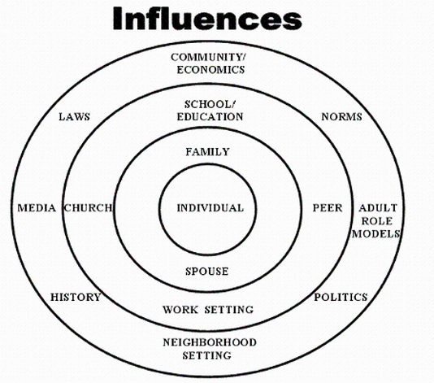
Through this project, we will also introduce various skills that will be beneficial to us throughout this course and in your future. These will include, but are not limited to, research skills, developing and asking insightful questions, understanding truth and validity, and recognizing the interconnectedness of various events.

SECTIONS TO COMPLETE:
- Identifying your circle of influence. During this first section, you will be completing a chart that will identify the various people, events, or groups that have an influence over you and the decisions you make or actions you take. The further an item is from the center, the less influence that item has over you. Try to think about all the different things you are involved in and where you may develop ways of thinking or acquire knowledge from.
- Identifying the communities that you are involved in. Based on the people you have identified in your circle of influence, we now want to work towards identifying what larger community those individuals are a part of that could have an impact or influence over us. This will help identify how we interpret events happening in various communities. For example, you may have identified a coach in your circle of influence, that coach is connected to you through the team you play on, and that team is part of the larger sports community that you are in. That coach may have an influence on your actions and decisions within the sports community but may not be as influential in other areas. Here you will be making a list of your influences and breaking down the areas and communities they are involved in. Once your list is done, highlight or circle the communities.
- Plotting our interconnectedness and understanding the impacts of those communities. In this stage, you will be building a web with you at the center and all your communities around you. For each community, look to find ways that those communities intersect for you. This is a very individual exercise and will be different for each person. Once you have included all your communities, begin to consider the different factors that could play a role in each community. For example, this could be culture, past conflicts, historically significant people, places, events or developments, social systems, belief systems, etc. Discuss how these different factors impact each respective community.
- Creatively display your final piece of work. This can be done by adding colour, details, or creative touches to your working document, or by choosing to assemble and display the information in some other fashion.

TIMELINE
- Complete your circle of influence and identifying of communities (Steps 1 and 2).
- Begin plotting your communities and developing connections.
- Start to research and explain the different factors that play a role in each community.
- Complete Step 3.
- Add your finishing touches and be ready to submit your final work.

EVALUATION:
Category | Exceeds – 5 | Meets – 3 | Does not meet - 1
Circle of Influence | Basic expectations are exceeded. Student demonstrates exceptional understanding and has clearly spent time and energy considering all aspects of this section. | Basic expectations are all met. Student demonstrates understanding of the requirements for this section. | Basic expectations are not met. Student has not demonstrated understanding of the requirements for this section. Further work is required.
Identifying Communities | Basic expectations are exceeded. Student demonstrates exceptional understanding and has clearly spent time and energy considering all aspects of this section. | Basic expectations are all met. Student demonstrates understanding of the requirements for this section. | Basic expectations are not met. Student has not demonstrated understanding of the requirements for this section. Further work is required.
Mapping Communities and Connections | Basic expectations are exceeded. Student demonstrates exceptional understanding and has clearly spent time and energy considering all aspects of this section. | Basic expectations are all met. Student demonstrates understanding of the requirements for this section. | Basic expectations are not met. Student has not demonstrated understanding of the requirements for this section. Further work is required.
Self-Evaluation | Students Self-Assessed Mark: /15

