Canadian Studies
A Canadian First Nations Alphabet Book
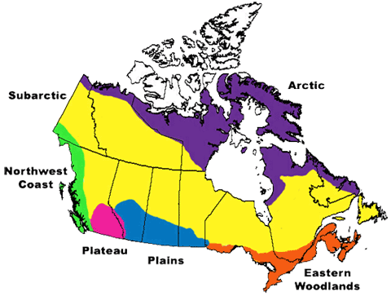
Task:

For this unit, you will be working in a group of 2-4 to create an A to Z alphabet book that will help build upon your understanding of the First Nations People in Canada. These books are very popular for children – this is your target audience to keep in mind when you are creating the text (note: you need to demonstrate your knowledge/learning, but keep the language simple).

You are free to reference as many different First Nations as you like. See below for a list that you can use:

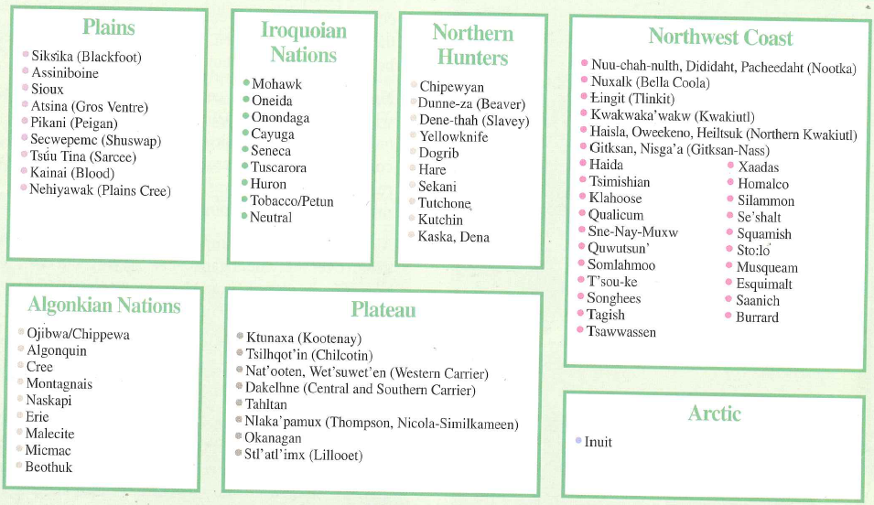

Research & Planning:

- Determine which First Nations groups you want to include and begin your research

Here are some websites you can use
- http://firstpeoplesofcanada.com/index.html
- http://www.thecanadianencyclopedia.com/customcode/Media.cfm?Params=A3native-people.swf
- http://www.aboriginalcanada.gc.ca/acp/site.nsf/eng/ao04607.html

Things you can include:

- Housing
- Food
- Tools
- Transportation
- Art
- Clothing
- Ceremonies/Spiritual Beliefs
- Leadership/Governing Bodies

- Select a number of words for each letter of the alphabet. It is better to have a couple to choose from.

- Once you have one word for each of the letters of the alphabet, select the image and compose the written description.
Format:

You are free to use any medium that you wish. You could make a hardcopy book, a slide presentation using tools such as Power Point, Photo Story, or Prezi, a movie covering each different letter, anything you wish!

- Your book should include:
  - A Cover Page
  - 26 pages (one for each letter of the alphabet)
- Each letter of the alphabet should stand out and be large in size
- The image you select needs to relate to the word
- Each explanation must be short but detailed description of the word
- Written in your own words
- Reference which First Nations group the image relates

Example:
Tipi
The tipi was the primary form of shelter used by the Plains tribes throughout the Prairies of North America during the warmer Spring and Summer months.
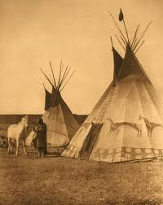

Assessment: /25

 | 0-2 (Does Not Meet) | 3 (Minimally Meets) | 4 (Meets) | 5 (Exceeds)
Required Information | - You have included very little of the required visual and written information | - You have included some of the required visual and written information | - You have included most of the required visual and written information | - You have included all the required visual and written information
Visual Component | -You have selected images that do not relate to the topic  -This component of your project is incomplete | -You have selected images that minimally or infrequently relate to the topic | -You have selected applicable images that relate to the topic | -You have selected excellent images that accurately represent the topic
Written Component | -The descriptions are poorly written and/or do not include the required information | -The descriptions are minimally complete and include most of the required information | -The descriptions are complete and include all the required information | -The descriptions are well written and include all the required information
Spelling & Grammar | - Has frequent grammatical errors and struggles with clarity and coherence | -Adequate mechanics with some errors in spelling, punctuation, sentence structure that impede understanding | -Good mechanics with minimal errors in spelling, punctuation, sentence structure | -Excellent mechanics with no errors in spelling, punctuation, sentence structure
Format & Finish | -The format you selected is not good  -Your project is incomplete | -You have selected a usable format  -Your project is mostly complete | -You have selected a good format  -Your project is complete | -You have selected an excellent format  -Your project is complete, polished, and creative

Group Members: _____________________________ _____________________________
_____________________________ _____________________________

