Canadian Studies Name:______________________________________

New France & British North America – The Final Fight for Canada
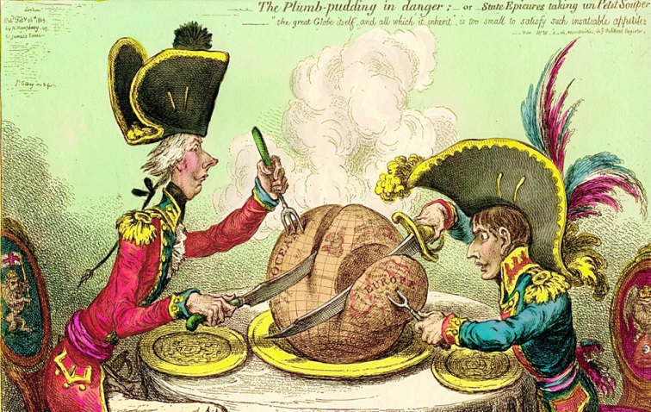

Just as the British and French took action against one another to counteract the other’s control in the fur trade, each built forts to along the Atlantic Coast to protect their interests. These forts eventually became strong military bases. Not only were they competing for control of the profitable fur trade, the world’s leading powers (Britain and France) had long been at war with one another; firstly throughout Europe, and later in North America as well. Wars were won and lost, treaties were signed, and land exchanged hands.

- Above is an example of a political cartoon that relates to the time period. What does this cartoon represent?
______________________________________________________________________________________________________________________________________________________________________________________________________________________________________________________________________________________________________
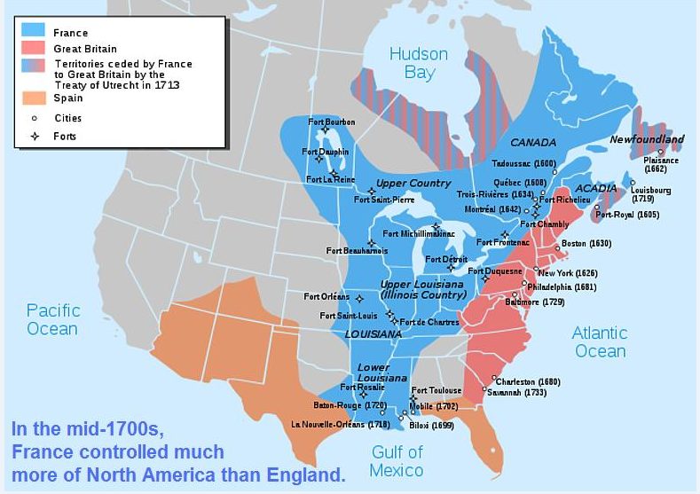
- What does this map tell you about North American before the last war between the French and British?
______________________________________________________________________________________________________________________________________________________________________________________________________________________________________________________________________________________________________

The Final Struggle for Control in North America pg. 69

The last of these wars was the Seven Years’ War (1756-1763). It was fought over land both in Europe and in North America. The French and British used different strategies throughout the war. The French kept most of their soldiers in Europe so that their larger numbers could beat the English there. The British were determined to defeat the French in North America so they sent seven to eight times the number of soldiers to North America. The outcome of this war had an enormous effect on the history of Canada.

- Why did this war have such an enormous impact on the history of Canada?
______________________________________________________________________________________________________________________________________________________________________________________________________________________________________________________________________________________________________
__________________________________________________________________________________________________

War in North America: A Three Pronged Attack pg. 70-71

- Looking at the map on page 70 in Canada Revisited, why was capturing these three forts strategically important?

________________________________________________________________________________________________________________________________________________________________________________________________________________________________________________________________________________________________________________________________________________________________________________________________________

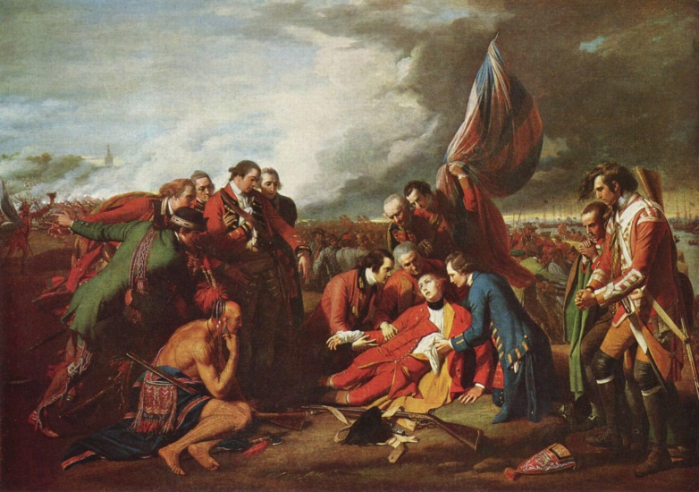

The picture is a famous depiction of the Battle of the Plains of Abraham. It was the battle the decided the fate of Quebec. Quebec was the centre of French power in North America. The British capture of Quebec would mean the end of French control in North America. North American would now be under British rule. New France became British North America.

- How do you think the lives of the French that remain in British North American will change?

________________________________________________________________________________________________________________________________________________________________________________________________________________________________________________________________________________________________________________________________________________________________________________________________________

