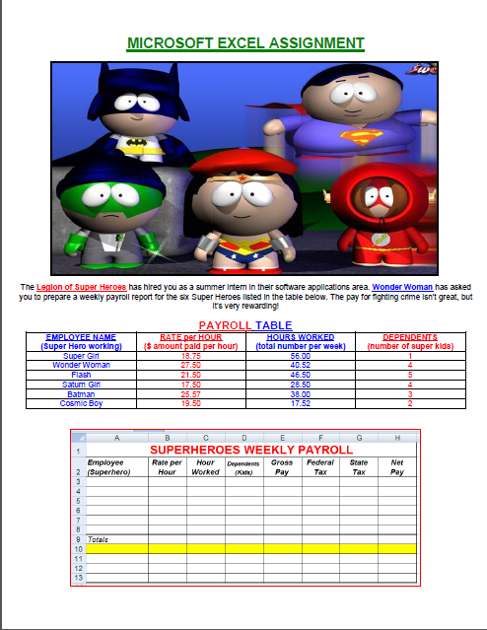
(1) Enter the worksheet title SUPERHEROES Weekly Payroll in cell A1 – use Arial font, red font color, size 16, Merge & Center the cells A1 to H1. Use Arial, size 10 for the remainder of the worksheet. Enter the column titles in row 2 as appears above, ensure that you insert a line space within each cell; change the height of row 2 to 30.00 points. Enter the row titles in column A, and the data from the payroll table in the columns as appears above. Right-align the data in cells A3 to A13.
(2) Use the following formulas to determine the GROSS PAY, FEDERAL TAX, STATE TAX and NET PAY for the first Super Hero (hey, Super Heroes have to pay taxes too!). BIG HINT: Pay attention to parenthesis and the “order of math operations”. To verify that your formula totals are correct, use a calculator (Start/Programs/Accessories/Calculator).
➢ GROSS PAY (cell E3): RATE multiplied by the HOURS
➢ FEDERAL TAX (cell F3): 20% multiplied by (GROSS PAY minus DEPENDANTS multiplied by 38.46)
➢ STATE TAX (cell G3): 3.2% multiplied by the GROSS PAY
➢ NET PAY (cell H3): GROSS PAY minus (FEDERAL TAX plus STATE TAX)
➢ Copy & paste the formulas for the first Super Hero to the remaining employees to save time.

(3) Calculate the totals for GROSS PAY, FEDERAL TAX, STATE TAX, and NET PAY in row 9.
(4) Use formulas to determine the AVERAGE, HIGHEST and LOWEST values of each column in rows 11, 12, and 13.
(5) Bold the worksheet title. Assign two decimal places where appropriate (money) and apply Currency Style “$” (except for Kids and Hours). Insert a light blue background in cells A2 to H2. Insert a light yellow background in the empty cells A10 to H10. Apply all the formatting (borders, centering, right and left alignment, etc) exactly as you see in the worksheet above.
(6) Change the width of the column A to 15.00 points. If necessary, change the widths of columns B through H for best fit.
(7) Use the CONDITIONAL FORMATTING command to display bold font on a light green background for any Gross Pay greater than $1050.00 in the range E3:E8. Use the help feature or the Internet to determine how to proceed.
(8) Enter your full name, course, date and Instructor name in the range A14:A17. Name the worksheet tab: Superheroes
(9) Sort the employee names (Super Heroes) by listing them alphabetically from Z to A.
(10) Insert a Pie Chart of your choice to reflect all the Super Heroes and the Net Pay amounts only. Position the Chart below your data.
(11) Cut (not Copy) the Chart to Sheet2 of your Excel file. Rename Sheet2 to: Chart; Delete Sheet3.

