Portfolio Assignment C

CLIPPERS #1

I would like you to create a new blank document and save the file as “Clippers1” (put your last name first).
All the information will be taken from their website: clippers.com (look under “team” menu)
Here are some of the guidelines that will help you to accomplish the feat:

** Do not use any clipart or WordArt for this exercise **

- Format right/left/bottom margins to ½” and the top margin to 1½”. Paper orientation is “portrait”.
- The main heading reads “Los Angeles Clippers”… center, bold, italics, and larger font size.
The subheading reads “2014-15 Roster”… center, bold, wavy underline, and font size smaller than the headline
The font size in the two tables is your choice – but be aware that both tables must fit on one page… I would suggest you start with a font size of 11 pt. or a font style that is a bit narrower in its width (like Arial Narrow).
- The two table titles, “The Players” and “The Support Staff”, should be left aligned, 18 pt. in size, bolded... select the same font style as you did for the main and subtitle headings.
- Information to be entered into the table should be as follows… you can copy and paste from the internet, but be careful, as it does change the formatting when you put into a Word document.
Column Headings: bolded and centered (both hor. & vert.). Change the shading colour. Do not abbreviate any words in the column headings. Notice that the “Position” column has been created.
Table Text: Not bolded. Center align all the information except for the people’s names, which are left aligned.
No background shading. All the rows are the same height. Vertically center all information.
- Indent each table, about ½ inch, in from the left margin.

7. “The Players” table:
Create a table large enough to enter all the players and their information (see next page). Some of the information from the Internet sheet will not be used, while some parts will be slightly altered.

8. “The Support Staff” table… this is where all the different coaches and trainers are listed
Use the same formatting you used for “The Players” table with the “The Support Staff” table. Both tables must be consistent in all aspects of formatting. Include you as an assistant coach.

- Insert a basketball-like shape. Center your first and last names in that shape. Make the ball’s size exactly 2” wide by 2” tall. Place it over 3-4 letters of the team name. Fill the shape with a two-colour gradient fill. Reduce the transparency of the colour to around 50% so that you can see the team/

- Sort the players by weight, lightest to heaviest. If two players are the same weight, then the person who has been playing longer should go first.

- Your table will look different than mine – for example, you will have “assistant trainer”, “athletic trainer” and the other categories listed on the website. Do not include any information about “Captain”, “injuried” or “created”.

Your Name

Los Angeles Clippers

2014-15 Roster

The Players:

# | Name | Position | Height | Weight | Years Played | Date of Birth | University

The Support Staff:

Positions | Name | College
Head Coach
Assistant Coaches for Player Development
Assistant Coaches
Strength and Conditioning Coach
Athletic Trainer

This information was obtained from Los Angeles Clippers Roster (http://www.nba.com/clippers/roster/index.html)

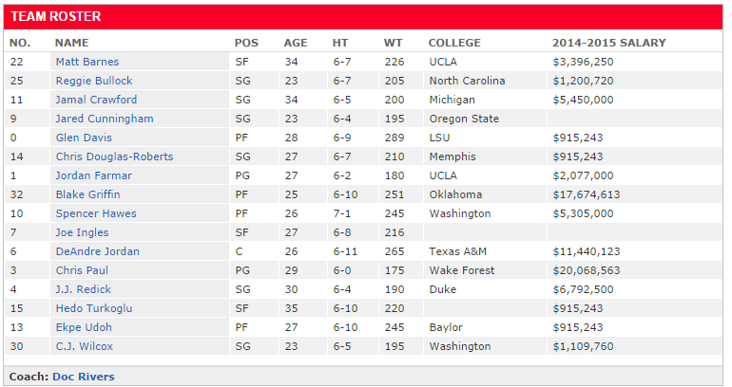

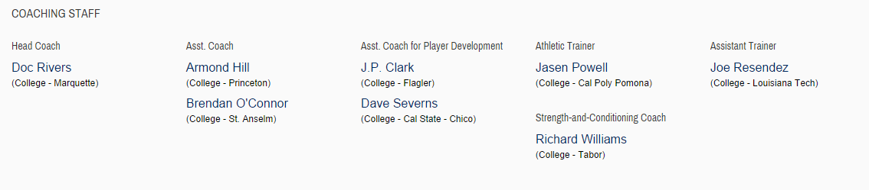

Although some players may have been traded, injured or added, use the information from the table presented below for your table. This was the roster shown as of October 14, 2014. You will have to go to the team website www.nba.com/clippers/roster for some of the information needed in the table.

