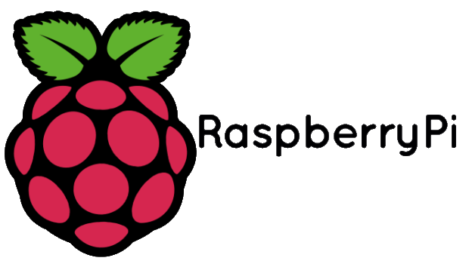

Inquiry Project

TASK:
For this project, you will be given a Raspberry Pi and the necessary accessories to operate it. Your goal is to build something with the Pi. This can be a program, physical product, mod, anything you can think of. There are lots of examples of different Raspberry Pi projects online that you can look at to help guide you or inspire you as to what you want to create. We have access to some other raspberry pi accessories that you could use in conjunction with your project.
You should try to develop an idea that will challenge you as a group and individually while also giving you an opportunity to learn or further develop a skill. Some projects can be completed in a shorter time frame so if that is the case for yours you may want to consider either expanding your project or coming up with an additional idea.
GOAL:
To develop problem solving, creativity, collaboration and communication skills through working with Raspberry Pi computers to develop or create a working project.
DETAILS:
- Groups of 2 – 4 (picked by students)
- One Raspberry Pi Starter Pack (Pi, SD Card w/ Raspbian, connector cables)
- Raspberry Pi Accessories available as needed (limited items)
REQUIREMENTS:
- Submission of Project Proposal Sheet
- Submission of regular updates on progress of project
- Presentation of final project to class

Be creative, have fun!

Completion April 22, 2016

