Question 1:
A person wants to use a lawnmower. The person goes to a lockable shed, opens the shed door, removes each object, in turn, that may be in the way and pushes the lawnmower out of the shed. Which of the following algorithms best describes this task?
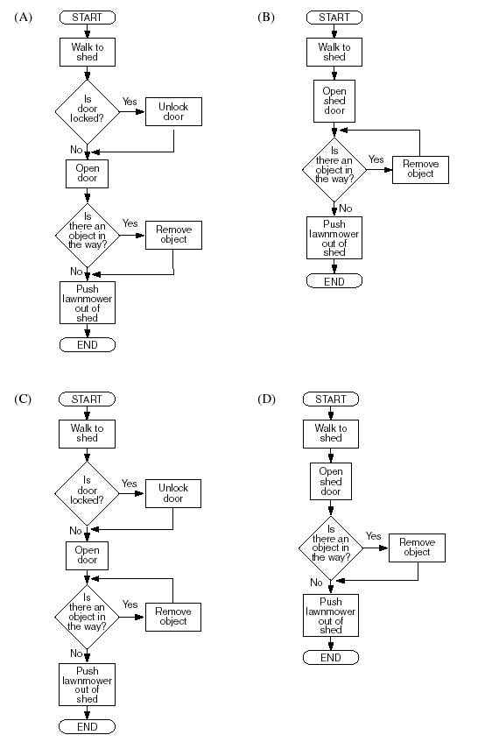

Question 2:
In a buyer rewards scheme, customers accumulate points each time they purchase goods. There are four levels of rewards: Bronze, Silver, Gold and Platinum, depending upon the number of accumulated points. The algorithm below is used to calculate the reward level each time a purchase is made.
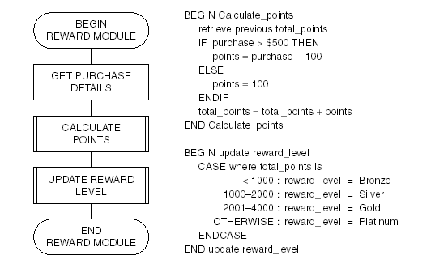
A customer who has already accumulated 700 points makes new purchases of $500 and $1300.
Their new reward level will be
(A) Bronze.
(B) Silver.
(C) Gold.
(D) Platinum.

Question 3:

READ A
READ B
REPEAT
SET C TO (A+B)/2
PRINT C
READ A
READ B
UNTIL A = 0

The following values are entered in sequence
4 6 2 0 0 8 3 5.

Which of the following shows the correct output?
(A) 5
(B) 51
(C) 514
(D) 5144

Question 4:
(a) An Internet service provider (ISP) has an on-line access policy that includes the following conditions:
1 a customer is restricted to 120 minutes for each on-line session;
2 no more than 20 Mb of download is allowed in each on-line session.
Time is to be logged in minutes, and downloads in whole megabytes. During an on-line session a small message ‘access OK’ is displayed in a corner of the screen.
Once either of the above conditions has been met, the message changes to ‘access terminated’ and the customer is automatically logged off.
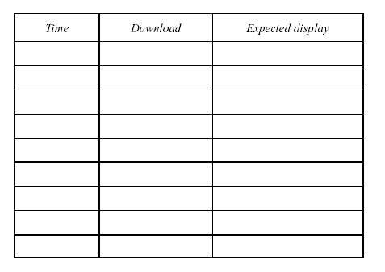
(i) Design a set of test data that will be needed to check the above conditions and show the expected display.

(ii) The algorithm module below was designed to implement the access
policy.
BEGIN INTERNET ACCESS CHECK
set time to zero
set download to zero
WHILE time < 120 OR download < 20
update time
update download
IF time < 120 OR download < 20 THEN
display ‘ACCESS TERMINATED’
ELSE
display ‘ACCESS OK’
END IF
ENDWHILE
END INTERNET ACCESS CHECK

There are errors in the above algorithm.
Identify the line number(s) in which an error occurs and explain the effect of that error.

Question 5:
BEGIN
set A = 2
WHILE A < 7
read B
set A = A + B
print A
ENDWHILE
END
If the values available for B in the above algorithm are 1, 3, 1, 1, 5, then the output from the algorithm would be
(A) 3, 6, 7
(B) 3, 6, 7, 8
(C) 2, 3, 6, 7
(D) 3, 5, 3, 4, 7

Question 6. Two players take turns until they guess a secret number. After each guess the player is told if the guess is too low, too high, or correct.
The algorithm that best illustrates this game is

