Adbusters Cultural Critiques

Outline:
For this project you will be creating 4 adbuster “spoof” style advertisements that aim to take a shot at popular ads. You want to modify current print advertisements for different products and put a humour twist on the ad that says that critiques the product. In the end you will create a layout for your 4 images that will have them on a single page.
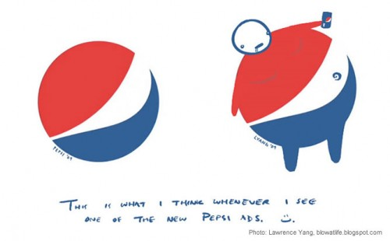

Photoshop Criteria:
For this project, we will not be introducing any new concepts but I would like you to find one online tutorial that covers a skill or technique in Photoshop that you would like to learn. This project is a chance for you to showcase the different Photoshop skills that you have. The more skills you are able to demonstrate, the better you will do on the project. You should be focusing on not only creating entertaining and visually appealing ads but also on using a variety of different skills and techniques.

