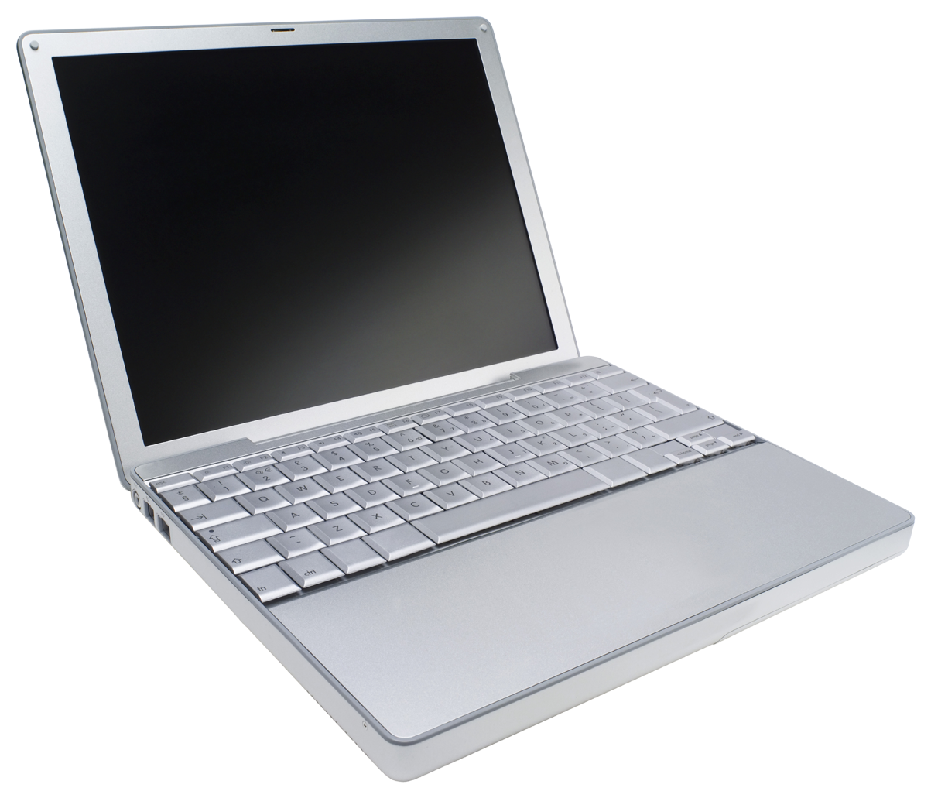
ICT Survey 11 Course Outline
Riverside Secondary Mr. Jamieson kjamieson@sd43.bc.ca
Welcome to ICT Modular Survey 11. You’ve made an excellent choice by deciding to take this course. Skills and proficiencies with technology are becoming more important in today’s world and this course is designed to give you an introduction into various aspects of technology.

Course Description
ICT Modular Survey 11 will introduce the basic components of computer programming, learning web development with HTML and CSS, and developing basic skills in 3D modeling and animation. Based on the ability of the class there may also be a minor unit on mobile app development. Students will learn to use a variety of skills throughout the duration of the course.

Students will be given the opportunity to work with multiple different programs and interfaces throughout the course as they continue to develop their skills and abilities.

Course Evaluation:
Each unit will entail a number of smaller, guided assignments in addition to a larger ongoing project. Students are encouraged to challenge themselves and to go ahead of the pace of the class as this will provide them with the most opportunity for learning.

Guided Projects | 20 %
Projects | 50 %
Independent Study | 15%
Personal Blog/Website/Team Support | 15%

Student Expectations
- Be courteous and respectful during class time
- Arrive to class on time, ready to work
- Take personal responsibility for work and participation
- Work as a group to solve problems. Your classmates will be a great resource
- Ask for help as many times as you need to find success
- If you have your own device that you would like to bring and use in class you are more than welcome to.
- Please avoid eating and drinking anything other than a capped bottle at your work station

