**Social Expectations/Gender Stereotypes**  
  
*Open a word document. Save it under “Body Image – Your Name.”  
Write down all the below words.*

*Brainstorm individually what society expects people that fit each category to be like.*

“Act like a man”

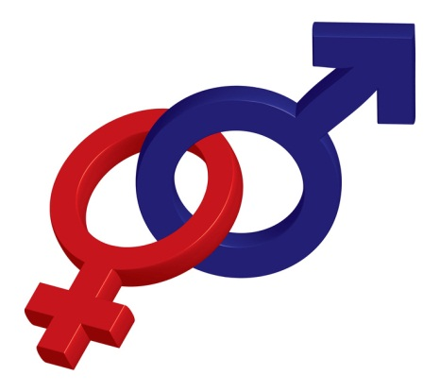“Be Lady Like”

Gay

Lesbian

Jock

Brainiac

Popular guy

Popular girl

Immigrant student

**In your YPI groups…**  
  
Ask who plays a role in creating these expectations?

Identify any problems or negative effects that you could see happening to someone who does not live up to these expectations but feels the need to?

What would be some signs that a person is feeling pressure to live up to expectations or stereotypes?

What are some solutions to help people deal with these problems?

C:\Users\clangford\AppData\Local\Microsoft\Windows\Temporary Internet Files\Content.IE5\0LCW90F5\MC900383810[1].wmf

**Body Image/Media Influence**

Step One

Page Set Up:

Create a word document, write “Who am I” as the title.  
Make a table with three sub-headings: Skills, personality, values.

Activity:

Fill in as many positive qualities about yourself as they can under each heading.

|  |  |  |
| --- | --- | --- |
| Skills | Personality | Values |
|  |  |  |
|  |  |  |
|  |  |  |
|  |  |  |
|  |  |  |

Examples -

|  |  |  |
| --- | --- | --- |
| Skills | Personality | Values |
| Skiing | Funny | Honesty |
| Sewing | Caring | Family |
| Baking | Sense of humour | Justice |

Step two

Information:

Two ways to view the body -

* + Functional – Seeing the body as serving a purpose; perceiving and appreciating what the body does for the individual
  + C:\Users\clangford\AppData\Local\Microsoft\Windows\Temporary Internet Files\Content.IE5\Z67K2D8P\MC900217156[1].wmfOrnamental – experiencing the body in terms of how it appears to others; judging the body based on how it looks.

Relationship between body image and self-esteem -

* + When we relate to our bodies ornamentally, we become vulnerable to the opinions of others and images of perfection.
  + When we relate to our bodies functionally; self-esteem tends to shift from being determined by external judgments to being shaped by abilities and accomplishments

Activity:

Make a continuum with ornamental on the left and functional on the right and place where they think of themselves.

l __________________________________________________ l

Ornamental Functional

Step Three

**Information:

*Watch a variety of commercials (youtube – Dove, Unilever (talk about how these companies still have the goal of selling their product) discuss the morality of having a “Dove Real Beauty campaign” while also selling a skin-whitening product in India. Show Old Spice commercials and talk about how they talk about men.*

**

* What do you think about unilever’s marketing methods?  
  - What pressures do these put on us as individuals?
* How does this impact our self-image?

Activity:

1. *Find images of people that you find attractive. One boy and one girl.*
2. *What is attractive about them?*
3. *How can our views and ideas of attractiveness affect other people?*
4. *Describe someone you know that you think is attractive and why you think so.*
5. *Reflect on what you can do to help achieve an image of yourself that you can be happy about.*
6. *Think about how many times each day you judge (or hear others judge) you own or someone else’s size or appearance, and what effect these judgments have on us cumulatively and over time.*
7. *List at least two physical features that you like about yourself.*
8. *How can you learn to accept and like your body?*

Homework:  
*Find a media clip (no more than 3mins) that shows some type of stereotype or displays an unrealistic body image (Positive or Negative.) Explain why you picked it.*