
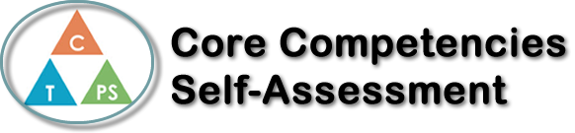
Name: kennedy | Date: October 28

  How does the artifact you selected demonstrate strengths & growth in the communication competency?  In what ways might you further develop your communication competency? | Self-Reflection  Describe how the artifact you selected shows your strengths & growth in specific core competencies. The prompt questions on the left - or other self-assessment activities you may have done - may guide your reflection process.  During this assignment our group was very well in communicating with one another and we always knew what we needed to do. We gave ourselves a 4PM deadline on Sunday and all had different tasks that we needed to complete before then. We all worked very well together and there were no issues or concerns for the project. I was overall very pleased with the results of our presentation and would definitely like to work with Alhan, Evelina and Chloe again.


How does the artifact you selected demonstrate strengths & growth in the thinking competencies?

In what ways might you further develop your thinking competencies?


How does the artifact you selected demonstrate strengths & growth in the personal & social competencies?

In what ways might you further develop your personal & social competencies?

Publish Your Self Assessment
You will now attach and/or embed your self-assessment to the bottom of the blog post with the artifact you have chosen. You may choose to make this post private or public. After placing your artifact on a blog post, follow the instructions below.
- Categories - Self-Assessment
- Tags - Now tag your post using the tag that corresponds to the competency that you have written about. You can choose more than one. Please use lower case letters and be exact.
  - #creativethinkingcc
  - #communicationcc
  - #criticalthinkingcc
  - #socialresponsibilitycc
  - #personalidentitycc
  - #personalawarenesscc
- Use the Add Document button located at the top of your post page and embed your self-assessment at the bottom of your blog post.
- Publish

