
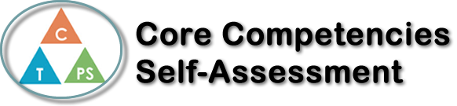
Name: Kendra Tucay | Date:

  How does the artifact you selected demonstrate strengths & growth in the communication competency?  In what ways might you further develop your communication competency? | Self-Reflection  Describe how the artifact you selected shows your strengths & growth in specific core competencies. The prompt questions on the left - or other self-assessment activities you may have done - may guide your reflection process.  One key thing I've improved upon in chemistry is the importance of clear communication. It involves communicating procedures in a way that's easy for others to understand. This skill has helped me ensure that everyone in the team is on the same page and reduces the chances of miscommunication. In chemistry labs we usually work in groups, which has taught me the significance of effective teamwork and collaboration. I've become better at listening actively, sharing ideas, and resolving conflicts professionally. These skills are essential for successful group work.  My goal for future labs is to improve my critical thinking and use different perspectives in order to figure out difficult questions in labs.


How does the artifact you selected demonstrate strengths & growth in the thinking competencies?

In what ways might you further develop your thinking competencies?


How does the artifact you selected demonstrate strengths & growth in the personal & social competencies?

In what ways might you further develop your personal & social competencies?

Publish Your Self Assessment
You will now attach and/or embed your self-assessment to the bottom of the blog post with the artifact you have chosen. You may choose to make this post private or public. After placing your artifact on a blog post, follow the instructions below.
- Categories - Self-Assessment
- Tags - Now tag your post using the tag that corresponds to the competency that you have written about. You can choose more than one. Please use lower case letters and be exact.
  - #creativethinkingcc
  - #communicationcc
  - #criticalthinkingcc
  - #socialresponsibilitycc
  - #personalidentitycc
  - #personalawarenesscc
- Use the Add Document button located at the top of your post page and embed your self-assessment at the bottom of your blog post.
- Publish

