The true monsters.
Well that was unexpected. When Alex woke up that morning she was expecting to get her usual morning bagel from the café down the street, go to work, and come home. Simple, right? Apparently, the universe had other plans. Like her discovering she’s been helping her boss smuggle money from the company she works for and dying, but nothing never goes the way anyone expects it to. She looked around the room which she seems to have ended up in.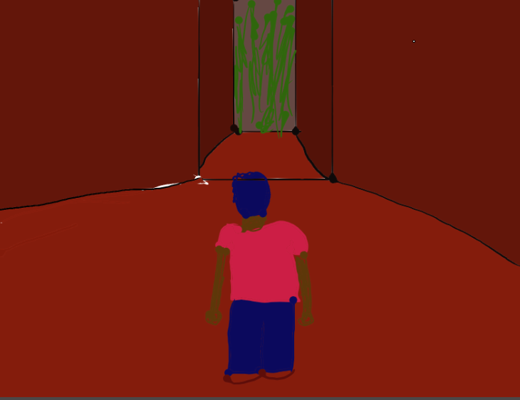
It was dark, hot, and there seemed to be screaming coming from down a hallway opposite her. After examining her surroundings, Alex decided to mentally go back through her day, just to try and make sense of her situation. Alex was having a slow day at the office she works at, being a secretary for the head of sales of a major company. Her boss was away on vacation and she didn’t have anything to do after finalizing some documents for when he got back, in a society of vampires, she found it odd that he would travel to the only warm place they’re world had to offer. She was sat at her desk, twiddling her thumbs when she decided to snoop around some older files, just to do something and besides, it wasn’t like the files were off-limits.
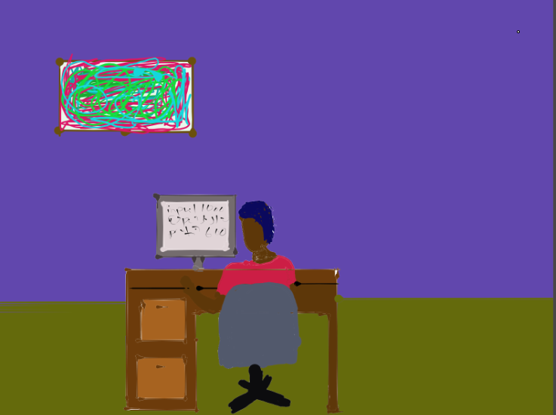
About an hour passed when one of she found something strange. She was looking through all the old sales records and found that every time her boss left for vacation, the sales total seemed to skyrocket. She decided to ask her co-worker about it. When she asked her co-worker, they seemed nervous, and they started stuttering. “I-I really don’t think it’s a good idea to keep looking around. Maybe it’s just a mistake.” Alex wasn’t convinced. After poking around some more, she found that her boss had been smuggling money from the company and taking large chunks out of the sales profit every week, and that she had been helping him cover it up unknowingly, and, that he was a human. She was going to bring this to the head of the office when suddenly, she was ambushed while walking, and shot. Everything turned black. She found herself looking at her own dead body, with a figure standing before her.
“I am the angel of judgement and I now give you a choice. For the evil, you have committed, you have two options of punishment. One, to go to purgatory, and endure all the hardships, until you find your way out. Or, go to the first circle of heaven, where you will be punished for eternity, albeit not roughly, yet still you will suffer. Which one shall you choose? Extreme pain for only a short while, or small pain forever?”
Alex looked at the figure with determination. “I choose purgatory.” She said
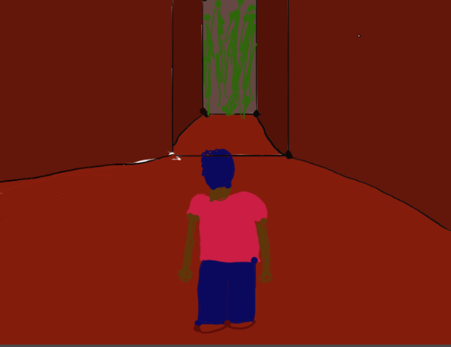
“Very well” said the angel, as wind seemed to circle around them. This brings us to now. Alex stood in a dark room with tortured screams rang in her ears. Alex walked towards the screams coming from the outside. As she walked, the world around her seemed brighter. She came out of the room and found herself in a forest. She walked out of the forest and found herself near a city.
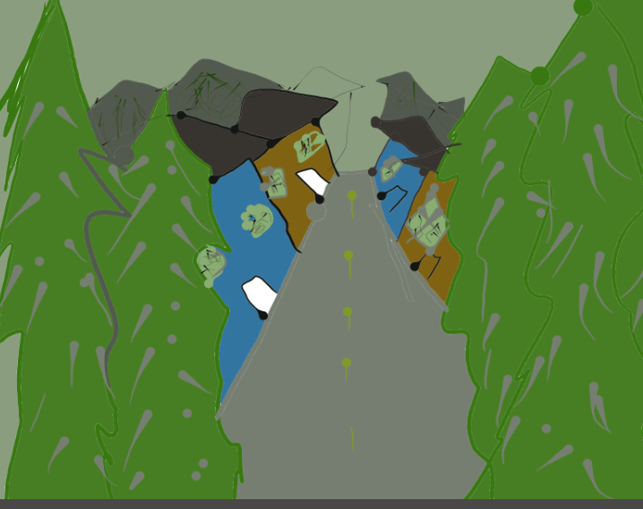
There were houses everywhere and she saw a few people do a double take, liking at her as they passed by. A stranger walked up to her and grabbed her arm. “Excuse me miss, but your parents are looking for you.” They said. “What?”, Alex deadpanned. She had no parents. Vampires were spawned not born. She had been spawned sixteen years ago and she had never once heard of anyone having parents except in the stories about another world where the dominant species had families and formed bonds based on whether they shared certain DNA from certain people. Confused, she let the stranger lead her away. The arrived at a house about a block down. When the stranger knocked on the door, two humans opened the door and hugged her. They seemed so relieved to see her yet Alex did not know why.
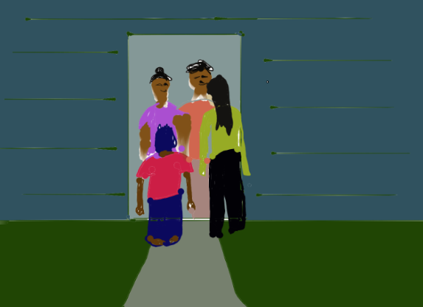
After the stranger had left and the two humans, one of the female sex and one of the male sex, it seemed, left her alone in a room, she examined her surroundings. She found photos of her younger self, and the humans smiling and laughing and being what humans would call a ‘family’. An angel feather appeared before her with a note attached. It said, “This is what you chose. The worst punishment for a shorter time. Here you shall remain as a human.” After inspecting the house, she turned to a TV which had the human news playing. She watched the program to try and decipher her situation. As she watched she noticed what immoral horrible things were happening in her new world. Trump, a monster even in her world, was now in control.
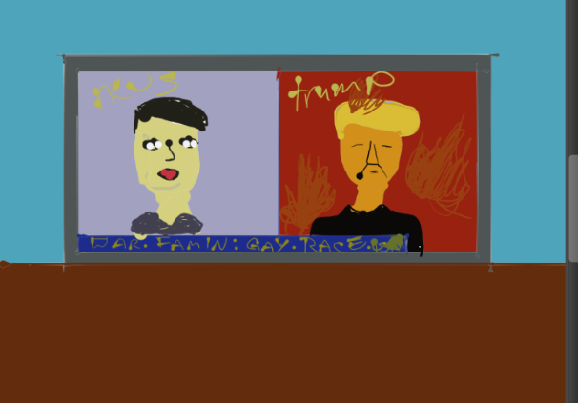
Humans did not care about other’s wellbeing and blew each other up and she saw people being shunned for being different. When she read made her choice earlier, she had not imagined that an angel would send her to this hell. A place so cruel, heartless, and full of death. When she woke up, she did not imagine that she would find such a vile creature in her world of vampires, and have such a horrible fate. She had been hearing the tortured screams of humanity before she walked out of that room in the forest, and there, she should have stayed. True pain was not whips or knives. This, this world humans had created, was hell. This, she decided, was where the true monsters lived.

