
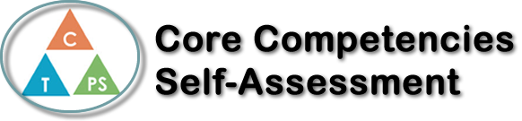
Name: Katia Tarry | Date: 2019-11-19

  How does the artifact you selected demonstrate strengths & growth in the communication competency?  In what ways might you further develop your communication competency? | Self-Reflection  In English 12 we had 5 different groups do 5 different novels and had group Lit Circles my groups book was Lord of The Flies. During our lit circles we discussed the event that happened and went over out weekly assignments. Over the course of our many discussions I improved the amount I would contribute towards the discussion. During the first few weeks I listened to what others had to say and didn’t contribute much but by the end of the novel I was saying my opinion a lot more and developing my answers further. I would consider my communication skills in small groups to be fairly strong, but I need to improve my ability to present in front of the class and larger groups.


How does the artifact you selected demonstrate strengths & growth in the thinking competencies?

In what ways might you further develop your thinking competencies?


How does the artifact you selected demonstrate strengths & growth in the personal & social competencies?

In what ways might you further develop your personal & social competencies?

Publish Your Self Assessment
You will now attach and/or embed your self-assessment to the bottom of the blog post with the artifact you have chosen. You may choose to make this post private or public. After placing your artifact on a blog post, follow the instructions below.
- Categories - Self-Assessment
- Tags - Now tag your post using the tag that corresponds to the competency that you have written about. You can choose more than one. Please use lower case letters and be exact.
  - #creativethinkingcc
  - #communicationcc
  - #criticalthinkingcc
  - #socialresponsibilitycc
  - #personalidentitycc
  - #personalawarenesscc
- Use the Add Document button located at the top of your post page and embed your self-assessment at the bottom of your blog post.
- Publish

