Exploring quadratic functions (7.1)
Follow the instructions laid out in this worksheet and post your answers in a blog post. Use www.desmos.com to answer the questions below.
Due: Wednesday Sept 26th
Title: Exploring quadratic functions
Categorize: Math 11
Tag: quadratics, pahlevanlu
- Find and write the definition of a quadratic function in words you understand. (use your textbook, google, etc)
A polynomial function in one or more variables in which the highest-degree term is of the second degree.
- Give an example of a quadratic function
y=3x²+8x-5
- Give an example of a function that is NOT a quadratic.
y=8x-5
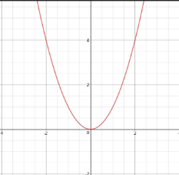
- Go to desmos.com and type in the following function: $y=ax^{2}+bx+c$
  - Desmos will give you the option of adding “sliders” for $a, b, c$ or all. Click all. This will allow you to change the values of $a, b, c$ to see how the graph changes.
  - Start with slider values $a=1, b=0, c=0$. Describe any symmetry you notice.
The lines are symmetrical, they both have the same amount of room on each side of the y axis
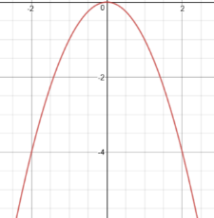
- Keep b = c = 0. Change the value of $a$:
  - $a<0$
    - Does the graph open up or open down?
Opens up
    - Does the graph have a maximum point or minimum point?
Maximum point
  - $a>0$
    - Does the graph open up or open down?
Opens down
    - Does the graph have a maximum point or minimum point?
Minimum point
  - $-1<a<1$
    - Is the graph narrow or wide?
Widens
  - $a>1 or a<-1$
    - Is the graph narrow or wide
Narrows
- We call the maximum or minimum point $(x,y)$ of a quadratic function the vertex. Complete the following statements:
  - When $a$ is positive, the vertex is a minimum
  - When $a$ is negative, the vertex is a maximum
- Let $a=1$ and $b=0$constant. Use the slider to change the value of $c.$Describe how the graph changes as $c$changes.
The bottom of the parabola moves up and down the y axis
Roots are the solutions to the quadratic equation. The roots are found by looking at where the curve crosses the x axis (x-intercepts).
Adjust the sliders for a, b and c so you can get a curve that just touches the x axis (y=0).
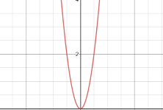
Equation: ____y=8x²+0x + 0___
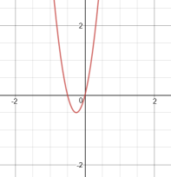
This quadratic equation has ONE solution.

Adjust the sliders so you can get the roots of 0 and -1

Equation: _____y=8x²+4x+0 _

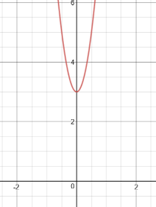
This quadratic equation has TWO solutions.

Adjust the sliders so that the curve does NOT cross the x-axis.

Equation: ______y=8x²+0x+3________

When the curve does NOT cross the x-axis, there are NO REAL solutions for this equation.

