Textile Industry
Questions
Burning:
How did the Industrial Revolution affect the Textile industry?
Guiding:
- How did the Textile Industry change during the Industrial Revolution?
- What were the working conditions in factories?
- What effects did working in the Textile factories have on the workers?

How did the Industrial Revolution affect the Textile industry?
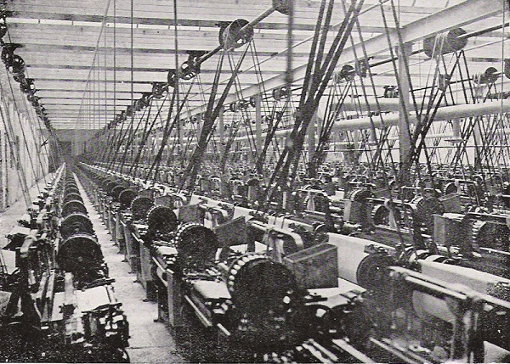
The Industrial Revolution affected the textile industry because before the revolution most items were made by hand. Most textile items were made from wool and the wool was hand spun. The Industrial Revolution created machines that could produce the goods faster. The artisans were replaced by machines. The spinning wheel and the loom were invented. The spinning wheel transformed plant and animal fibers into thread or yarn. The loom used the thread or yarn to weave cloth. The workers made clothing from many different materials. The workers used cloth which came from plants and animals. Wool came from sheep, silk came from silkworms, and linen came from flax. Before the Industrial Revolution, wool was in high demand, so they had to have lots of sheep and have room for the sheep to live. After the Industrial Revolution, cotton became more popular. The drastic changes that happened because of the spinning wheel and loom is that production time was quicker and the cost to produce material was cheaper.
Many jobs were created in the factories because of the new ways of making the clothing and because the need for these goods. As a result, factories had to stay open for longer hours, the men, women, and children had to work longer hours and more days, and the demands on the workers increased. In 1833, the Factory Act was passed. The Factory Act was new laws to protect the workers. Another change that happened because of the factories is that many people had to move from farms to the cities. Since so many people moved the cities, the cities started to get overcrowded. The change from living in a rural to an urban society was a huge change in the way people lived. Since so many women needed work the factories could pay them very poorly. The women had to do all of the hard jobs that the men did like pull carts full of coal in tiny underground tunnels. The women did lots of hard work in the textile industry. Some of the women liked the change because they felt like they had independence and money of their own for the first time.
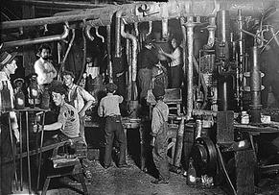
What effects did working in the Textile factories have on the workers?
Since the working conditions were so poor in the Industrial Revolution the workers suffered a lot. Many of the workers got very sick, badly injured, or died. A lot of the children did not live past the age of 5 years old. The tunnels were not stable and would collapse and trap the workers underground. Since they were breathing so much dust the workers got lots of diseases like cancer.
How did the Textile Industry change during the Industrial Revolution?
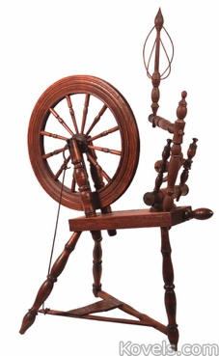
The textile industry changed a lot during the Industrial Revolution. The textile industry first had artisans making hand-made items. One thing that changed was the cottage industry. The cottage industry is when the women worked at home as part of the family business. After time the cottage system died and thousands of people in homebased businesses had to find new work. The women who stayed in the countryside started working as servants for people who had lots of money. Some of the women did farming work like weeding and harvesting. Other women moved to the cities and went to work in the factories.
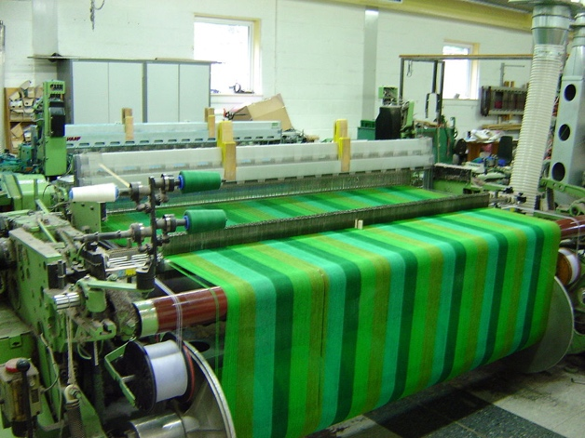

What were the working conditions in factories?
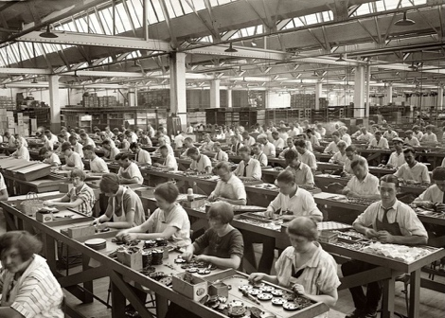
The working conditions in the Industrial Revolution were not good. The workers had very long and hard days. They had to work for 12 hours a day and 6 days a week. The workers got paid very little. Women got paid less and did a better job than the men. The kids got paid even less than the women. If the workers got sick or missed work, they usually got fired from their job. The workers got no time off work. Most of the jobs they had to do were very dangerous and unsafe. They had to use machines that were not safe, and it was not common to lose a limb or a finger. Some of the workers had to work in underground tunnels. In the factories there was very bad lighting and made it hard for the workers to see. In the factories and tunnels, there was lots of dust and made it hard to breath. The factories had lots of fire hazards and the smallest spark could make an explosion or blaze. Lots of factories had kids under the age of 5 working. They had the kids working in unsafe conditions. They liked having the kids work because they could pay them less. It was also useful to have the kids work to get into small places that adults could not fit into.

