General Form to Standard Form / Standard for to General Form

General form and standard both give us different information so why not use them both. It is a mandatory skill to be able to put an equation in general form into standard for and vice versa.

General form:



Standard form:



To convert an equation in general form into standard form you must complete the square.

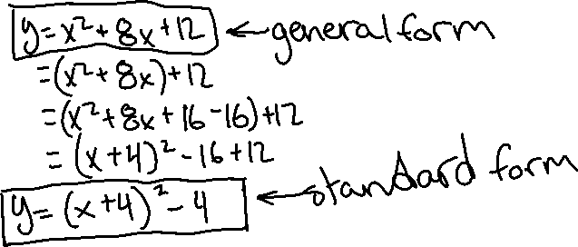

To convert an equation in standard form into general form you must expand.

