Geometric Series

The definition of a geometric series is, “a series of numbers or quantities in geometric progression.” Similar to arithmetic series you calculate the sum of the series by adding a constant, however, in geometric series to calculate the sum you must multiply a constant (common ratio).

You are able to find the common ratio by using the formula:



If the series is geometric the common ratio should be the same all throughout the series.

Ex.



To find the sum of a geometric series you must use the formula:

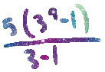This formula can be used for questions such as: