
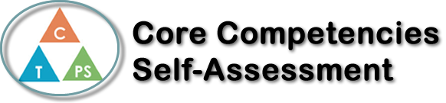
Name: Julie Einarson | Date:

  How does the artifact you selected demonstrate strengths & growth in the communication competency?  In what ways might you further develop your communication competency? | Self-Reflection  Describe how the artifact you selected shows your strengths & growth in specific core competencies. The prompt questions on the left - or other self-assessment activities you may have done - may guide your reflection process.  In English this year, I completed spoken word. This project taught me a lot about myself, and through my spoken word, I developed tools to express myself. My spoken word was about mental illness and paranoia, and in order to write my spoken word I had to reflect on myself and my state of being. This allowed me to grow in terms of personal and social awareness, as I became more aware of who I was and where I was doing in terms of mental wellbeing.


How does the artifact you selected demonstrate strengths & growth in the thinking competencies?

In what ways might you further develop your thinking competencies?

x

How does the artifact you selected demonstrate strengths & growth in the personal & social competencies?

In what ways might you further develop your personal & social competencies?

Publish Your Self Assessment
You will now attach and/or embed your self-assessment to the bottom of the blog post with the artifact you have chosen. You may choose to make this post private or public. After placing your artifact on a blog post, follow the instructions below.
- Categories - Self-Assessment
- Tags - Now tag your post using the tag that corresponds to the competency that you have written about. You can choose more than one. Please use lower case letters and be exact.
  - #creativethinkingcc
  - #communicationcc
  - #criticalthinkingcc
  - #socialresponsibilitycc
  - #personalidentitycc
  - #personalawarenesscc
- Use the Add Document button located at the top of your post page and embed your self-assessment at the bottom of your blog post.
- Publish

