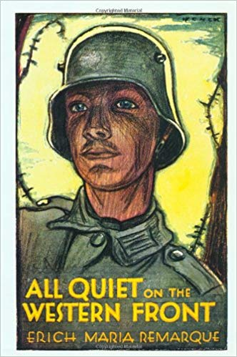
All Quiet on the Western Front
By Erich Maria Remarque
A student at the University of Munster, Erich Maria Remarque was drafted into the German army at the age of 18. He fought on the Western Front during World War I and was wounded no fewer than five times, the last time seriously. Published in Germany in 1929 as Im Westen Nichts Neues, his novel sold 1.2 million copies within a year; the English translation, All Quiet on the Western Front, published the same year, went on to similar success. It was subsequently translated into 12 languages and made into a celebrated Hollywood film in 1930.
Vocabulary: put the definition of each word in your OWN words AND put it into a showing sentence (NOT copied from the internet)
Vocabulary Word | Definition in your own words | A showing sentence created by YOU
Veracity (n) | Something that is true | The judge said the veracity of the Neymar case.
Unimpeachably (adv) | Something that is unquestionable | It’s unimpeachably that Ms. Thomasen is the best teacher ever.
Implored (v) | Ask someone to do something desperately | I implored my sister to leave the room
Cunning (adj) | crafty | The cunning fox ate my dog’s food
Disconcerted (adj) | Confused | I felt disconcerted when my dad told me to something, but my mom told me to do the opposite
Trifling (adj) | Something unimportant | Doing sports is not trifling
Ostracized (v) | Excluding someone | Miguel ostracized Manuel from their group od friends.

Prereading: In the space below, describe how you would feel if you were required to go to war for your country (in 2023). Answer in full sentences, describing how you would feel and why. What would your parents say? What would your friends say? Would they support you or not?
If I had to go to war by the time, I’m 18, I will feel supper mega ultra scared. I think I would be so sacred and nervous that I couldn’t even talk. When I’d reach the battlefield, the speed of my heartbeat will be 100000000000000000 miles per hour, but I think I would be a little brave and be able to defend my nation until death.
While reading: Use your reading strategies (inferring, visualizing, questioning, connecting) as you read. Record your thinking with stickies (I will give to you and explain more fully in class)
After reading: Choose TWO different stickies (connection, visualization, question, inferring) and describe your thinking. (Eg. If you connected to a character, explain why. If you visualized a scene, describe it. If you questioned the author or the actions of the character, explain. If you inferred (read between the lines) tell me what you “read” between those lines.)
Infer page 17: infer what Paul gives Kroppa a cigarette he is birring him to give Kemmeich morphine
Visualization page 9: The three boxes stand in the midst of the glowing red field- poppies.
Questions. Answer the following in full sentences with details from chapter one.
- Why do the men get more rationing of food than expected?

Because 70 died in the war.
- Where and how do the men find joy despite being at war?

By hanging out with each other and disposing their waste.
- Who convinced the boys to go to war? And how?
The teacher telling them they were cowards
- What was the attitude of German society about going to war with England?
Between the upper- and lower-class attitudes.
- How did the soldier’s attitude about the adults change as a result of the battles they experienced? Paraphrase into your own words.
They thought that they were role models but after the released they weren’t.
- Describe the scene in the hospital in your own words. What did it smell, sound, look like?
It smelled very bad, like sweat carbolic and pus.

- The boys have become desensitized and demoralized by their experiences. What is the proof of this?
They do not care that their friend’s dying they are only interested in his boots.
- The book is written in first person point of view of a German soldier. Based on what you are learning with Mr. Chan, do you think this chapter would be different if it was written in the point of view of a Canadian soldier? Why or why not?
I don’t think because both were being pressured and also had the attitude towards war.
- Choose ONE of the following quotes and explain the significance and the meaning.
They think they are very strong but they don’t realise that that might die in the war.

"The soldier is on friendlier terms than other men with his stomach and intestines. Three-quarters of his vocabulary is derived from these regions, and they give an intimate flavour to expressions of his greatest joy as well as of his deepest indignation. It is impossible to express oneself in any other way so clearly and pithily. Our families and our teachers will be shocked when we go home, but here it is the universal language."

OR

"Yes, that's the way they think, these hundred thousand Kantoreks! Iron Youth! Youth! We are none of us more than twenty years old. But young? That is long ago. We are old folk."

Post Writing
In point form, brainstorm what you have learned about WW 1 based on the first chapter of this novel.
The food is bad.
It is terrible and traumatizazing

