How to Make: Solar Box Cooker
Ever wanted a fun, cheap, and a hot way to explore the world of physics? If the answer is yes, think about following this procedure to make your very own solar box cooker, which cooks food from the energy of the sun!
Here is what it should look like:
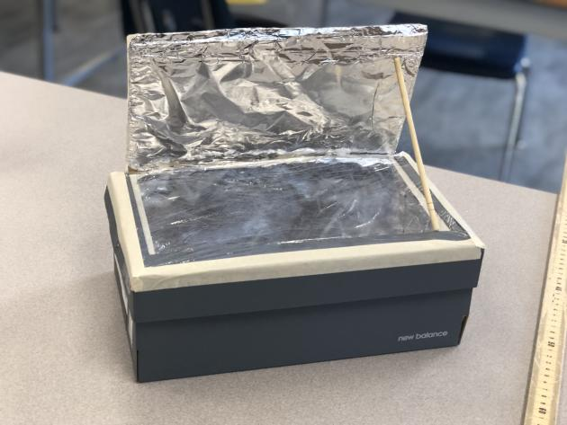

Materials:
- Any shoe box or pizza box
- Tin foil
- Masking tape or duct tape
- Saran wrap
- Liquid glue or glue gun (supervision required)
- Exacto knife (supervision required)
- Black construction paper
- A chopstick or pencil

Steps:
Step 1:  Cut 3 lines at on the lid of the shoe box, about 2 cm from the edge of the lid with the exacto knife | 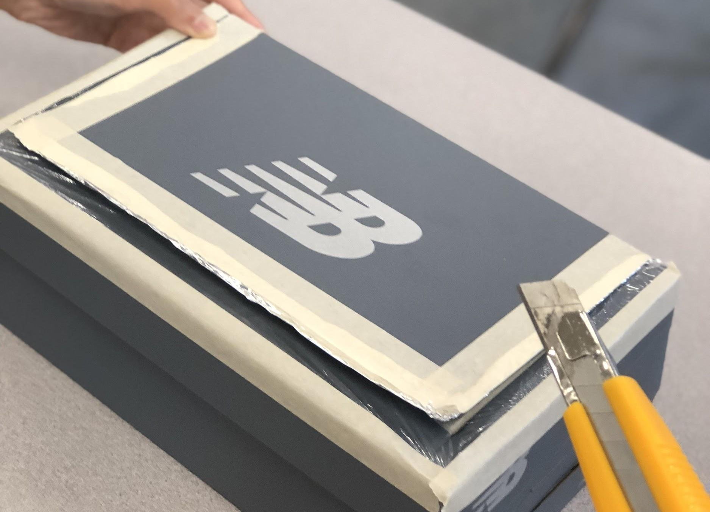
Step 2:  Once cut, open up the flap you cut and put tin foil on the inside.  Then use masking tape to tape it to the back of the flap. | 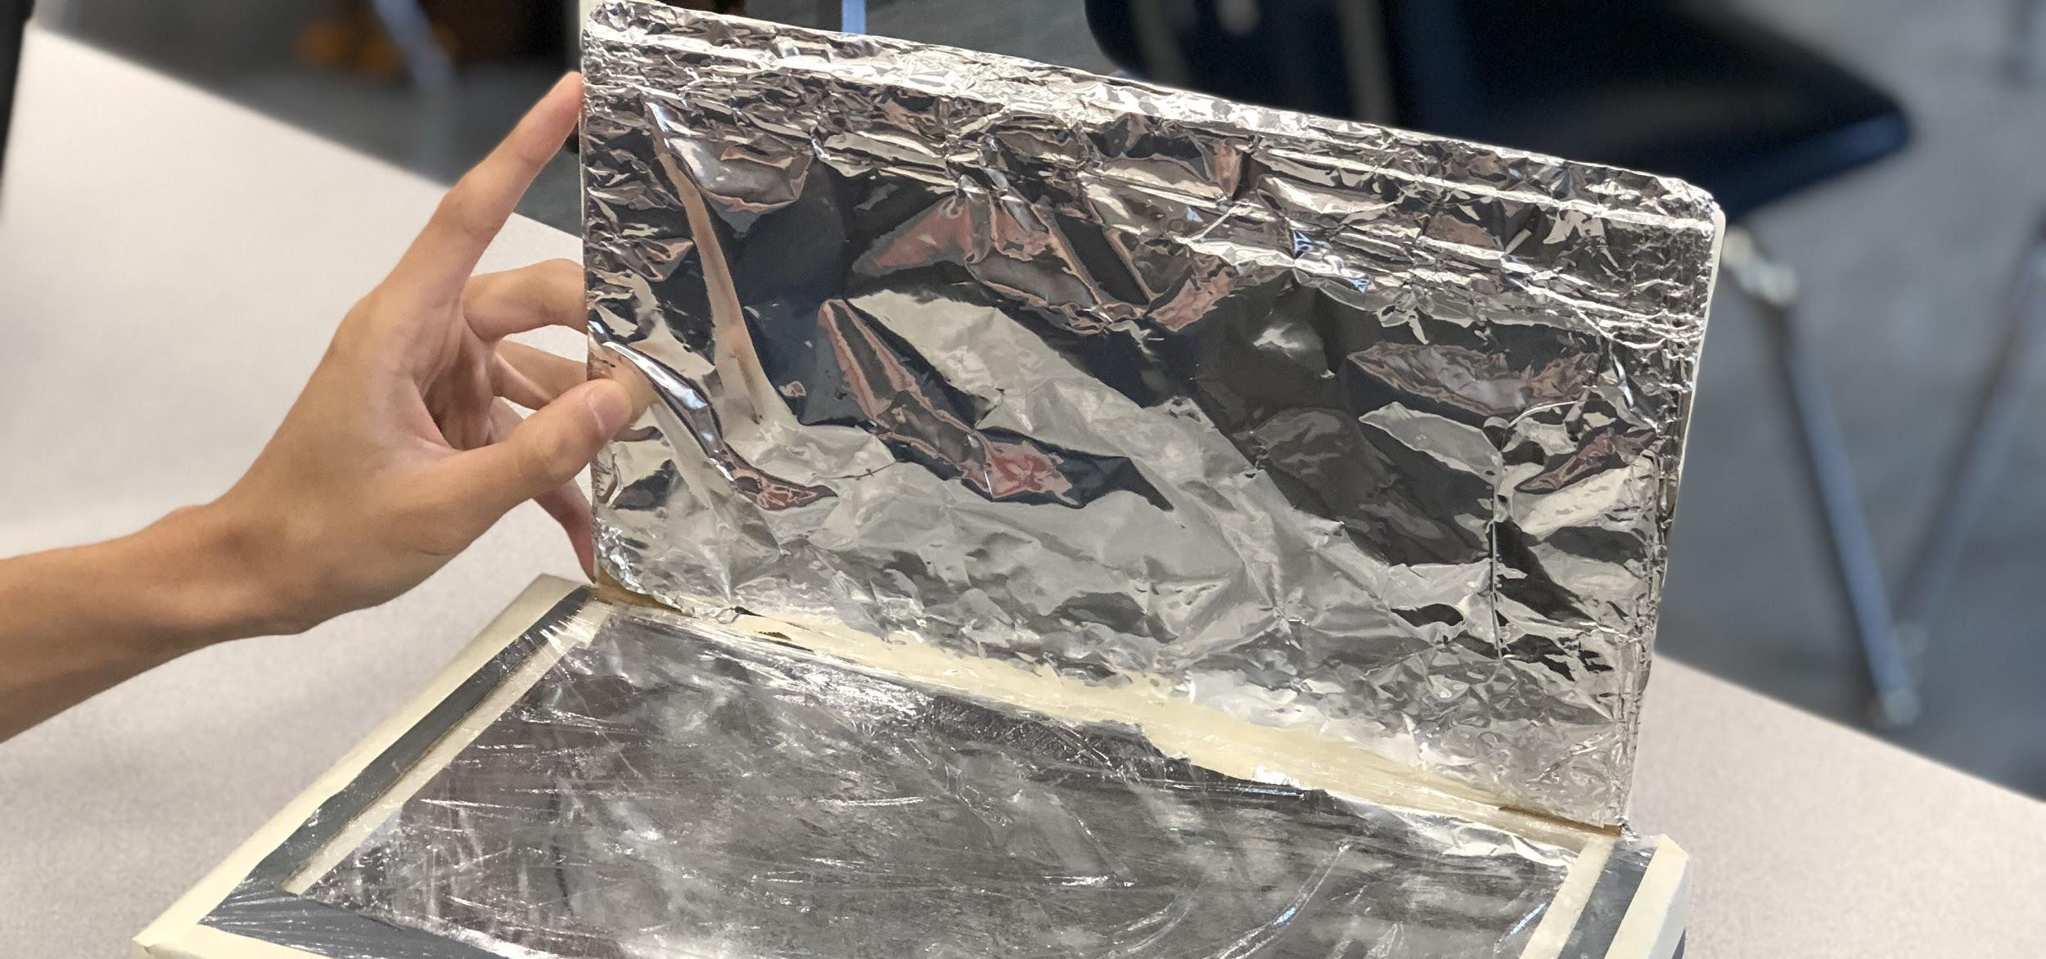  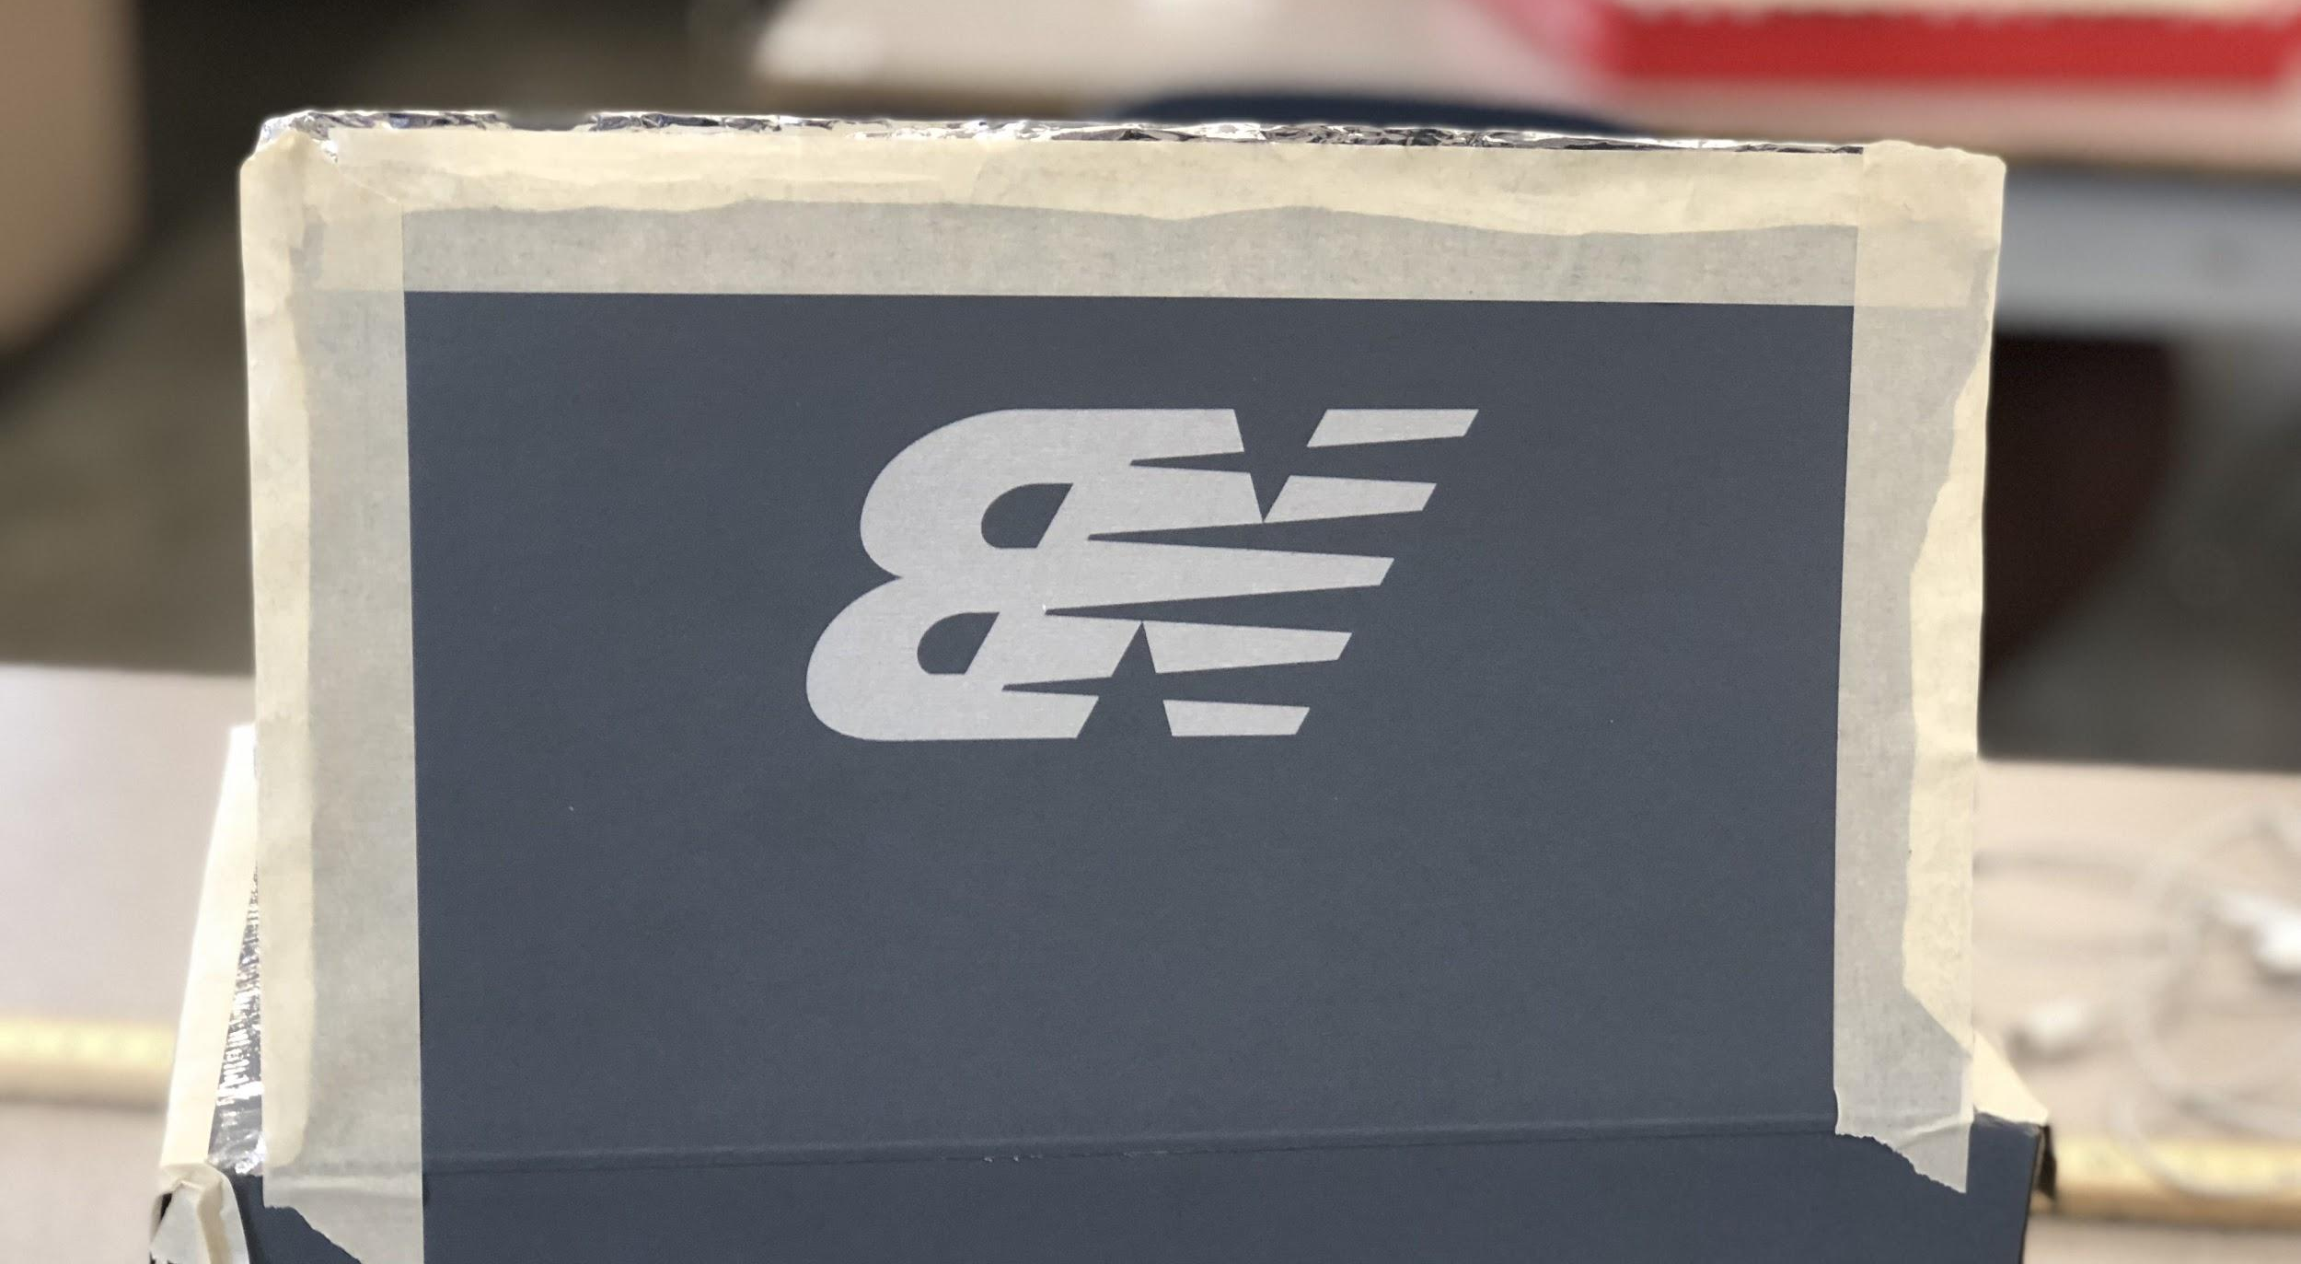
Step 3:  Put a layer of saran wrap on the bottom of the box lid. (Get a parent or a friend to help!)  Put masking tape around the edges to hold the saran wrap in place. | 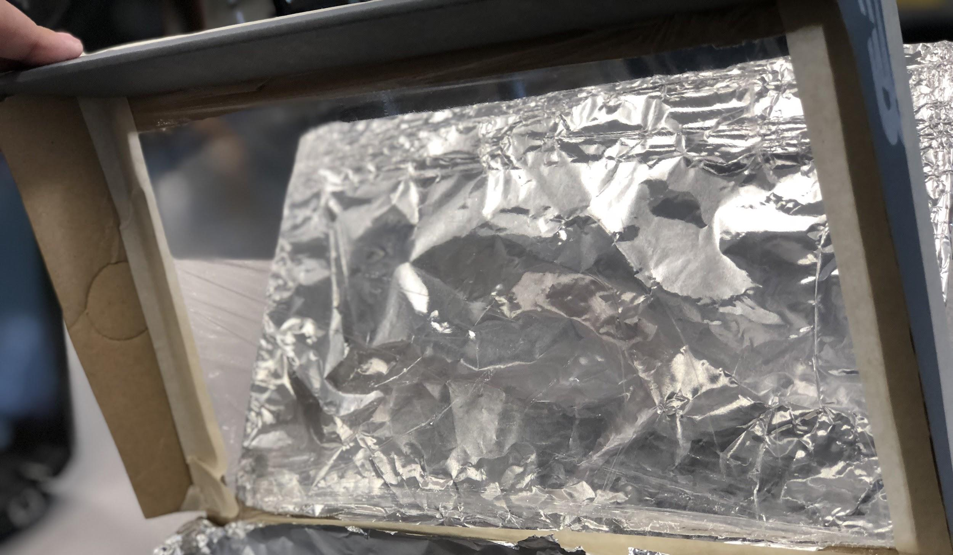
Step 4:  Lift up the flap and put a layer of saran wrap on the top of the box lid  Put masking tape around the edge of the shoe box to hold the saran wrap in place | 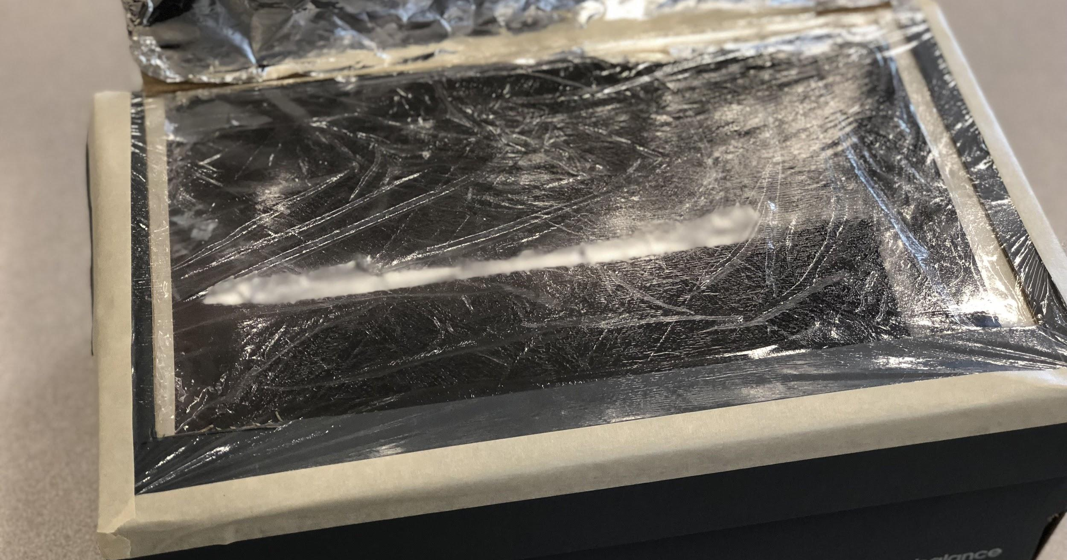
Step 5:  Open the entire shoe lid and glue your tin foil around all 4 walls of the shoe box. \  (Try to keep the tin foil as shiny as possible!) | 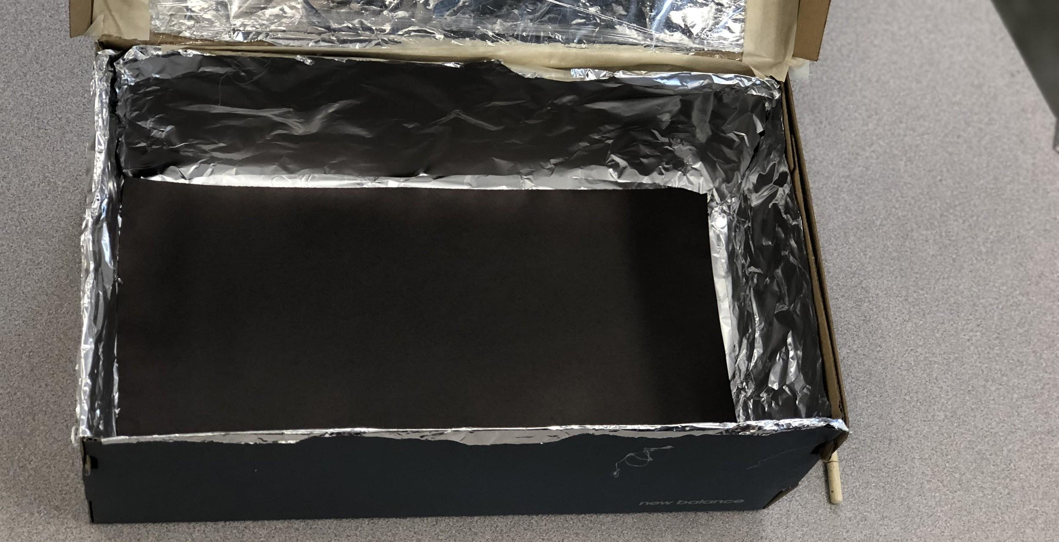
Step 6:  Place a layer of black construction paper at the bottom of the shoe box (The black construction paper helps maintain the heat!) | 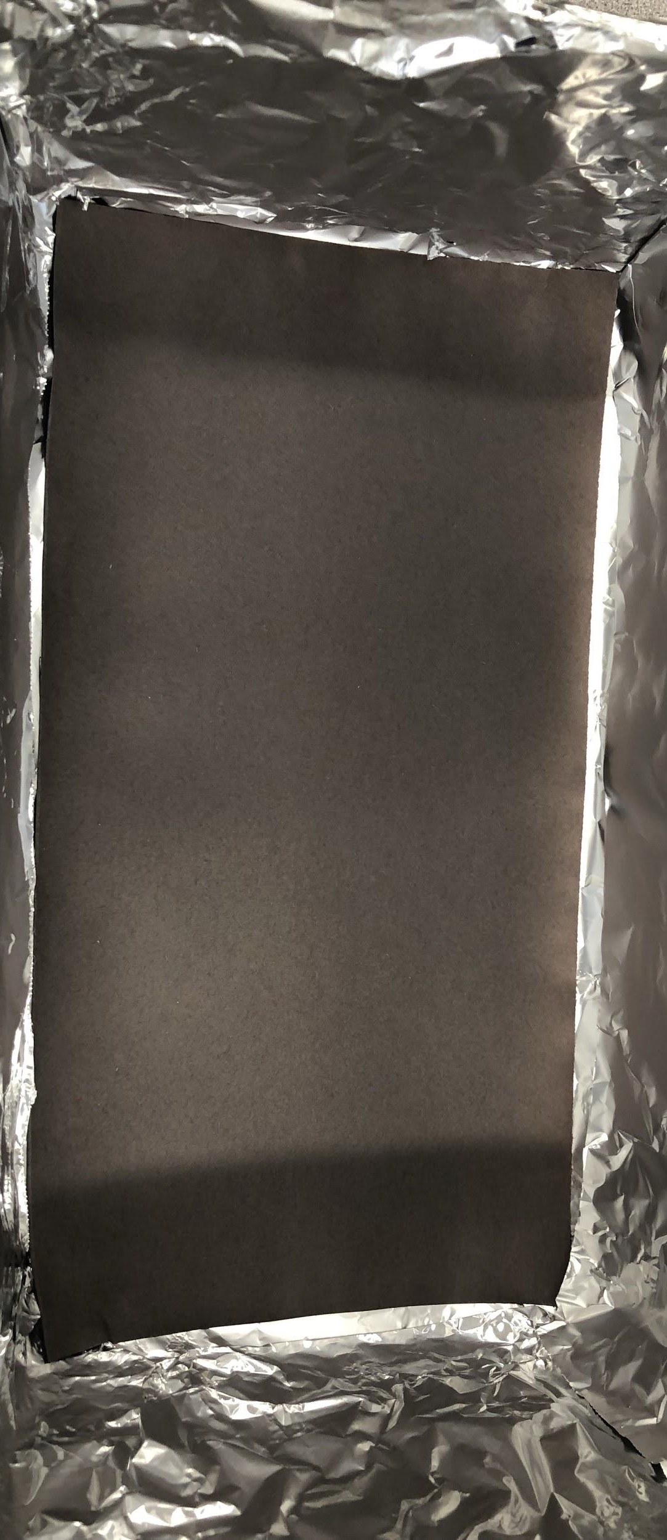
Step 7:  Put a chopstick or pencil on the top of the shoebox to support the flap so it doesn’t fall down. Make sure that the lid stays at around a 60 degree angle | 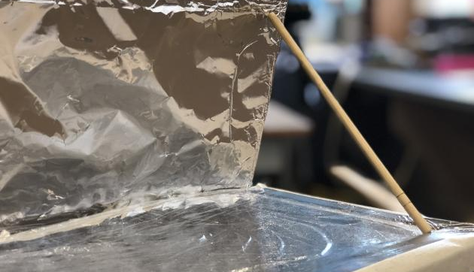

There you go! That is how you make a fully functional solar box cooker which can cook food on a hot sunny day. Bring it on the next picnic that you go on with your family or friends!

To operate the box cooker, place your food inside the box and point the box in the direction of the sun. The food should cook in under 30 minutes. Have fun!

