Earthquakes and Impacts

Part 1
Abbotsford- Rural and Suburban
Population- 141,000
Regions- Riparian, Farm land, and some Forest
Soils- Mostly Sand, Silt, and Clay, (ice age sediments) Gravel and Sand, and Till. On Sumas mountain Granite rock, Volcanic Rock, and Sandstone.

Most of the people live on Gravel and sand, and Till (Ice Age sediments), this area is the Suburban area. Also There is Suburban Areas on Sumas Mountain (Granite rock, Volcanic Rock, and Sandstone).
The Rural Farm land is on Clay and Silt, and Sand and Silt.

Businesses/Economy:
-Agriculture/Farming, Abbotsford Produces 2nd most Agriculture in Canada.
-Abbotsford Airport
-Castle Fun Park
-Manufacturing
-Film

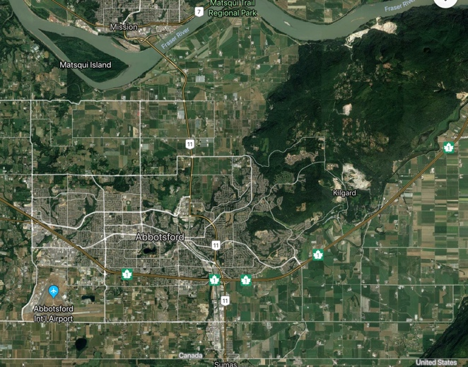

Part 2
Juan De Fuca Plate- North American Plate
Convergent Boundary, Subduction Zone
The Juan De Fuca Plate is Converging towards the North American Plate, and it’s going underneath (Subduction Zone). If and When it Slips, the outcome will be a huge earthquake. P and S waves will be produced, heading towards Costal States and Provinces along the Juan de Fuca plate (Oregon, Washington, British Columbia ).

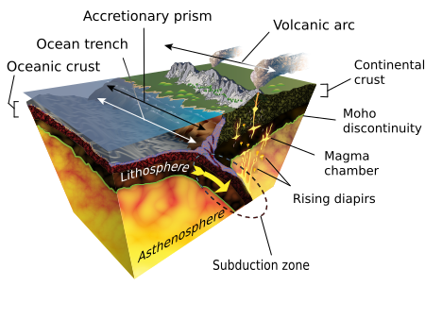
In Abbotsford The Farm Land Close to the River, Sand and Silt will Liquify In an Earthquake.
In land from the river, Clay and Silt will most likely not Liquify, but since the soil is soft it will not be sturdy, and makes a poor foundation.
Farmland will be shaken up and some of it will sink. This means Farmers can’t Produce food from there farms, because it’s destroyed.
This will effect:
-Jobs
-Economy
-Lack of food/Produce
-Going out of Buisness
-Highway #1

In The Suburban (Gravel and Sand, Till, Granite rock, Sandstone, and Volcanic Rock) area.
Silt and Clay and Sandstone Sediments/Soils will likely landslide because these soils are weaker and erode easily. However Till, Granite Rock, and Volcanic Rock are all structurally sound soils that make great foundations. Most of Abbotsford populations built there houses on these soils, and a lot of company’s built there buildings on these soils.
Earthquake effects on Suburban region:
-Destruction to Buildings (Brick and Concrete Will crack, wood is flammable)
-Contaminated water supply
-No Jobs to Work
-No Electricity
-Roads out of service
-Food shortage
-People lose homes
-Businesses shut down

Abbotsford’s Suburban Area takes up most of the population, most of Abbotsford buildings area built from 1990-Modern, due to a huge population groupthink in the mid 90s. The house are mostly wood (potential flammable in earthquake), but the new houses up on Sumas mountain area made with steal frames which make them sturdy. The bigger buildings down South Fraser Way are made up brick making it prone to collapsing. Over in the Rural Area there are way less people and everyone is spread out. Since the soil is less sturdy buildings on these soils will most likely sink or collapse. Good thing Abbotsford didn’t build the city Center in Sand and Silt and clay.

The Airport, Manufacturing businesses, Agriculture, and small businesses will not but operating, therefor they will be losing a lot of money. Because of the harmful earthquake the businesses will be broken down or broken, some of the smaller business and restaurants and maybe some of the farms will have to shut down after depending on the damage. If all the businesses are shut down, and roads people won’t have access to daily needs, food, and water. The earthquake will put our economy in reverse, and put people in pause for a while.

Part 3
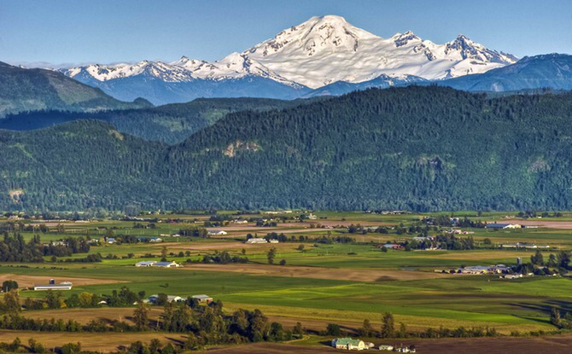
I am Joshua Mitchell-Dyck, I like to eat at Tim Hortons, and I play Basketball, and I live in a modern (steal based) house on Sumas Mountain (Volcanic Rock). The Big Earthquake just hit, we can’t leave our house because all the roads are covered in debris (trees, branches, housing material, cars), and the roads are damaged. My house has no power and all our food in our fridge and freezer are going bad. Our water supply is limited, and dirty. We need to go buy food and water but the roads are closed, and all the local grocery stores are closed. I have to eat Cheerios without milk for Dinner, and granola bars for lunch. We can’t bathe, flush the toilet, do the laundry, or brush our teeth. We decide to walk on the side of the road into town. Some of the buildings are totalled, others with slight or major damage, other with little to no damage but everything is closed. A lot of people are on the street, most are trying to help or some help, some look like they have lost there homes. We come upon the city square and there are people giving out kits, they gave us each one and we went back home. The kits containing 12 waters, protein bars, soap, extra clothes, and a blanket. For weeks I couldn’t eat proper food, or drink water from the tap, I couldn’t watch TV use wifi, or up any electrical appliance, I couldn’t cook food, I couldn’t shower or flush the toilet, or even drive around. I can’t eat the foods I like, or do the things I enjoy. I can’t play basketball, or play video games. I can’t go to mcdoanlds either.

The weeks go on and slowly the city rebuilds it self off the 2 Billion dollar loan from the government, but surely it will never be the same.

-1 week to clear the roads
-1.5 weeks to regain power
-1.5 weeks to repair highway #1
-1.5 weeks for some people to start going back to work
-1.5 weeks until school reopens
-2 weeks to open reopen the first grocery store (Walmart)
-2 weeks to reopen some restaurants (Mcdonalds and Tim Hortens)
-2.5 weeks to fix cities sewage
-3 weeks to send clean water to houses
-3 weeks to reopen first farm and Manufacturing Business
-3.5 weeks to reopen first small businesses (Locally run)
-4 weeks to reopen Airport
-1 Year to rebuild all the houses

Things that will never be the same:
- Castle fun Park closed down do to breakdown (land slide went through castle fun park)
- Some farms and big businesses closed
- People died
- People lost jobs
- Riparian land turned into River
- People had to relocate houses
- We have to pay off a 2 Billion dollar loan

What we learned for the future, The houses built on Sturdy foundation, and with strong materials ended up not taking much or any damage. But the houses with weak materials, built on soft foundation, ended up getting destroyed and the people/ Business either had to move or close.
“Build your house on Solid Rock”

