Hurricane Florence

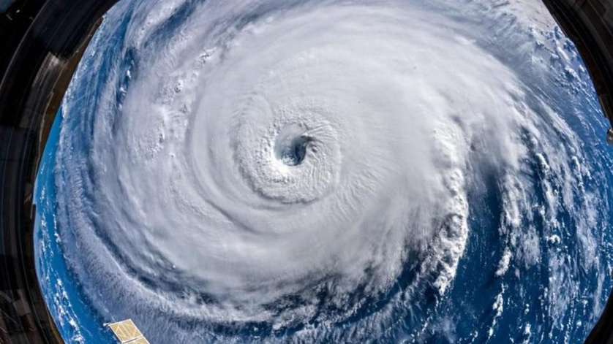

In the Carolinas, USA, a hurricane with winds up to 220km/h took place at the beginning of September. It started on September 3rd, 2018, hit the Carolinas (North and South Carolina) on September 14th,and ended on the 17th of September in West Virginia. The 400 mile wide hurricane poured about 9.6 trillion litres of water on North Carolina alone, 18 trillion litres on USA soil. 48 Deaths in all three states (North Carolina, South Carolina, West Virginia) in this disaster, most were caused by electricusion related incidents. It rained so hard that over 30,000 houses were in 10 feet of water. Winds were so strong 800,000 were left without power in North Carolina. 12,000 people were in shelters in North Carolina. This disaster was so big that 1.7million people were told to evacuate. The Hydrosphere and Atmosphere (wind and rain) in the storm effect sociosphere and lithosphere (people and land). The Hurricane floods land and houses, knocks down trees, and the power lines and generators interact with the flooded land and electrocute.

Response
Most people responded to the hurricane by evacuating, the people who stayed in there house, most had to be rescued out of there homes. The more intereor they were the less they got affected. Some people stayed back to rescue which is really good to see and helped save many lives. Evacuating may seem controversial because you don’t want to leave your belongings and life possessions behind, but it will save your life, if no one evacuated the death rate would be a lot higher. I feel kinda sad about this, people lost lives, a lot of damage (13 Billion dollars in Damage), and people lost homes. But part of me is impressed, 58 deaths is a low death rate compared to Hurricane Katrina killing 1833 people. There we 9700 National Guard Troops rescuing people from boats, rescuing many. I’m sad for the lives that were lost, but happy because I know it could’ve been a lot worse. I would use the same solutions they used for this hurricane. I would send a lot of rescue troops, and alert and prepare everyone for what is to come. In Florence’s case they alerted everyone a weeks before and told over 1.7 million people to evacuate before the storm hit. I know from experiences, phones get notification warning for disasters that are about to happen. I was in Texas for a missions trip, and at 3 in the morning everyone I was with had an alarm coming from there phone, for a flash flood warning. It wasn’t too bad, but we were alerted, and ready to evacuate before the floods happened. This is very useful because in a society that majority of the people use phones and always have it near them. If send everyone an emergency warning on there phones with an alarm, everyone will know what’s to come and be prepared. Alerting people through there phones and telling them what to do is what I would do In a natural disaster.
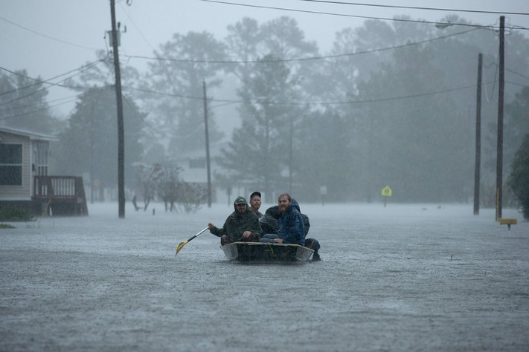

BBC News. (2018). US 'brute' of a storm turns deadly. [online] Available at: https://www.bbc.com/news/world-us-canada-45517260 [Accessed 15 Sep. 2018].

Global News. (2018). Hurricane Florence makes landfall in North Carolina. [online] Available at: https://globalnews.ca/news/4449384/hurricane-florence-landfall/ [Accessed 15 Sep. 2018].

