Josh Thompson
Mrs. Thomasen
English 12
Sept 17 2019

Chicken in the Cooler
My 1998 Subaru Legacy GT. The only reason I took this job at a butcher shop. My father and I had made an agreement that I would have to pay for my insurance once September arrived. Three days a week I was up at 8 and out the door by 9:30 to make sure I would arrive early to impress my boss. Today however I am slow to get out the door and by the time I see the grungy, brown brick building it’s already 9:55. I pull into the awful, awkward, and annoying parking spot. I grab my phone out of my glovebox and check it for any messages before getting out of my car. I trudge my tired, unmotivated self to the front door. None of my coworkers have arrived yet so I put my earbuds in and lean against the coarse wall. Twenty minutes have passed when two customers show up and I explain to them that neither my boss or co-worker have showed up yet and I can see that they are disappointed. Another 5 minutes pass by and I finally text my boss: “Hey Johnny, is anyone coming in today?”
“Has no one arrived yet?” he texts back.
“Nope.”
“Ok I’ll be there in 2 minutes.”
Another 5 minutes pass by and my boss finally hobbles around the corner looking annoyed that he has to come in today. I tower next him as he unlocks the door. I step into the bland butcher shop. I finally get to start working. My boss tells me to unwrap everything. I reach into the cold display case and smell the cold meat, The kind of scent that no one likes. The kind of scent that doesn’t grow on you. The kind of scent that’ll make you puke if you were out the night before. I finish off and take the garbage from the night before. The stench of this garbage bin is terrible. I don’t know if I have ever seen this garbage bin empty. I force the bag into the top of the other piles of garbage and force the lid to close. I head back inside taking one last breath of fresh air because I don’t know when I will get another chance to go outside.
I return and see that my co-worker, Tanisha, has finally showed up. She is cutting up chickens and scowling.
“Hey kid, vacuum seal this chicken for me,” she commands me.
“Yeah, ok let me just finish washing up this stuff in the sink,” I respond back.
I walk over and I’m overwhelmed to see that the sink is full to the brim with trays, knives, and parts of the meat grinder. I pause for a moment then turn on the sanitizer hose. As the water shoots out burns my skin. I start the washing process: hold the item, spray it, scrub it, rinse it, put it where it belongs. I get into a rhythm and zone out. I hear my co-worker and my boss talking mean about the assistant manager for not showing up. The assistant manager covered both of their shifts because they were at a music festival and stayed an extra day, so why shouldn’t he get to take the day off? I get frustrated because he is a way better worker than both of them. Whatever. I keep going with my washing and then I realized something: I don’t need to pay for a full year of insurance, just 3 months and I currently have enough for 3 months. I don’t need this job. I finish up washing everything. Now I start to unclog the sink. I stick my fingers in the hot water and scrape the boiled fat out of the drain. I hate this part. I keep doing it until the water can drain and the sink is clean. I begin my next task of bagging and sealing chicken. I grab a pair of gloves and bags. I pick up a couple of cold, slimy chicken breasts and put them into a bag. I fill the bag about halfway full and turn to go seal it but my co-worker stops me tells me to fill it more. I get about 15 bags done then my boss gives me a new task. He tells me to wrap old ground beef and pork so that it can be frozen. I make my hand flat to chop into the chilled ground beef. Once I weigh it, I start wrapping it.
“Nope, make it tighter,” my boss tells me.
I try again.
“Tighter” I hear once more.
I really try to tuck and roll the beef this time.
“No man, you gotta make it tighter. Like a burrito,” said my boss.
“I’m trying my best, I’m just not that good at it yet I guess.” I respond.
I finish up with my loosely wrapped ground beef and put them in the freezer. I turn to see that the sink is full again. I start my cleaning routine all over again. I zone out listening to the radio, playing its same 3 songs on repeat. My day dreaming gets interrupted by my co-worker who tells me to come into the cooler room where we store all the meat. She hands me a bag of the chicken I sealed earlier.
“This isn’t sealed right,” she complains. She looked at all the other bags: “This one’s fucked, this one’s fucked, they’re all fucked. Re-package all of them,”
“Ok, well I thought I was doing it right, is it possible the vacuum sealer isn’t working right?” I ask.
“No! Look at it. Its fucked, you’re fucked,” she yells at me and then walked out slamming the cooler door in my face. She’s as evil as Medusa (and looks the part). My face gets flushes with anger and embarrassment.
How could she treat me like that? All I was doing was trying to help her. This workplace isn’t right for me, I think to myself. I take off my apron, grab my stuff, and head for the door.
“Hey Johnny, can I talk to you for a second,” I say with a shaky voice.
“Yeah sure what’s up?”
“I can’t do this; this workplace isn’t for me. I quit.” I tell him and leave.
As I drive home, I feel ashamed for quitting. I feel angry for how I was treated. But most importantly I feel proud for removing myself from a toxic workplace. My eyes are watery as I drive and I’m struggling to see but I manage to make it home. I get out of my car and realize I will be able to find a new job once summer ends but for now I can just get to enjoy summer with my 1998 Subaru Legacy GT.

- I pull into the awful, awkward, and annoying parking spot – Rules of threes, alliteration
- The kind of smell that no one likes. The kind of smell that doesn’t grow on you. The kind of smell that’ll make you puke if you were out the night before. I finish off and go take out the garbage from the night before. – Parallelism, Rule of threes.
- “This one’s fucked, this ones fucked, their all fucked. Re-package all of them,” – Repetition
- As I drive home, I feel ashamed for quitting. I feel angry for how I was treated. But most importantly I feel proud for removing myself from a toxic workplace. – Emotive Language
- She’s as evil as medusa herself (and looks the part). – Simile, Allusion.

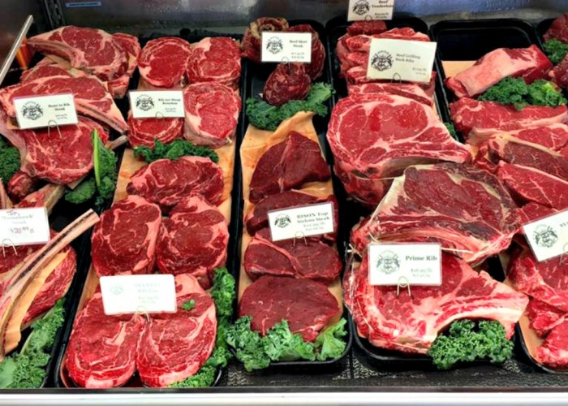
I am proud of my dialogue on this narrative essay.
I think I need to improve my vocab and trim down some of the sentences.

