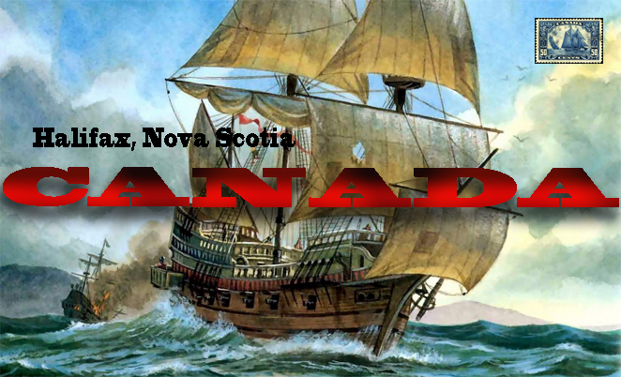
Address: 1234 Devonshire St. London, England.
Dear Father,
It is August 13th 1868. I have arrived in Canada from England by boat, the boat ride took a long time and was very rough. We docked in Halifax, Nova Scotia and the weather here is very mild. I miss our home in London very much, because I don’t know many people and it may be hard to start a new life. I have tried a new food from the locals called Pemmican, which is dried buffalo meat and some berries, I don’t like it but it is common for long trips. Tomorrow I will start on a journey west, and hopefully make it to New Brunswick by next week.
Your son, Josh

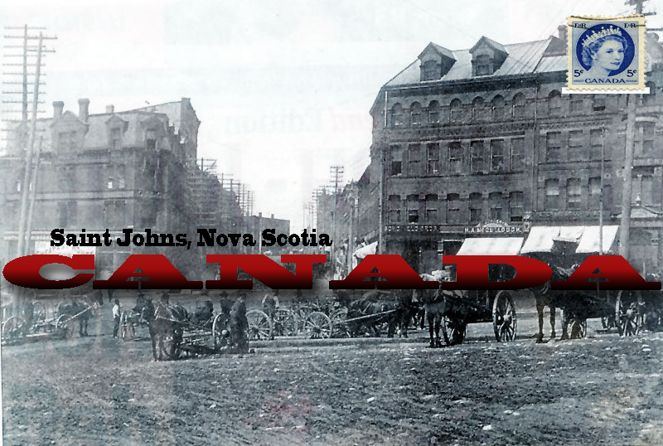

Address: 1234 Devonshire St. London, England.
Dear Father,
It is August 20th 1868. In the past week, I have made it to New Brunswick, The journey was about 416 kilometers from Halifax. Each day I walked 11 hours, and I mostly ate the Pemmican food I told you about, and had to stop in different towns on the way to refill on supplies. I am running low on money, so I am hoping that once I settle I will find work and a way to make money. I have met a whole lot of different people, there is a group of people here known as the Metis, which is when a French man marries an Indian woman and they make babies. I heard that in Quebec they speak French so I am worrying that passing through there may be an issue if I can't find many English speakers. I am going to stay a couple of nights and then continue my journey west, I have been told about a settlement known as the Red River Colony and I hope to be able to settle there.
Your son, Josh
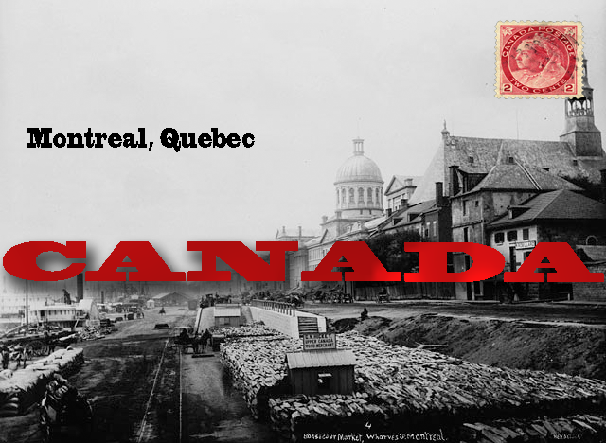
Address: 1234 Devonshire St. London, England.
Dear Father,
It is September 4th 1868. In the past couple of weeks, I have made it to Montreal, Quebec, a journey of over 900 kilometers. Just like my trip from Halifax to Saint John, I walked, but this time I only walked 10 hours a day. The extra hour of rest was very nice to have. I need to have one of the local shoe makers fix my boots, as they are beginning to break. Just like I had been told, majority of the people here speak French, but I have still could find people who speak English and French, which is nice because without them I wouldn’t get very far here. After spending a few days here, I will embark on what will hopefully be my final journey, and make it to the Red River Settlement. On the way, there I will stop in a city in Ontario but I won't write to you until I get to the Red River Colony as I do not want to waste any time.
Your son, Josh
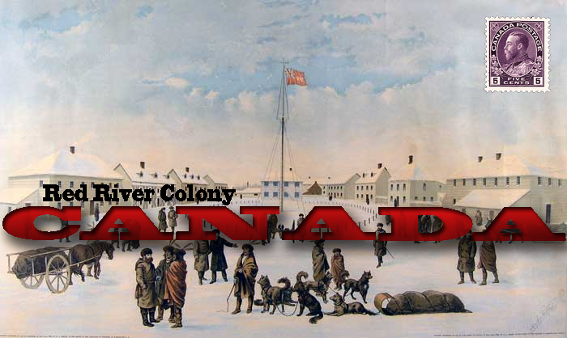
Address: 1234 Devonshire St. London, England.
Dear Father,
Its September 28th 1868. In the past 4 weeks, I have made it to the Red River Colony. The journey was at least 2000 kilometers and I walked 12 hours a day, but I got my shoes fixed in Montreal. Ontario was very nice to pass through as there were many English speakers. There are a lot more Metis people out here then in Ontario and Quebec. Unfortunately, the Metis seem to be angry with the Canadian government because they have been sending surveyors out to survey the land. I'm not sure that settling here was the best choice, but I have to make the best out of it. I am hoping that soon I will get some land and build a house and I may farm the land. Tomorrow I am going to go out and try to meet some other new settlers.
Your son, Josh

