Ireland

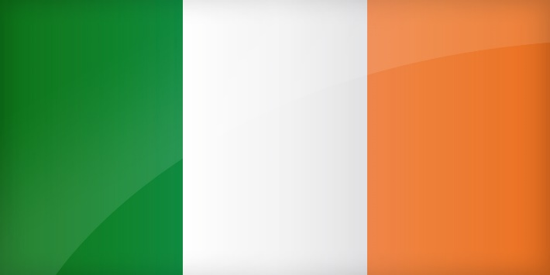
Geography

Physical Geography
Ireland is located in Western Europe, and has an area 84,421 km²
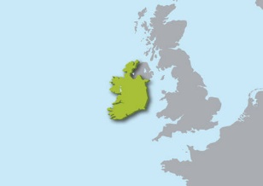

Landmarks
Some landmarks in Ireland are The Blarney Castle, the cliffs of Moher, and the Ring of Kerry.
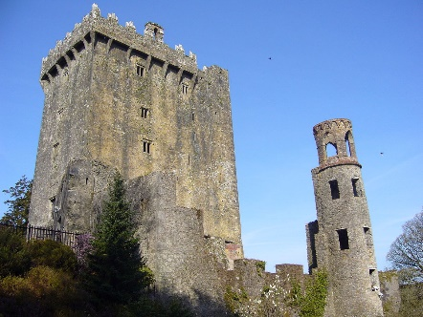

Population
The population of Ireland is 4,746,402.

People

Language
The main languages spoken in Ireland are Irish and English.

Religions
Majority of Religion in Ireland is Roman Catholic, but other religions such as Judaism, Islam, Buddhism, and Hindu are practiced in Ireland as well.

Culture
Major holidays celebrated in Ireland, include St. Patrick’s Day, Easter Monday, and Christmas.
.Some festivals in Ireland are the Cat Laughs Comedy Festival, a comedy festival that was founded in 1994, the Cork Jazz Festival, a jazz festival that happens in late October, and the Fleadh Cheoil.Na Heireann, a music festival that has been around for over 60 years.

Standard of Living
The standard of living in Ireland is lower than the Europe average with the average household income being 22 969 USD.

Industry

Key Industries
Some industries in Ireland are the Alcoholic beverage industry, financial services, aircraft leasing, engineering, information and communications technology, medical technology, and pharmaceuticals.
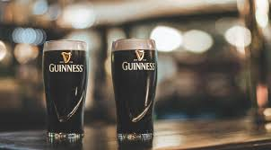

Currency Exchanged
1 EUR converts to 1.52 CAD

Tourism Highlights

Videos
Top 10 Irish Tourist Attractions

Book a trip
Click here

Sources
https://en.wikipedia.org/wiki/Ireland
http://www.worldometers.info/world-population/ireland-population/
http://www.citizensinformation.ie/en/employment/employment_rights_and_conditions/leave_and_holidays/public_holidays_in_ireland.html
https://www.irishtourism.com/must-see-attractions-in-ireland/festivals-in-ireland/1225
http://www.oecdbetterlifeindex.org/countries/ireland/
http://www.irishexaminer.com/ireland/irelands-standard-of-living-below-eu-average-344682.html
http://www.xe.com/currencyconverter/convert/?From=CAD&To=EUR

