
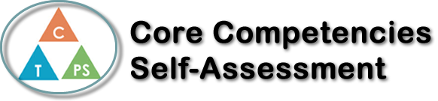
Name: | Date:

  How does the artifact you selected demonstrate strengths & growth in the communication competency?  In what ways might you further develop your communication competency? | Self-Reflection  Describe how the artifact you selected shows your strengths & growth in specific core competencies. The prompt questions on the left - or other self-assessment activities you may have done - may guide your reflection process.  I think that for the song we had to create Jayden and I really used a lot of creative and critical thinking. Especially with the song that we chose to be the base, we had to really think about the different words to rhyme with the base. It also definitely made it harder that our whole subject was on our classmate, but in the end, we figured it out. We had to think of different words and a classier vocabulary. We also had to plan out how the song would sound and when we would have time to record. I feel like we definitely were proud of the end result and the way we worked. Next time I think we can extend our creativity and even make a music video if we have the time, which would also take more planning.


How does the artifact you selected demonstrate strengths & growth in the thinking competencies?

In what ways might you further develop your thinking competencies?


How does the artifact you selected demonstrate strengths & growth in the personal & social competencies?

In what ways might you further develop your personal & social competencies?

Publish Your Self Assessment
You will now attach and/or embed your self-assessment to the bottom of the blog post with the artifact you have chosen. You may choose to make this post private or public. After placing your artifact on a blog post, follow the instructions below.
- Categories - Self-Assessment
- Tags - Now tag your post using the tag that corresponds to the competency that you have written about. You can choose more than one. Please use lower case letters and be exact.
  - #creativethinkingcc
  - #communicationcc
  - #criticalthinkingcc
  - #socialresponsibilitycc
  - #personalidentitycc
  - #personalawarenesscc
- Use the Add Document button located at the top of your post page and embed your self-assessment at the bottom of your blog post.
- Publish

