`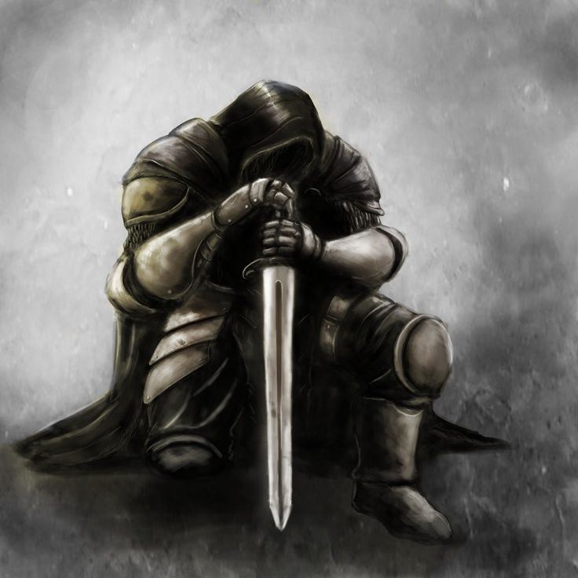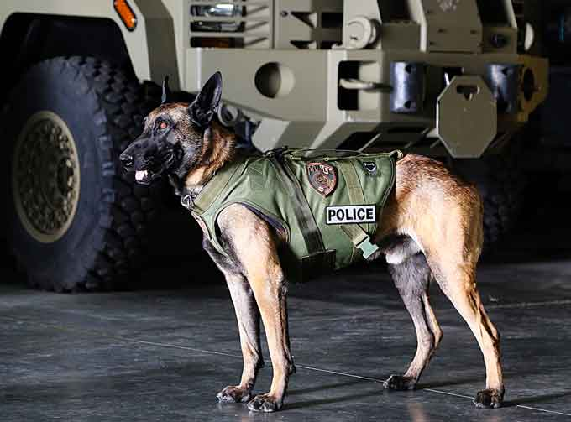

“But two hours of daylight remained, and he still went on.” (Howard O’Hagan Pg.96)

“Any man who froze his hands or his feet only had Himself to blame.” (Howard O’Hagan Pg.96)

“Be proud of yourself no matter what happens.”