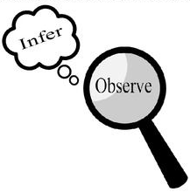
Observations and Inferences
Science 10 Name: BLK:

OBJECT | OBSERVATIONS  Words that describe the object | INFERENCES  Ie: Where might the object come from? Possible uses? Etc. | QUESTIONS YOU HAVE ABOUT THE OBJECT
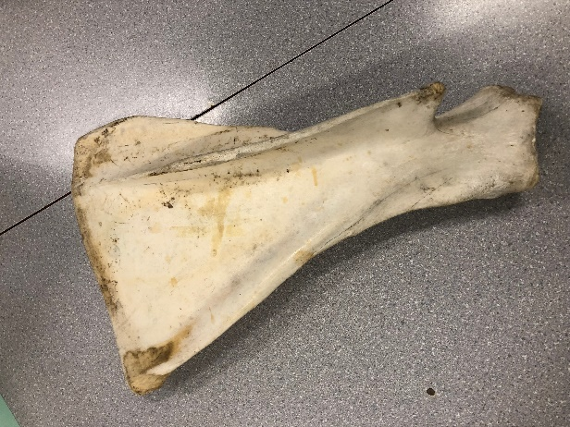 | Bone  Hard  Thin  Semi-translucent  White  Flat  Wide  Bulky  Light weight | May come from a larger animal  Used as a tool a long time ago  Belonged to a big body part  (possibly a thigh?) | How old is it?  What animal did it belong to?  Which body part is it from?  Where can you get one of these?  Which country does the animal originate from?  Is this a crucial body part for the animal?
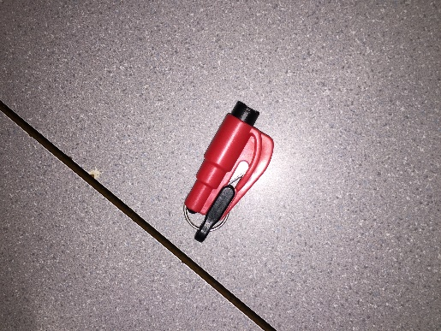 | Red  Plastic  Small blade  Keychain loop  Black  Cheap  Small  Easy to use  Quick release to blade | Could be used to cut things  Could be used on a daily basis (keychain)  Could be used for emergencies (red) (easy to use) (small) (keychain) | Is it a self-defence mechanism  Is it expensive?  Who would carry this type of keychain?  Do you need training to handle one of these?  Where can you get one of these, if available to the public?
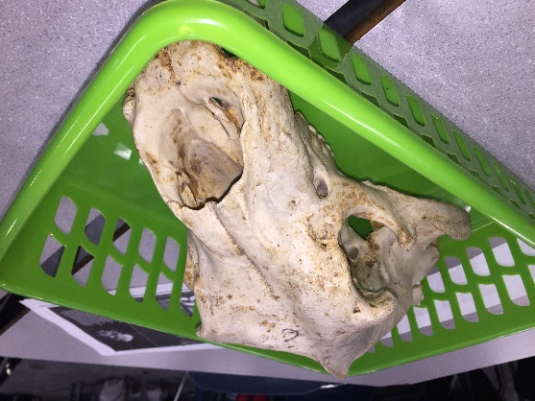 | Beige  Brown spots  Many holes  Sharp teeth (large teeth)  Two chipped teeth (canines)  Smooth with bumps  Lumpy surface  Bulky  Holes for the eyes and nose | Could belong to a large animal  Could be an animal that Is bigger  Could belong to a carnivore (sharp teeth)  Could belong to an animal with a bigger mouth (dog type) | Which animal did it belong to?  Why were there chips in the teeth?  Why is there a huge hole where the nose would be?
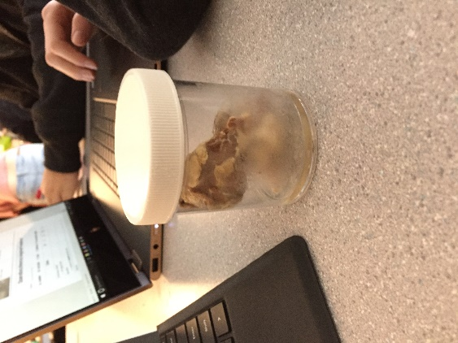 | Wet  Washed out colours  Grey circle  White tip  Larger eyes  Grey / cream colour  Attachments to it’s stem (burgundy colour)  Many components at it’s stem | Could belong to a sheep  Could be very old, filled with preservatives  Could be used for dissection  Could be specially prepared for educational use | Who do the eyeballs belong to?  How long ago were they taken?  How are they preserved?  Are the colours washed out because of the preservatives?

Observations/Inferences Assignment Assessment
Name: _____________________
Ex: Excellent VG: Very Good G: Good S: Satisfactory IN: Improvement is needed
Criteria | IN | S | G | VG | Ex
The following is included
- All 4 Images included
Observations:
- A minimum of 5 detailed observations made
Inferences:
- Thoughtful and logical inferences made
Questions:
- 2 thoughtful and logical questions made
- Spelling/grammar
- Assignment was completed on time
/10

