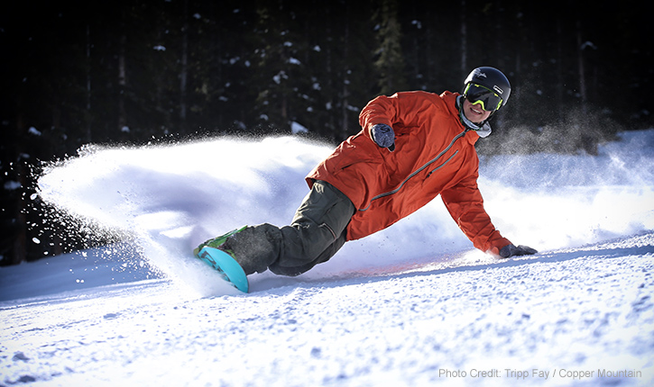
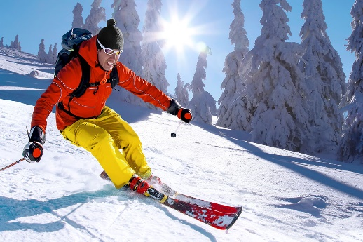
At December 15, this day is the first day at the winter viction, in this winter viction I went to ski and snowboard, and had a Christmas dinner with my all family, at December 20 my couin and I went to skiing, an that day I learn snowboard, this is the first time to play snowboard, but I know how I know how to ski, my cousin all is same to me they know how to play ski, but they don’t how to snowboard, when I learning to play snowboard my cousin and I crash in to the tree too, after we finish snowboarding we went to bought hot chocolate, then we are countain to skiing, we ski untail 9:00p.m., then my dad pack we up back to home.

