
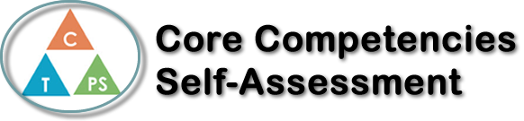
Name: John Carlo Macapagal | Date: June 19, 2020

  How does the artifact you selected demonstrate strengths & growth in the communication competency?  In what ways might you further develop your communication competency? | Self-Reflection  Reflect upon your time in Calculus 12. Not only have you made it through one of the more difficult courses in your high school career, you have also done so during a challenging world event. Which core competency has been utilized the most for you, to get you through this course? (You can pick more than one if you feel you’ve tackled a couple). Write a couple paragraphs explaining why.  You can refer to the PDF attached the assignment to delve into the specifics of each core competency.  I think that I have utilized personal and social competencies the most during this Calculus 12. I know that I am not only responsible to get help when needed but I am also responsible for my own learning. Taking notes in class and doing assigned homework to help me better understand the topic. During the pandemic, I also demonstrated my responsibilities. Since there wasn’t really anything stopping you from doing what you want while in a class meeting, being able to stay focus on the teacher’s lesson was really important. Throughout Calculus, I’ve demonstrated my responsibility to learn by taking notes and doing homework. While I demonstrated my some responsibilities, I feel like I could have still do better by asking the teacher for help when I needed them.


How does the artifact you selected demonstrate strengths & growth in the thinking competencies?

In what ways might you further develop your thinking competencies?

✅

How does the artifact you selected demonstrate strengths & growth in the personal & social competencies?

In what ways might you further develop your personal & social competencies?

