
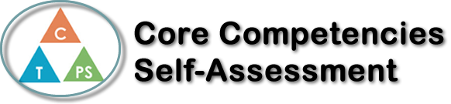
Name: Joel Thirsk | Date: June 19th 2020

  How does the artifact you selected demonstrate strengths & growth in the communication competency?  In what ways might you further develop your communication competency? | Self-Reflection  Describe how the artifact you selected shows your strengths & growth in specific core competencies. The prompt questions on the left - or other self-assessment activities you may have done - may guide your reflection process.  I can motivate myself as well as empower others to work hard and cooperate as a team. I have worked hard this past semester, and have successfully been able to connect and engage with all my peers. These connections have been built on trust and friendship and it has led to good teamwork and good work ethic in all settings I have been placed in. I have stepped up numerous times to be a leader and continually encourage others to do the same. I think that all effective teamwork comes from trust and cooperation of all members, and a large influence of that is a strong leader. I believe I can be that leader and encourage others to be that leader too.  I can strategize and organize my time so that I can successfully complete all tasks at hand. Throughout this semester I have struggled with time management but can now say that I have found strategies to help me organize my time, which ultimately relieves me of stress, as well as helps me get more tasks done. I have organized my time by setting up a “two minute rule” that helps me quickly finish any small tasks that take around 2 minutes and then I check them off a list so that I don’t feel as stressed to do as much. After I finish the simple two minute tasks, I have the larger tasks at hand, but they don’t feel as daunting because I now feel accomplished that I got some things done and this helps me start and complete the large tasks with a good attitude.


How does the artifact you selected demonstrate strengths & growth in the thinking competencies?

In what ways might you further develop your thinking competencies?

X

How does the artifact you selected demonstrate strengths & growth in the personal & social competencies?

In what ways might you further develop your personal & social competencies?

Publish Your Self Assessment
You will now attach and/or embed your self-assessment to the bottom of the blog post with the artifact you have chosen. You may choose to make this post private or public. After placing your artifact on a blog post, follow the instructions below.
- Categories - Self-Assessment
- Tags - Now tag your post using the tag that corresponds to the competency that you have written about. You can choose more than one. Please use lower case letters and be exact.
  - #creativethinkingcc
  - #communicationcc
  - #criticalthinkingcc
  - #socialresponsibilitycc
  - #personalidentitycc
  - #personalawarenesscc
- Use the Add Document button located at the top of your post page and embed your self-assessment at the bottom of your blog post.
- Publish

