
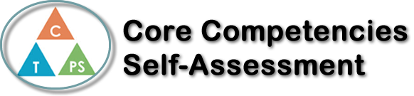
Name: Joel Thirsk | Date: Jan 12, 2020

  ****  How does the artifact you selected demonstrate strengths & growth in the communication competency?  In what ways might you further develop your communication competency? | Self-Reflection  Describe how the artifact you selected shows your strengths & growth in specific core competencies. The prompt questions on the left - or other self-assessment activities you may have done - may guide your reflection process.  This is my Core Competency reflection for my Video Essay, regarding social media, and if it is good or bad. This artifact that I have selected really demonstrates my communication ability, as I chose to prove that social media is a good thing, and had to use communication skills to do that. This video essay not only shows my ability to share my opinions and views, but also to present facts to support my view and give insight on why I have that opinion. The video essay took many hours, as I had to create a script, to clearly state my opinion if social media was good or bad, and had to make sure to give powerful points that have a large impact on the way other people may see social media. Another large communication skill I used was having to speak clearly, and be in depth but also not drag out my point. After completing the script, I had to use a clear and confident voice, to record myself speaking, to add a voiceover onto the presentation.  On future projects, to further develop my communication ability, I would be sure to use language that is slightly more complex, so that my work would be able to be presented at a formal meeting, because it would be more professional. I also believe that communication skills can always be improved, so simply practicing proper communication skills and techniques in life, will help me be able to then use those skills and put them into my work.


How does the artifact you selected demonstrate strengths & growth in the thinking competencies?

In what ways might you further develop your thinking competencies?


How does the artifact you selected demonstrate strengths & growth in the personal & social competencies?

In what ways might you further develop your personal & social competencies?

Publish Your Self Assessment
You will now attach and/or embed your self-assessment to the bottom of the blog post with the artifact you have chosen. You may choose to make this post private or public. After placing your artifact on a blog post, follow the instructions below.
- Categories - Self-Assessment
- Tags - Now tag your post using the tag that corresponds to the competency that you have written about. You can choose more than one. Please use lower case letters and be exact.
  - #creativethinkingcc
  - #communicationcc
  - #criticalthinkingcc
  - #socialresponsibilitycc
  - #personalidentitycc
  - #personalawarenesscc
- Use the Add Document button located at the top of your post page and embed your self-assessment at the bottom of your blog post.
- Publish

