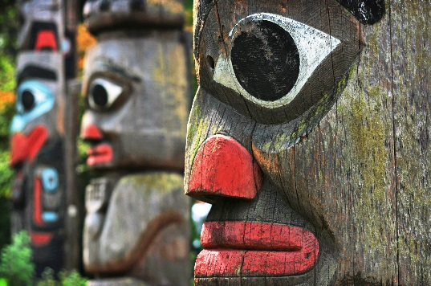
“Totem”
Background: Thomas King, novelist, short-story writer, essayist, screenwriter, photographer (born 24 April 1943 in Roseville, California). A Member of the Order of Canada and two-time nominee for the Governor General’s Award, King is often described as one of the finest contemporary Aboriginal writers in North America. He is part Cherokee and part Greek.
Prewriting:
Read the opening stanza from Rudyard Kipling’s famous colonialism poem “White Man’s Burden”. Do a quick google search on the history of this poem and the meaning. Be ready to discuss your findings.
“The White Man’s Burden” by Rudyard Kipling
Take up the White Man’s burden—
Send forth the best ye breed—
Go send your sons to exile
To serve your captives' need
To wait in heavy harness
On fluttered folk and wild—
Your new-caught, sullen peoples,
Half devil and half child

Now read the following poem by Rita Joe. As with the author above, do a google search on the biography of Rita Joe. What did you learn?

I am the Indian,
And the burden,
Lies yet with me.
By Rita Joe
Write a short explanation of the meaning of Rita Joe’s poem in response to Rudyard’s poem.

Pre-discussion:
- What kind of art do you think best represents Canadian identity? In other words, if you were to enter a “Canadian Art Gallery” what would you expect to see?

Questions:
- Text driven questions to help understand the story on a surface level:
- Where is the setting of the story? Be detailed (physical and emotional setting)

- What was the title of the show on exhibit?

- How did the patrons and the employees feel about the totem poles?

- What did they do to get rid of the problem?

- What was the final solution?

- With the people in your group, do the “symbolism” sheet. You must hand in the symbolism chart with this assignment to get full marks.
Symbolism in the story. Explain the best you can, what each thing symbolizes. Keep in mind the big ideas of this story such as the treatment of Indigenous in Canada and the reservation system.
The Totem Poles

The storage room and limited space
The seascape artwork

The totem poles in the museum
specifically?
Beebe Hill and Walter Hooten

The grunting and giggling of the totems (the noises they make)

The totems continuing to grow despite being cut down

Can you find any more symbols? (you must do this for full marks)

- Deeper questions that extend understanding:

- Did the aboriginal people of Alberta carve totem poles? Look it up on your device. Why do you think Thomas King chose to use totem poles in his story and not an indigenous piece of art from Alberta? (discuss with your group- think stereotypes)

- Is the conflict in the story character vs character, character vs self, character vs society, character vs supernatural, character vs. environment? Explain your reasoning.

Irony Definition (watch the videos that are on my Edublog)
Irony is a figure of speech in which words are used in such a way that their intended meaning is different from the actual meaning of the words. It may also be a situation that may end up in quite a different way than what is generally anticipated. In simple words, it is a difference between the appearance and the reality.
- Explain why this story is ironic. What kind of irony is it? Explain in full.

- This story is a satire. Explain why.

- Theme statement: (Topic + treatment +/- = result) (this will be done as a class)

Bringing it all together. Answer the following questions in point form:
- Based on your understanding of the film Inconvenient Indian and the themes of “Totem” and “A Short History of Indians in Canada”, what are the many factors that have shaped First Peoples Identity in Canada?

- What are the many things Indigenous people are doing to reclaim their culture?

